Onboarding Remote Employees
Provided by: Horst Insurance

Table of Contents
Introduction 4
Technology Planning 6
Planning for the Employee’s Workstation 7
Expectations of the Employee 7
Getting Equipment to the Employee 7
Company-owned Devices 8
Personal Devices 8
Remote Cyber Security Breaches 9
Remote Cyber Security Checklist 10
Cyber Policies for Company-owned Devices 11
Cyber Policies for Personal Devices 11
Set the Foundation Early 12
Be Realistic About Job Descriptions and Expectations 13
Preboard New Hires 13
State-specific Considerations and Employer Liability 13
Formalize the Remote Onboarding Process 14
A Successful First Week 14
Orientation Delivery 15
An Effective Orientation Schedule 15
Content and Content Delivery 15
Introductions 16
Preparing a Remote Form I-9 Process 16
Effective Communication Channels 16
Initial Projects and Responsibilities 17
Checking in Daily 17
Inclusivity 17
Recruit a Mentor 17
Follow Through With New Hires 18
Make Remote Onboarding Exciting 19
Establish Management Expectations 19
Proactively Ensure Remote Workstation Is Functioning Effectively 20
Consider an Intranet Site 20
Prerecord Trainings 20
Use a Company Networking Platform 20
Think Outside the Box 20
Retaining Remote New Hires With Career Pathing 21
Engage Early, Often and Intentionally 21
Evaluate the Process 22
Use Checklists to Stay on Top 24
Use Surveys for Benchmarking 24
Hiring Process 24
Technology 25
Branding 25
First Day 25
First Month 26
First 90 Days 26
General Remote Onboarding Process Questions 26
Summary 26
Appendix 27
Remote Onboarding Checklist 28
Remote Workstation Checklist 31
Remote Anti-harassment Policy 36
Telecommuting Policy 37
Telecommuting Authorization 40
Basic Employment Information 42
Form I-9 (Updated 2019 Version) 43
Form W-4 46
Direct Deposit Form 50
New Employee Announcement 51
Employee Emergency Contact Form 52
Receipt of ABC Company Employee Handbook 53
Remote Onboarding Scorecard 54
COVID-19 Remote Work Policy 55
Pandemic Flu Leave Policy 56

Introduction
Due to the coronavirus disease 2019 (COVID-19) pandemic affecting workplaces, many employers are expediting remote work and evaluating current telecommuting practices. During these times, it’s not just seasoned employees working from home—it’s also new hires. Employers are being challenged with the task of onboarding increasingly more remote employees than ever before. Remote onboarding refers to completing an onboarding process primarily or entirely in a virtual or remote fashion, with the intent of that employee primarily telecommuting. This includes acclimating remote hires to their new roles, setting clear guidelines for performance and company culture, and sharing the necessary knowledge for a new employee to succeed within a remote environment.
While, in some cases, remote work is being adopted out of necessity, many employees feel confident in their abilities to fulfill their roles remotely. The Harris Poll conducted a survey on behalf of Glassdoor among nearly 1,000 employed adults during the COVID-19 pandemic. Results found that 60% feel confident in doing their job efficiently, even if it means doing their job remotely indefinitely, while 50% believe they would be equally or more productive. With increased utilization of telecommuting, employers can use this opportunity to review current practices and optimize this experience for employees.
Remote work, or “telecommuting,” does bring both advantages and challenges to the way companies do business. Advantages can include boosted productivity, potential cost savings and increased flexibility for employees. Other benefits can include increased retention, reduced greenhouse emissions, the ability to tap into a broader geographical talent pool and more.
There are also challenges to telecommuting, such as the potential for a lack of collaboration, and technology and security concerns. However, this toolkit will provide you with information on best practices for having new employees succeed in a remote environment, and find ways to overcome challenges associated with such environments.
The Importance of the Onboarding Process
Why is onboarding so important? The answer is simple: This is the first chance to show new employees why you do what you do and to set them up for success within your company culture. Onboarding helps develop your brand and can build a positive reputation for your company among talented job seekers.
According to a study by the Wynhurst Group, when employees go through structured onboarding, they are 58% more likely to remain with the organization after three years. When you share your company’s goals and values with your employees while simultaneously showing them how to do their jobs, everyone benefits.
Moreover, employers who do not take onboarding seriously risk losing the new employees they spent so long trying to get in the door. In fact, the average company loses 17% of its new hires during the first three months, according to the Harvard Business Review. The importance of the first 90 days cannot be overstated. Use the resources in this toolkit to strengthen your remote onboarding program and retain your talent. Ignoring this process now can lead to consequences in the future.

Technology Planning
An effective technology experience can be key to having successful remote onboarding outcomes. Many potential technology-related issues can be avoided by utilizing proper planning and putting effective practices in place.
Before the First Day
As you set expectations for the new employee, ensure technology-specific expectations are clearly articulated through the recruiting and onboarding process. For remote hires, expectations of the employee’s remote workstation will be vital for success on Day One, as well as planning for how the employee will be receiving the equipment, and policies and practices of your organization.

Planning for the Employee’s Workstation
Notably, a remote employee’s workstation will revolve around a computer that the employee will be using for work. Outlined in this toolkit are different strategies and policies employers can consider, such as having the employee use a company-owned computer, or having the new hire use an employee-owned computer through a Bring Your Own Device (BYOD) policy. An employer should be prepared and prioritize having a high-functioning computer ready to go for the new employee on Day One.
For reference of common components of a remote workstation setup, review the Remote Workstation Checklist, which can be found in the Appendix. Employers will want to determine which components of the workstation they will provide and which components will be provided by the employee. To plan for an ergonomic workstation setup, review the Ergonomic Workstation Checklist, which also can be found in the Appendix.

Expectations of the Employee
The employee should be expected to have access to an ergonomic, available work location with a quality internet connection and minimal distractions during planned work hours.
A minimum of 1.5 Mbps (megabytes per second) is a good benchmark for bandwidth requirements. For reference, popular video-conference tool Zoom recommends a minimum of 1.2 Mbps of bandwidth to best use their software for high-definition video calls, according to their website. This requirement could vary depending on the types of tasks the new employee will be completing to be successful in his or her role, and should be clearly communicated as part of the recruiting or onboarding process.
Expectations for the new employee may also include preparing some or all components of his or her workstation, and employers can consider different options for getting necessary equipment to the employee prior to or on their first day.

Getting Equipment to the Employee
Options for planning the setup of the remote employee’s workstation include:
- Provide equipment to the new employee on their first day. As COVID-19 influences updates to employment laws and employment practices, you may still be able to meet with your new remote employee if they are local. If your local laws allow for it, consider meeting with new hires at the office to welcome them to the company, get them set up with any necessary equipment and deliver any printed training materials. Be sure to test the equipment to make sure it works before you both leave the office. Keep social distancing guidelines in mind when meeting with new hires, and avoid shaking hands to prevent the spread of COVID-19.
- Ship equipment to the new employee in advance of their first day. If you won’t be meeting with the new remote employee on their first day, employers can also consider shipping equipment and materials. This may include some or all of the equipment for the employee’s workstation and relevant printed materials. Due to the COVID-19 pandemic, keep in mind that shipping times may be delayed. Ensure that all necessary equipment reaches the new employee prior to his or her first day.
- Have remote employees provide their own devices through a BYOD policy. Employers can consider a BYOD policy, allowing employees to provide laptops, other mobile devices or other components of their workstation that they will be using.
As you plan the new employee’s workstation, your strategy for delivering equipment to the new employee could include a combination of the above options.
Electronic Devices
When planning for an employee’s workstation, consider establishing best practices for both company-owned and employee-owned devices. These devices include but are not limited to the computer that the remote employee will be using for work.

Company-owned Devices
If the new employee will be using a company-owned computer or other devices, make sure to have a plan in place. Plan ahead for how the workstation can be set up ahead of time so that the new employee can have a seamless transition on Day One. This may include having your IT department set up the computer with necessary software, ensuring the new employee has clear how-to guides on how to use necessary tools, and has any passwords or credentials that they’ll need to get started.
Even when using a company device, remote employees aren’t immune to cyber security threats and other challenges. Employers may want to consider best practices to put in place for remote employees who will be accessing company networks. Review the Remote Cyber Security Overview and Cyber Policies for Company-owned Devices sections of this toolkit for examples of best practices and policies that employers can consider for remote employees.

Personal Devices
BYOD refers to the practice of allowing employees to use their own personal devices, usually laptops, at and for work. The growing trend of BYOD is fueled by several factors, one of which is an effort to attract and retain new, younger employees who have a high level of familiarity with technology as well as preferences for which devices they use. Other reasons companies adopt BYOD include the potential for reducing costs, increasing productivity and enabling employees to work flexible hours and from remote locations.
Within a BYOD program, employers can also consider the option of providing remote employees a “technology stipend.” This can help in providing some of the benefits of a BYOD program while removing some of the financial stress for the employee.
Although a BYOD policy offers many attractive qualities, several legal, financial, security and privacy considerations come with it that are unique to employee-owned devices. Most issues stem from poor security on the device and thus unsecured company data. If you take insufficient steps or, worse, don’t do anything to protect your company’s information and interests, your data could become susceptible to unauthorized access. Laws on both federal and state levels address protection of personally identifiable or sensitive personal information. Because of these laws and the penalties associated with noncompliance, employers may want proper safeguards that could be placed on employees’ use of personal devices that contain sensitive information.
Review the Remote Cyber Security Overview and Cyber Policies for Personal Devices sections of this toolkit to plan for how some of these challenges can be best managed.
Remote Cyber Security Overview
When onboarding remote employees, there are some general considerations employers can plan for when considering remote cyber security practices. General considerations for employers include how to best plan for cyber security breaches, remote network setup, device setup and cyber policies.
Businesses both large and small may want to consider how they can best be proactive in order to protect against growing cyber threats. The following cyber security considerations are not intended to be exhaustive nor should any discussion or opinions be construed as legal advice. It is generally recommended that businesses using sophisticated networks with dozens of computers consult a cyber security expert and legal counsel in addition to using the following cyber security planning guidance.

Remote Cyber Security Breaches
The majority of cyber criminals are indiscriminate when choosing their victims. The Department of Homeland Security (DHS) asserts that cyber criminals will target vulnerable computer systems regardless of whether the systems belong to a Fortune 500 company, a small business or a home user. When planning for remote work, consider that attacks on devices used remotely for work are also at risk of a security breach.
A breach in cyber security can lead to unauthorized usage of a remote computer through tactics such as the following:
- Installing spyware that allows the hacker to track internet activity, and steal information and passwords.
- Deceiving recipients of phishing emails into disclosing personal information.
- Tricking recipients of spam email into giving hackers access to the computer system.
- Installing viruses that allow hackers to steal, corrupt or delete information, or even crash the entire system.
- Hijacking the company website and rerouting visitors to a fraudulent look-alike site and subsequently stealing personal information from clients or consumers.

Remote Cyber Security Checklist
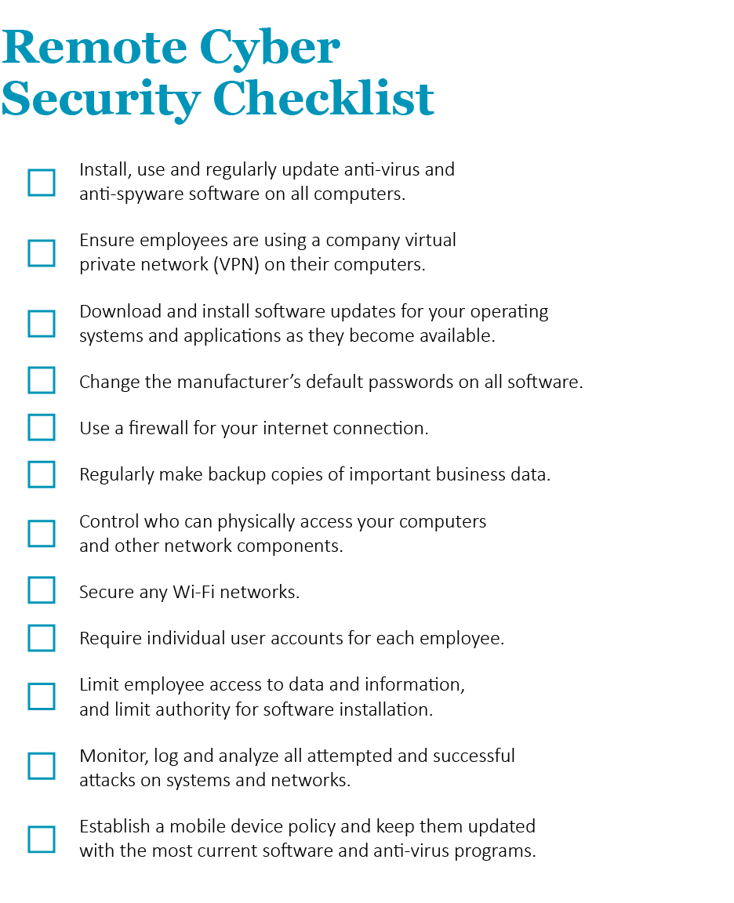
Regardless of whether the new hire will be using a company or employee-owned computer, cyber security should be a companywide effort. Consider implementing the following suggestions at your organization:
While general cyber security practices should be considered, there are specific policies that employers can consider in regard to company-owned and employee-owned devices.

Cyber Policies for Company-owned Devices
When planning for remote access of company networks through a company-owned device, there are recommended practices that employers should consider. One of the most effective and least expensive means of preventing serious cyber security incidents is to establish cyber security policies for remote use of both company-owned devices and networks.
The following are a few specific elements of an effective policy:
- Define what types of company-owned equipment, network and data use are
acceptable within policy.
- Stipulate which apps are allowed and forbidden, and determine how this will be enforced.
- Set strict security procedures that include complex passwords in order to access the device and company networks.
- Define what types of personal use, if any, are allowed on the company-owned device.
- Establish a company virtual private network (VPN) for use on the employees’ home broadband network.
Additional security options are also worth exploring, such as multifactor authentication, providing cyber security awareness training and keeping IT resources well-staffed.
Depending on the types of data regularly handled by your business, it may also make sense to create separate policies governing who is responsible for certain types of data. For example, this may mean limiting access to data and sensitive company or client information for employees who do not require it to complete job functions.
When creating or changing policies, employers should consult with IT departments as to the feasibility and reasonableness of suggested policies, as well as consulting with local legal counsel.

Cyber Policies for Personal Devices
Through a BYOD policy, employers have the option of allowing employees to use their own devices for work. While allowing employees to use personal devices for work offers various benefits, there are serious consequences if something goes wrong and your company is not protected with a written and signed BYOD policy. Implementing a written BYOD policy will help reduce some of the uncertainties and risks associated with this growing technological trend.
Employers are recommended to create written guidelines for security measures that employees can take when they carry company information on their personal devices. A written policy should outline general rules about device use and the rights and obligations of both the employer and employee. It is important to maintain a balance between protecting company interests and respecting employees’ expectations for privacy. Anything that might be perceived as a violation of privacy should be clearly outlined.
The following are a few specific elements to consider when creating an effective BYOD policy:
- Clearly state which devices are allowed under the BYOD policy.
- Specify who owns what on the device. If your company retains the right to wipe the entire device, provide guidelines for how employees can back up personal data such as photos and contact lists.
- Outline what IT support will be provided to the employee.
- Describe the process for removing company information from a device owned by an employee who is leaving the organization.
- Integrate your current acceptable use policy into the BYOD policy.
- Establish a company VPN for employee use on home broadband networks.
Consult with your legal and IT departments as to the feasibility and reasonableness of suggested policies.
Also, ensure that your BYOD guidelines are legally and reasonably enforceable. You may not be able to prohibit certain activities on an employee-owned device, but you can at least manage or limit undesirable behaviors. Further, it is essential that you enforce the policy consistently. A policy is only as good as the enforcement behind it, and if you do not require equal adherence from all employees, you could expose your company to discrimination lawsuits. When creating or changing policies, make sure to consult with IT as well as local legal counsel.

Set the Foundation Early
Simply offering training courses to new hires will not be sufficient for remote onboarding. Employers should consider all the smaller aspects that create an efficient and painless transition into the company, particularly in a remote role. This means working with stakeholders well before new hires start. Establishing a strong remote onboarding foundation prior to Day One can be key for long-term success. This section discusses some tips for doing just that.

Be Realistic About Job Descriptions and Expectations
Give new hires realistic previews of their jobs and make sure the descriptions are as honest as possible. Doing so will guarantee that you and the new hires are on the same page and have the same job expectations. This can help retain new employees, since confusion or uncertainty can cause new hires to quit soon after starting. Surprised about their responsibilities is the last thing your new hires should feel on their first day. Ensuring new employees understand their positions in advance helps reduce the chance of them feeling ill-equipped when learning their new roles. Ensure that this includes remote workstation and schedule expectations, and any travel requirements that the positions may require.

Preboard New Hires
Everyone remembers how stressful the first day of a job can be. Help alleviate some of that stress by preboarding. This process involves sending new hires any information they may find useful in advance of Day One. Sending the following information beforehand can help reduce new employees’ stress and prepare them for a busy first day:
- A welcome letter or email
- A detailed schedule for the employee’s first week
- A welcome kit, including Information about the company and the industry
- Specific plans for delivery and setup of the employee’s technology and workstation
- Information about a BYOD policy, if applicable
- Helpful first-day resources, including a schedule and information about who their manager or mentor will be
- Essential HR and tax forms
- Any necessary links for virtual meetings or video conferences
- Passwords and credentials for initial login

State-specific Considerations and Employer Liability
As with on-site employees, employers should have a plan in place for remote employees in regard to employer liability and legal concerns. What happens if an employee slips and falls at home, while on the clock? Or what if an employee commits a crime in the scope of his or her employment while telecommuting? What about workers' compensation? What state is the remote employee legally employed in?
Employer liability remains a considerable concern for telecommuting employees. Note that employment compliance for remote employees can vary from state to state. As guidelines can vary, make sure to consult with local legal counsel for legal advice.

Formalize the Remote Onboarding Process
Make sure the remote onboarding process is formalized, including your training and orientation. This does not mean the process has to be boring—merely that training should not be ad-libbed by staff at the last minute when the new hires arrive. A formalized onboarding process can go on for days, weeks or even months. Make the most of this opportunity and get new hires up to speed on everything going on within your organization. Explain your company’s structure, its place in the industry and its management hierarchy. Above all, make sure remote hires are getting the same training as everyone else in their departments. Formalizing the remote onboarding process will ease the tensions of starting in new remote roles.

A Successful First Week
One of the most common mistakes employers make with onboarding plans is not setting clear expectations. Because your onboarding process may now be done remotely and you’re not there in-person to monitor a new hire’s progress, setting expectations becomes even more important. Expectations that should be discussed include the company’s values, the team’s objectives and the new hire’s responsibilities.

Orientation Delivery
Training new hires remotely isn’t always ideal for managers or the new employee. As such, prioritize the training and only train new hires on the skills that are absolutely essential for them to be able to do their job. As they progress into learning more about their role, there will be plenty of opportunities for more advanced training.

An Effective Orientation Schedule
Planning out the schedule for the new employee can be a stress reliever. Make sure to be very clear with the employee’s to-do list for the week, which should coincide with his or her schedule. Set clear expectations ahead of time, and make sure to pass along a checklist of steps that should be completed to the employee. Giving clear guidelines on how to accomplish tasks will make the employee feel confident and at home.
On top of introductions and learning materials, an orientation schedule will need to include time for tasks such as:
- Benefits enrollment
- Direct deposit setup
- Policy acknowledgments
- HR overview
- IT overview
- Completion of HR forms
Consider that, for documents such as policies and the employee handbook, there should be remote-specific dialogue and expectations. An example would be an anti-harassment policy, which should have specific guidelines for remote behavior. Consider reviewing the Remote Anti-harassment Policy included in the Appendix of this toolkit as a guideline for what this policy could look like.

Content and Content Delivery
An effective onboarding experience will have content that keeps a new employee engaged, but will also be informative. Consider how you can develop remote content and a content delivery strategy that won’t just be engaging, but successfully deliver key points about the company overview, values and organizational goals, while providing necessary new employee steps and role-specific training.
Content delivery could include many channels:
- Video calls
- Prerecorded videos
- Emailed documents
- In-person presentations (if the employee is visiting the office to begin orientation)
In the first week, the new employee should be spending time with IT to learn about best practices and tools that they will be using. After these training sessions, you should direct the employee to centralized channels of information where talent can access how-to guides and FAQs easily. With the influx of content the new hire will be taking in in their first week, this will allow the new hire to continue to reference any necessary information as they become more familiar with necessary tools and available resources.

Introductions
Whether in person or remotely via a video-conference, face-to-face interactions allow the new employee to feel welcomed and make connections with his or her teammates and peers.
Set a goal of having an introduction or check-in between the new employee and their supervisor on Day One, if at all possible. Through the first week, set time aside for the new employee to get acclimated to each individual member on his or her team.

Preparing a Remote Form I-9 Process
Completing Form I-9 is part of any onboarding process, and the process may change if onboarding a remote employee. As required by law, Form I-9 document verification requirements typically are satisfied as part of an in-person orientation process within the first three days of employment. If the employee will be physically attending on Day One, this process can proceed as standard. For a remote I-9 Verification process, the new employee can complete Section 1 remotely; however, documentation will need to be verified for the employer to complete Section 2. Some vendors offer local I-9 verification remotely through local employment offices, notaries and more.
On March 20, 2020, in response to COVID-19, the U.S. Department of Homeland Security announced flexibility in requirements related to Form I-9 compliance. Temporarily, employers have the option of reviewing the employee’s identity and employment authorization documents either in the employee’s physical presence or virtually. Employers may choose to inspect necessary documents remotely, through email, fax or video. If reviewing documents remotely, employers will then be required to review the physical documents once the temporary flexibility is lifted.
As of Jan. 31, 2020, employers are advised by U.S. Citizen and Immigration Services to begin using the new version of Form I-9 released on Oct. 21, 2019. Note that, beginning May 1, 2020, employers will be required to use the new version of the form.

Effective Communication Channels
Given that the employee will be primarily communicating remotely, the employee should be trained on the various communication channels that they will be using, and where they can find the updates and news that they need. These can include:
- Intranet
- Email alerts
- Internal social-media tool
- Employee handbook
- Conference or video calls
The new remote employee won’t be hearing updates word-of-mouth, so it is important to be intentional about sharing all necessary updates.

Initial Projects and Responsibilities
While new hires shouldn’t be overloaded with work in their first week, many new hires will be eager to make an impact. Plan ahead for how new hires can be involved with a project in their first week. While new hires will be able to ease into their eventual workload, create opportunities for small accomplishments within their first days of employment. Even small tasks and projects will allow the new employee to feel as if he or she is adding value, and will help to begin developing employee engagement.

Checking in Daily
Having employees work from home can help keep them healthy, but it can become isolating, especially for new hires. Schedule a daily call or video chat to help new hires feel like part of the team and allow them the opportunity to ask questions.

Inclusivity
When deciding whom to include in the remote onboarding process, do not just think about the people who are involved in the new hires’ day-to-day operations. Include other stakeholders like HR managers, executives and anyone else who may be important in the company as a whole. Have these people introduce themselves, along with their roles, and encourage them to extend an open line of communication. Do not be afraid to virtually introduce new hires to important clients either, if appropriate. Doing so can help new employees by providing a glimpse of whom they will be working with on a regular basis—plus, it reassures clients that they will continue to be taken care of.

Recruit a Mentor
Assigning mentors to new hires can be invaluable to the remote onboarding process. Sun Microsystems conducted a study that looked at data from more than 1,000 of its employees over a five-year period and found that its mentoring program led to positive results for a majority of the workforce. According to the study, 25% of employees who participated in the test group had a salary grade change, compared to the 5% who did not participate.
Additionally, mentors were promoted six times more often, and mentees were promoted five times more often than those not in the program. Retention rates were also higher—69% for mentors and 72% for mentees, compared to a 49% retention rate for employees who did not participate in the program.
Mentors can help new hires in a variety of ways, including the following:
- Give new hires a better understanding of the workplace by offering a different point of view.
- Act as a safe source for questions, since new hires might not feel comfortable asking their managers certain things.
- Reassure new hires that they are not alone and that there are contacts besides HR and their managers who can answer everyday questions.
- Help new hires learn the organization’s culture more quickly so they can be as productive as possible.
For remote employees, having a strong mentor can be an advantage for the new employee as he or she begins to navigate the remote work environment.
New hires are not the only ones who can gain from the mentoring experience. Offering the chance to advise others can increase a mentor’s confidence and overall job satisfaction. Organizations that provide mentoring support show that they care about their employees and that they are invested in the long term. Additionally, it displays confidence in the mentor to groom new employees for success.

Follow Through With New Hires
Remember, successful remote onboarding does not happen overnight. It takes dedication and follow-through from both the new hires and whoever is guiding them. An easy pitfall to slip into is leaving new hires to their own devices during the onboarding period, perhaps to review training materials. Try to avoid isolating new employees, and instead encourage them to talk with others and establish contacts who can help them with questions during their onboarding. This section details some of the ways you can help foster a productive onboarding process for new employees while keeping them engaged throughout it.

Make Remote Onboarding Exciting
While new hires are going through training and orientation, incorporate activities that liven up the process and make them feel involved. Sitting through a series of training lectures makes for a very long day, and new hires are likely to feel burned out after a while. Consider the following activities to help jazz up your training program:
- Have trainees guess company statistics, like how many customers are served each day or the number of products produced in a month.
- Facilitate a “Jeopardy” game where the questions are related to the subject being taught.
- Quiz new hires on the subject matter of a training session to encourage active listening and participation.
- Hold “mocks” where new hires pretend they are doing an essential job function, like interacting with an upset customer, assembling a product or creating detailed spreadsheets.
- Require new hires to give a short presentation on what they learned in a given week (or after training ends). Use this to gauge whether individuals require more guidance before starting full time in their role.
In short, show that your company is not just going through an administrative hiring process—new hires were chosen for a reason, and the company acknowledges the value that they will bring to the organization. Make new hires proud to be working for you by showing your appreciation for them.

Establish Management Expectations
It is important that managers contact new hires on Day One and make sure they have an open conversation about their roles in the department and in the company as a whole. This would be a good time to give a tour (or virtual tour of company or team content), introduce them to other team members, establish a mentor and reiterate the company’s cultural expectations.
Managers should share department goals and the method for tracking these goals early on. It also reinforces the fact that new hires are part of a larger team, working toward greater company goals.
Apart from the department and company goals, managers should also lay out clear guidelines for new hire success. This can look different depending on the organization, but it typically includes communicating team expectations, identifying personal responsibilities and having a clear path for the onboarding process. Essentially, new hires should not have to guess what their managers are expecting from them. Establishing expectations early on will help new hires understand their place in the organization.

Proactively Ensure Remote Workstation Is Functioning Effectively
Set up a standard process to check in with the new employee regarding his or her workstation. This should be done regularly–a new employee may be nervous about asking for help if something isn’t functioning properly, so by setting aside time to make them feel comfortable about bringing up concerns, this will ensure any issues are addressed.

Consider an Intranet Site
Many organizations have an internal website (or intranet site) specifically for employees to access important company information. Unfortunately, employees do not always find these sites useful or engaging. Consider using an intranet site and stocking it with resources you know new hires will need. Examples of important resources include an employee handbook, training schedules, an employee directory and links to industry websites. During onboarding, be sure to demonstrate this site and ask new employees to explore it.

Prerecord Trainings
Training via live or prerecorded video for those in remote locations, instead of paying for travel costs, is another way of using technology to your advantage. Consider pairing prerecorded sessions with software that can quiz and track trainees’ progress online. Having remote learning opportunities like this can make scheduling much easier and allows new hires to learn at their own pace. This is especially important to consider when you have Generation Z individuals entering the workforce (those born between 1995 and 2010), since they are accustomed to getting the majority of information via technology.

Use a Company Networking Platform
There is a growing need for companies—including yours—to think about social networking. Platforms like Yammer and Chatter provide resources for employees to build meaningful connections within the organization. These platforms act similarly to social media sites like Facebook, but they are protected behind your company’s firewall and only accessible by your employees. This can be a great way to engage with employees in a more casual way, which can be welcoming for new hires.

Think Outside the Box
Do not be afraid to think outside the box when it comes to onboarding. Remember, the process is about integrating new hires into your company culture and helping them transition into their new roles. A formalized process that offers a variety of useful information is integral, but trying different things can be useful too. In fact, offering a variety of teaching methods and platforms can actually increase the success of your program. Keep in mind that you can extend onboarding for as long as you deem necessary. Some onboarding programs continue for months. Determine what success looks like for new hires at your company and tailor your onboarding process to achieve that goal.

Retain Remote New Hires With Career Pathing
Your goal as a company should be retaining the talented individuals you spent a significant amount of time and money recruiting. A recruiter’s worst nightmare is having new hires leave after a few months. With this in mind, it is paramount that you define clear paths for new hires within the organization. Let them know where their position can lead if they stay with your company, or what career opportunities there are in other departments. The key is to keep them even if they decide the roles they were hired for do not align with their ultimate career goals.
If new hires are not acclimating well to their new position, do not give up without a fight. Help plot a course for internal career development opportunities that align better with the new hire’s interests. Let new employees know that they have a future with the company. Explain how individuals in similar roles have moved across departments and found success. You spent a lot of time recruiting and onboarding these individuals, so you should do everything you can to keep them and not waste those resources.

Engage Early, Often and Intentionally
According to Gallup, only 30% of the U.S. workforce feels engaged in their work. The rest are either not engaged or, even worse, actively disengaged. Employees who are not engaged show a lack of enthusiasm and are less committed to their workplaces. Actively disengaged employees are more likely to steal from their employers, negatively influence their co-workers, miss workdays and drive customers away. Disengaged employees cost the United States an average of $500 billion each year in lost productivity. This illustrates how important engagement during the onboarding process can be.
To feel engaged, new hires must understand that what they will be doing matters to the company and that their performance will make a difference. Illustrate the impact of new employees’ roles in the company by encouraging your workforce to own their work and to take pride in what they do. You should be engaging with new hires and stressing these points throughout the onboarding process.
An employee engagement survey is a great starting place for addressing this issue. Many consulting firms offer such surveys, but you can also create and conduct one on your own. They typically gauge opinions on management, direct supervisors, co-workers, employer-employee communication, opportunities for advancement, job characteristics and HR policies. Consider asking new employees to complete the survey after 90 days of employment, once they have a chance to form opinions.
By identifying areas that are hindering employee engagement, your company can focus on improving those areas so it can move toward a more engaged, productive and profitable workforce. Engaging early and often in the onboarding process can get new hires accustomed to having dialogues with their managers. This open communication can pay off hugely and help encourage employees to speak up when they have concerns. If engagement is ignored during onboarding, employees may be less likely to speak up down the road.
Remote employees will need to be engaged intentionally. Tips include:
- Be intentional about giving remote employees an opportunity to share their thoughts and ideas.
- Set up check-ins with remote employees, keeping in mind that remote employees may not be aware of best practices for check-ins.
- Ensure that remote and non-remote employees alike have equal opportunities to share ideas, speak during meetings and be given visible work assignments.
While it can be easy to assume that employees may be able to fare well on their own in the office, remote employees should be engaged very intentionally by managers.
The onboarding process should lead to continued engagement for the new employee. Begin to plan for how your teams can succeed in a virtual environment. While the first 90 days are important, processes should be developed with a bigger picture in mind.

The First 90 Days
Setting Up Remote Employees for Success
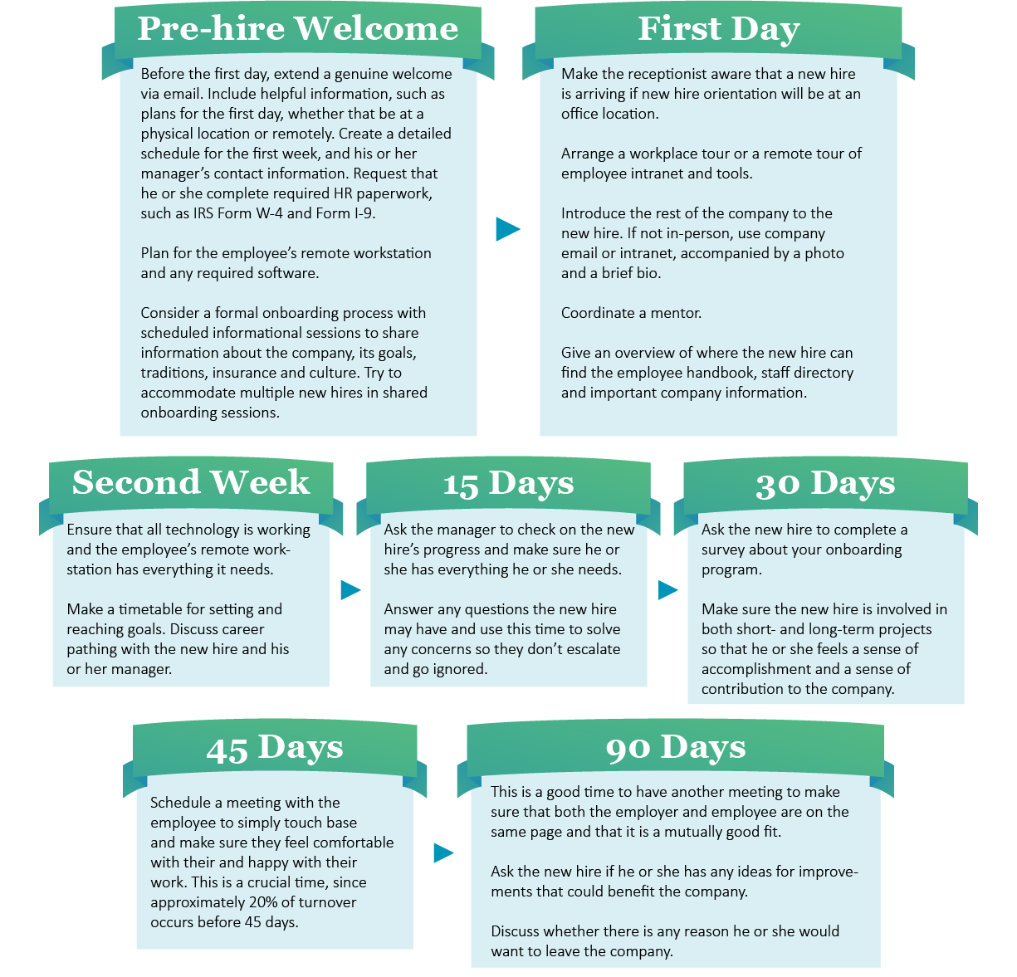
As you design a remote onboarding process—remember that updating and improving processes will be an ongoing effort. By taking appropriate steps, employers can ensure that the remote onboarding experience goes as smoothly as possible for each new employee, while continuously evaluating the process. By using checklists, surveys, and continuing ongoing discussions with new hires, employers can evaluate and improve their onboarding programs for remote employees.

Use Checklists to Stay on Top
Keeping track of new hires’ onboarding progress can be overwhelming for even the most seasoned HR team. Consider utilizing a simple checklist to navigate the onboarding process in a way that creates a welcoming atmosphere and a long-term relationship. The Remote Onboarding Checklist listed in the Appendix can be used as a starting point for you to create an onboarding plan, whether it used by a hiring manager, manager or mentor.

Use Surveys for Benchmarking
Part of a successful onboarding process involves listening to employee feedback and using that feedback to make changes as needed. Consider asking each employee to complete a short survey after 90 days of employment—when he or she has finished the onboarding process and has had time to become acclimated to his or her job, yet still remembers specifics about the experience.
Deciding whether to keep the survey responses anonymous depends on what you expect from the survey’s results. It is sometimes difficult to make necessary onboarding changes when you don’t know the details surrounding anonymous survey responses. However, you are more likely to get honest answers this way. Companies like SurveyMonkey—whose website allows you to customize and distribute surveys directly through its servers—are popular choices for employers who choose to keep employee responses anonymous. Another route is to directly email a survey to each employee, expecting complete transparency so that you can more easily adjust your processes.
Some examples of onboarding survey questions include the following:

Hiring Process
- Was the job description clear and understandable?
- Was the HR contact professional and knowledgeable during the hiring process?
- Was the length of time between the submission of your application and the employer’s response reasonable?
- Was the length of time between the submission of your application and the job offer reasonable?
- Are you satisfied with the hiring process overall?

Technology
- Were remote expectations clearly communicated prior to your start date?
- Did your workstation function effectively?
- When you needed IT support, were you able to receive friendly and timely assistance?

Branding
- Before applying for this job, were you familiar with the company?
- Were you sent information before the first day that helped you know what to expect before beginning your employment?
- During your onboarding session, were you provided with concise information regarding the following:
  - The company’s mission?
  - Your role in the department and the company?
  - The organizational structure?

First Day
- Was your team ready for you to begin?
- Were you welcomed by your manager and introduced to your team?
- Was your remote workstation effectively planned for?
- Was the information you received about employee benefits clear and helpful?
- Was the information you received about personnel policies clear and helpful?
- Did you know who to contact regarding specific questions after your first day?

First Month
- Were you assigned proper training during your first month?
- Did you know what was expected of you during your first month?
- Did you know where to get the answers to your questions?
- Was the performance management system explained to you?

First 90 Days
- Did you receive ongoing feedback from your supervisor about your performance?
- Is the work you are doing now consistent with what was described in the job posting and during the interview process?
- Are you satisfied with the overall orientation that you received?

General Remote Onboarding Process Questions
- What was your motivation for choosing and accepting this position?
- Do you have any recommendations for improving our recruitment, hiring or remote onboarding processes?
- Is there any additional feedback that you can share?
- How would you evaluate your remote onboarding and orientation process?

Summary
Onboarding remote employees the right way can improve retention and save money, while building upon your company’s culture and brand. Use the information and resources in this toolkit to think about how you onboard remotely, and whether there is room for improvement. The resources here can help take your process to the next level. Open communication about expectations, roles, career paths, impact and personal goals can spread from the initial onboarding process to new employees’ entire tenure at the company. Take advantage of the information above and in the Appendix below to get a jump-start on making remote onboarding your own.
This guide is intended as a general overview and is not a substitute for legal advice. For more information on the compliance side of onboarding or any of the business topics within this toolkit, contact Horst Insurance.

Appendix
Onboarding remote employees is not a simple task. It requires a lot of work from many stakeholders. This section takes away some of that burden by offering valuable resources that you can print or email and use for your new hires. This appendix contains a selection of resources designed to help your organization onboard talent. It features key HR documents, checklists, telecommuting policies, important forms, internal policy agreements and much more.
Speak with Horst Insurance if you have any questions about these resources. Note that some sections may require customization.

Printing Help
There are many printable resources in this appendix. Please follow the instructions below if you need help printing individual pages.
- Choose the “Print” option from the “File” menu.
- Under the “Settings” option, click on the arrow next to “Print All Pages” to access the drop-down menu. Select “Custom Print” and enter the page number range you would like to print, or enter the page number range you would like to print in the “Pages” box.
- Click “Print.” For more information, please visit the Microsoft Word printing support page.

Remote Onboarding Checklist

BEFORE THE EMPLOYEE’S START DATE

Job Duties and Schedule
- Contact the employee with useful information that may include any of the following:
  - Information about whether part or all of the orientation will take place remotely or at a specific location
  - Confirmation of the start date, time, place, parking, maps and dress code
  - Name of his or her mentor, if applicable
  - Request to complete new-hire paperwork, Form I-9, tax forms, direct deposit form and emergency contact information
- Add regularly scheduled meetings to the employee’s calendar.
- Plan the employee’s first orientation, training and assignments.

Social
- Email the employee’s department with relevant information about their new team member, such as his or her start date, role and a brief bio. Copy the new employee, if appropriate.
- Select and meet with the new hire’s mentor, if applicable. Provide suggestions and tips.
- Set up meetings with critical people for the employee’s first few weeks.

Work Environment and Technology
- Plan for the employee’s remote workstation.
- Communicate technology expectations of the employee ahead of their start date.
- Order any necessary training materials.
- Order business cards if necessary.
- Order equipment and plan for necessary software.
- Arrange for access to common shared network drives.
- Add the employee to relevant email distribution lists.
- Arrange for employee phone service and/or phone plan.

Training & Development
- Arrange pertinent training required for the job.

FIRST DAY

Job Duties and Schedule
- Introduce the employee to the virtual workspace.
- Review outline of duties and expectations for the first week.
- Review hours of work. Explain policies and procedures for overtime, use of vacation, sick time and holidays.

Social
- Be available to greet the employee on the first day, either in-person or via video chat.
- Introduce the employee to others in the workplace and his or her mentor.

Employee Intranet and Tools
- Give the employee a key or building access card.
- Give the employee a tour of employee intranet and key tools.
- Explain how to get IT support.

Technology
- Provide information on setting up voicemail and their computer.
- Ensure that the employee has a fully functioning workstation.

FIRST WEEK

Job Duties and Schedule
- Give the employee his or her initial assignment—something small and doable.
- Briefly check in with the employee each day to address any questions or concerns that may arise.
- Explain the annual performance review and goal-setting process.
- Review the process related to the probationary period, if applicable.

FIRST 3 MONTHS

Job Duties and Schedule
- Conduct regularly occurring one-on-one meetings while giving timely, useful feedback.
- Meet for an informal three-month performance check-in.
- Create written performance goals and professional development goals.

Social
- Meet with the employee’s mentor to review initial stages of mentorship and answer questions.
- Make sure that the employee is a part of ongoing conference or video calls on a regular basis.

Training and Development
- Ensure the employee has attended all scheduled training and is signed up for any future training sessions that may be needed.
- Provide information about continued learning opportunities, if applicable.

FIRST 6 MONTHS

Job Duties and Schedule
- Conduct a six-month performance review.
- Review progress on performance goals and professional development goals.

FIRST YEAR (BETWEEN 6 AND 12 MONTHS)

Job Duties and Schedule
- Celebrate successes and recognition of the employee’s contributions.
- Continue providing regular informal feedback; provide formal feedback during the annual review process.
- Have a conversation with the employee about his or her experience to date.
- Discuss potential goals for the next year.

Training and Development
- Discuss the employee’s professional development goals and identify relevant learning opportunities.

Remote Workstation Checklist

Home Office
- Adequate space within the employee’s home for an office:
  - Workstation should comply with organization-specific ergonomic and safety guidelines.
- An environment with minimal noise and distractions.

Broadband
- Employees should have broadband that can download and upload at a minimum of 1.5 Mbps:
  - This may vary, depending on the position and expectations.
  - The employee should plan for other users of the broadband that may be connecting on their home network using available broadband simultaneously.

Technology
- Computer, either provided by the employer or employee:
  - The computer should have hard drive capacity and memory to perform necessary job duties.
  - The computer should include a webcam, if video calls will be part of the employee’s job responsibilities.
- Headset
- Power cord
- Cellphone
- Phone subscription service
- Printer (optional)
- Fax machine
- Mouse (optional)
- Keyboard (optional)
- Dual display (optional)

Office supplies
- Notebooks
- Binders
- Paper
- Pens
- Pencils
- Staples
- Other role-specific supplies

Chair and Desk
- Comfortable and ergonomic chair
- Desk
- Standing desk (optional)

Software
- VPN established for employee’s home broadband network
- Phone subscription service
- Internal network access given to the employee for all necessary job functions
Presented by Horst Insurance

Date: Review conducted by:

This checklist is designed to help you evaluate your computer workstation and your video display terminal (VDT) to prevent common stresses and injuries associated with use.
CHAIR | YES | NO | N/A
Chair height (up/down) and backrest tension/angle are easily adjustable. | ☐ | ☐ | ☐
Chair is equipped with a padded seat and back cushion. | ☐ | ☐ | ☐
Front edge of seat pan is rounded and seamless. | ☐ | ☐ | ☐
Seat is at least 18" wide x 15" long. | ☐ | ☐ | ☐
Chair has nonslip upholstery with porous "breathable" fabric. | ☐ | ☐ | ☐
Backrest has height-adjustable lower back support. | ☐ | ☐ | ☐
Backrest is at least 18" tall x 14" wide. | ☐ | ☐ | ☐
Seat tilts back only slightly as the backrest tilts back. | ☐ | ☐ | ☐
Chair swivels easily on casters. | ☐ | ☐ | ☐
Chair is supported with five legs for stability. | ☐ | ☐ | ☐
Base of chair is at least 24" around. | ☐ | ☐ | ☐
Height- and width-adjustable armrests provided if needed. | ☐ | ☐ | ☐

FOOT/LEG POSITIONS | YES | NO | N/A
Feet are flat on the floor or on a footrest. | ☐ | ☐ | ☐
You have 3" to 6" of legroom between legs and workstation. | ☐ | ☐ | ☐
Thighs are parallel to floor. | ☐ | ☐ | ☐
Knees are at a 90- to 110-degree angle. | ☐ | ☐ | ☐

KEYBOARD | YES | NO | N/A
Keyboard is detachable and slightly sloped at about 10 to 15 degrees. | ☐ | ☐ | ☐
Keyboard is prevented from slipping. | ☐ | ☐ | ☐
Wrists are relaxed and straight (neutral). | ☐ | ☐ | ☐
Wrist rest or parallel support armrests used, if needed. | ☐ | ☐ | ☐
Arms are close to body with elbows at 90-degree angle. | ☐ | ☐ | ☐
Wrist/forearms are parallel to floor. | ☐ | ☐ | ☐
Mouse is at same level as keyboard and within easy reach. | ☐ | ☐ | ☐

WORKSTATION | YES | NO | N/A
Display screen is 18" - 30" away from your eyes. | ☐ | ☐ | ☐
Table/desk height is adjustable if needed. | ☐ | ☐ | ☐
Table/desk surface is 25" - 27" above the floor and 30" deep. | ☐ | ☐ | ☐
Adequate space to adjust height/location of monitor. | ☐ | ☐ | ☐
Front edge of table is rounded . | ☐ | ☐ | ☐
Materials used most often are arranged within easy reach. | ☐ | ☐ | ☐
Document holder is at same height and distance as the display screen. | ☐ | ☐ | ☐
Telephone headset or speakerphone used if needed. | ☐ | ☐ | ☐
Storage drawers located under desk/table do not restrict knee clearance. | ☐ | ☐ | ☐

DISPLAY SCREEN/MONITOR | YES | NO | N/A
Brightness and contrast controls are adjusted for viewing comfort. | ☐ | ☐ | ☐
Display screen is 18" - 30" away from your eyes. | ☐ | ☐ | ☐
Top line of display (print) is slightly below eye level. | ☒ | ☐ | ☐
Display is tilted slightly to reduce reflections and glare. | ☐ | ☐ | ☐
Display screen is clean and free of flickering. | ☐ | ☐ | ☐

LIGHTING/GLARE REDUCTION | YES | NO | N/A
Indirect or shielded lighting used to reduce reflections and glare. | ☐ | ☐ | ☐
Window blinds or drapes are adjusted or closed when needed. | ☐ | ☐ | ☐
Lighting levels are adjusted (where possible) throughout the day. | ☐ | ☐ | ☐
Face of display screen is at right 90-degree angles to windows. | ☐ | ☐ | ☐
Ceiling lights are located to the side of the screen (not directly overhead). | ☐ | ☐ | ☐
Anti-glare screen/filter used if necessary. | ☐ | ☐ | ☐
Task lighting or desk lamp adjusted to avoid glare and reflections. | ☐ | ☐ | ☐

Remote Anti-harassment Policy
ABC Company is committed to providing a workplace free from discrimination, harassment and retaliation. Note that “workplace” is not limited to a physical location an employee is assigned to perform his or her duties. But rather, such prohibited actions extend to conduct that occurs remotely via electronic means.
ABC Company will not tolerate harassment of any type based on race, color, religion, sex (including pregnancy), national origin, age (40 or older), disability, or genetic information and other characteristics protected under state, federal or local laws. Such conduct in any form is prohibited in the workplace (including places of remote or virtual work), at work-related functions or outside of work if it affects employees in the workplace. This policy applies to all employees, clients, customers, guests, vendors and persons with whom ABC Company does business.
All employees must ensure they understand this policy and their obligations. Whether an employee’s conduct violates this policy will be based on how an employee’s conduct is received and whether a reasonable person would find the conduct to be in violation of the policy.
Harassment is defined as unwelcome conduct that is based on race, color, religion, sex (including pregnancy), national origin, age (40 or older), disability or genetic information. Harassment becomes unlawful where:
- Enduring the offensive conduct becomes a condition of continued employment; or
- The conduct is severe or pervasive enough to create a work environment that a reasonable person would consider intimidating, hostile or abusive.
Anti-discrimination laws also prohibit harassment against individuals in retaliation for filing discrimination charges, testifying or participating in investigations, proceedings or lawsuits under these laws, or, for opposing employment practices that they reasonably believe discriminate against individuals, in violation of these laws.
Petty slights, annoyances and isolated incidents (unless extremely serious) will not rise to the level of illegality. To be unlawful, the conduct must create a work environment that would be intimidating, hostile or offensive to reasonable people.
Offensive conduct may include, but is not limited to, offensive jokes, slurs, epithets or name-calling, physical assaults or threats, intimidation, ridicule or mockery, insults or put-downs, offensive objects or pictures, and interference with work performance. Harassment can occur in a variety of circumstances, including, but not limited to, the following:
- The harasser can be the victim's supervisor, a supervisor in another area, an agent of the employer, a co-worker or a nonemployee.
- The victim does not have to be the person harassed, but can be anyone who is affected by the offensive conduct.
- Unlawful harassment may occur without economic injury to, or discharge of, the victim.
Appropriate performance reviews, counseling or discipline by your manager do not constitute harassment.
If you feel that you are being harassed, you should take the following steps:
- Tell the harasser that his or her actions are not welcome and that they must stop, if you feel comfortable enough to do so.
- Report the incident immediately to your manager or human resources representative.
- Report any additional incidents or retaliation that may occur to your manager or human resources representative.
All reports will be investigated immediately and thoroughly. Complaints and actions taken to resolve complaints will be handled as confidentially as possible. Appropriate actions will be taken to stop and remedy such conduct, including interim measures during a period of investigation.
Retaliating or discriminating against an employee who reports a suspected incident of harassment or who cooperates in an investigation is prohibited. Employees who violate this policy or retaliate against an employee in any way will be subject to disciplinary action, up to and including termination.

Telecommuting Policy
Purpose
This policy establishes the guidelines ABC Company will use to select and manage those employees approved to telecommute.
Scope
This policy applies to all ABC Company employees authorized to work remotely as a primary job function. It does not include those who are temporarily allowed by their manager to work from home or other location on an irregular basis due to extenuating circumstances.
Definitions
Telecommuting is defined as working from a home or other off-site location, using electronic communications such as the internet to connect with the primary place of employment.
Criteria for Selection
ABC Company always strives to provide equal opportunities to all employees when it comes to working situations. However, telecommuting is not conducive to every employee and position. Keeping this in mind, ABC Company will review all reasonable employee requests to telecommute using the following criteria:
- Is the employee a good candidate for telecommuting?
  - Dependable
  - Flexible
  - Proven performance
  - No record of disciplinary action
  - Comprehensive knowledge of position
- Can the duties of their position be successfully fulfilled through telecommuting?
- Measurable work activities
- Little need for face-to-face interaction with co-workers
- Clearly established goals and objectives
- Duties can be performed alone
Equipment needed is limited and can be easily stored at the off-site location
Note: The management of ABC Company reserves the right to deny or revoke telecommuting privileges at their own discretion.
Responsibilities
Position requirements and responsibilities will not change due to telecommuting. Workers face the same expectations in relation to professionalism, work output and customer service, regardless of where their work is being performed. The amount of time an employee is expected to work in a given week will not change, although the exact scheduling of allotted hours will be left up to the discretion of their direct supervisor(s). If an employee’s physical presence is required at ABC Company’s primary work location they are expected to report once given adequate notice.
Contact With Primary Location
Employees approved for telecommuting are responsible for maintaining regular contact with their supervisor(s). The supervisor(s) will act as the employee’s primary contact at ABC Company. Both the employee and their supervisor(s) are expected to work together to keep each other informed of any developments that occur during the workday.
Employees must have approval from their supervisor(s) to:
- Alter their defined work schedule.
- Move company equipment to a new location.
- Transfer primary off-site operations to a new location.
Off-site Work Areas
ABC Company has a legal responsibility to provide liability coverage to its employees. Such legal responsibilities extend only to authorized, off-site work locations during scheduled work time. ABC Company is responsible only for damages that result directly from official job duties. ABC Company also accepts no responsibility for employees’ personal property.
As ABC Company could foreseeably be held responsible for an injury befalling an employee in their off-site work area, ABC Company reserves the right to inspect off-site locations for safety concerns. Such an inspection will always be planned in advance for a time convenient for both the inspector and the employee.
If employees have domestic responsibilities they must attend to during scheduled working hours, they are expected to do so in a reasonable manner that will still allow them to successfully fulfill their job duties.
Off-site Security
While positions that regularly deal with highly sensitive information may not be ideal candidates, such employees may be allowed to telecommute under certain circumstances. In these situations, it is up to the employee to enforce a rigorous standard for ensuring the security of all sensitive information they are entrusted with. Failure to do so will result in loss of telecommuting privileges.
Expenses
Working primarily off-site could result in expenses not directly addressed by this policy. If such expenses are necessary for their official duties as prescribed, ABC Company will reimburse the employees. However, since reimbursement is subject to management approval and is not guaranteed, potential expenditures should always be approved prior to any transactions being made.
ABC Company Equipment
Employees approved for telecommuting will be supplied by ABC Company with the equipment required to perform their duties. It must be kept in mind that:
- All equipment purchased by ABC Company remains the property of ABC Company. All equipment is expected to be returned in a timely fashion should the employee cease telecommuting operations for any reason.
- Hardware is only to be modified or serviced by parties approved by ABC Company.
- Software provided by ABC Company is to be used only for its intended purpose and should not be duplicated without consent.
- Any equipment provided by ABC Company for off-site use is intended for legitimate business use only.
- All hardware and software should be secured against unauthorized access.

Telecommuting Authorization

Name of Employee: _________________________________________

Position: __________________________________________________

Home Address: _____________________________________________

Best number to reach you when telecommuting (circle best number):

Home _____________ Mobile ______________ Work Phone __________________

You are authorized to telecommute with the following schedule:

 | Monday | Tuesday | Wednesday | Thursday | Friday | Saturday
7:00 a.m.
8:00 a.m.
9:00 a.m.
10:00 a.m.
11:00 a.m.
12:00 p.m.
1:00 p.m.
2:00 p.m.
3:00 p.m.
4:00 p.m.
5:00 p.m.
6:00 p.m.
7:00 p.m.

The company reserves the right to modify this schedule or terminate your telecommuting at any time. You may request a modification of your schedule or end telecommuting at any time with Company approval.

ABC Company is required to oversee employee safety and to comply with federal, state, and local labor and employment laws for employees who telecommute as well as those who work in the office. You must, therefore, comply with all company policies and directives regarding your home workplace. In addition, you must permit the Company to inspect your home workplace from time to time upon request.

From time to time, you may be required to work in the office during a period when you would normally telecommute.

You are responsible for working during the designated telecommuting hours, and you should therefore be available to your supervisor, colleagues, clients or customers, and others during your telecommuting periods. Nonexempt employees may not work overtime without written authorization from their supervisors.

The following equipment will be provided by the Company:

_____________________________________________________________________________

_____________________________________________________________________________

Company equipment installed in your home is to be used only for work purposes. You are responsible for any damage to Company property caused by negligence or circumstances within your home (e.g., children and pets). You are required to return all Company equipment promptly upon request. You are responsible for the maintenance and repair of any personal property used for your work.

You must report to your supervisor or other designated person if you are ill, if equipment or power fails, or if for any other reason you will not be working during a designated telecommuting period.

You are subject to all Company rules and policies as described in the employee handbook.

I accept the foregoing terms and conditions for telecommuting.

___________________________________________ ____________________________
Employee’s Signature Date

Approved By:

___________________________________________ ____________________________
Supervisor’s Signature Date

Basic Employment Information
Employee Information
Full Name: ______________________________________________ Birth Date: _________________
Address: _____________________________________________________________________________
Main Phone: ___________________________ Personal Email: ____________________
Social Security Number: ______________________________ Marital Status: _____________________
Spouse’s Name: __________________________________________
Spouse’s Employer: ________________________ Spouse’s Phone: _________________________
Job Information
Job Title: _________________________________________ Supervisor: _________________________
Work Location: ____________________________________ Work Email: _________________________
Work Phone: ___________________________
Start Date: __________________________ Salary: ________________________
Dependent Information (for insurance purposes only)
Name of Dependent | Relationship to Employee
___________________________________ | ___________________________________
___________________________________ | ___________________________________
___________________________________ | ___________________________________
___________________________________ | ___________________________________

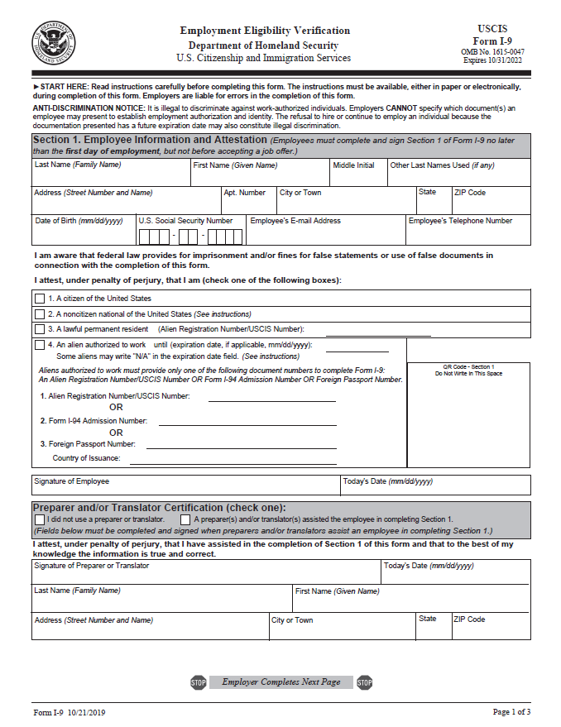
Form I-9 (Updated 2019 Version)
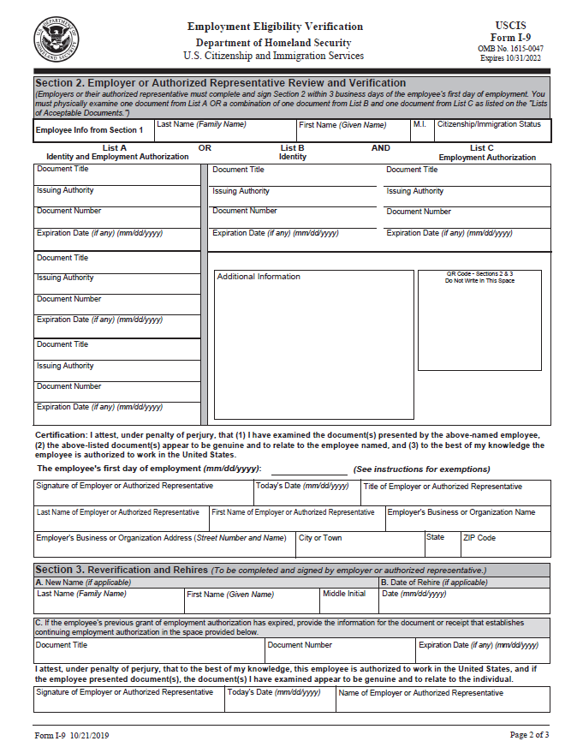

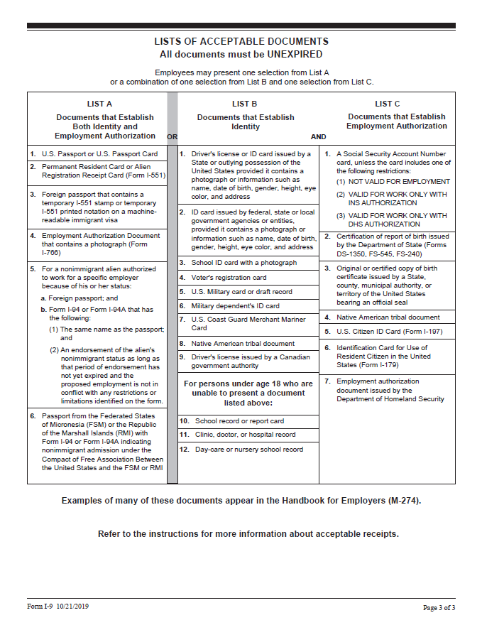

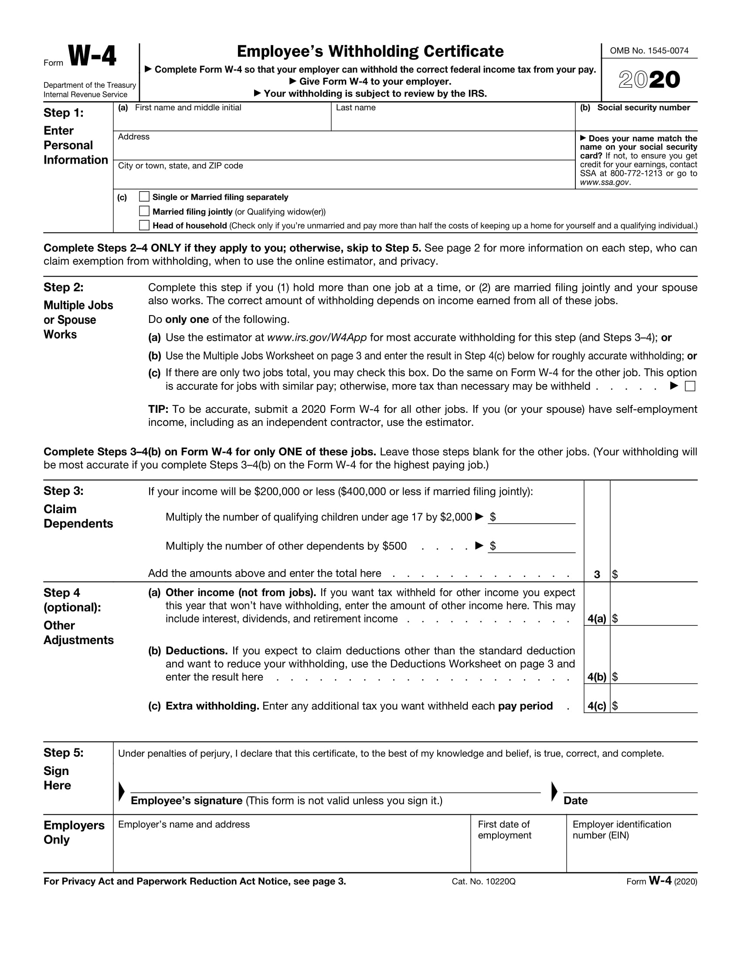
Form W-4
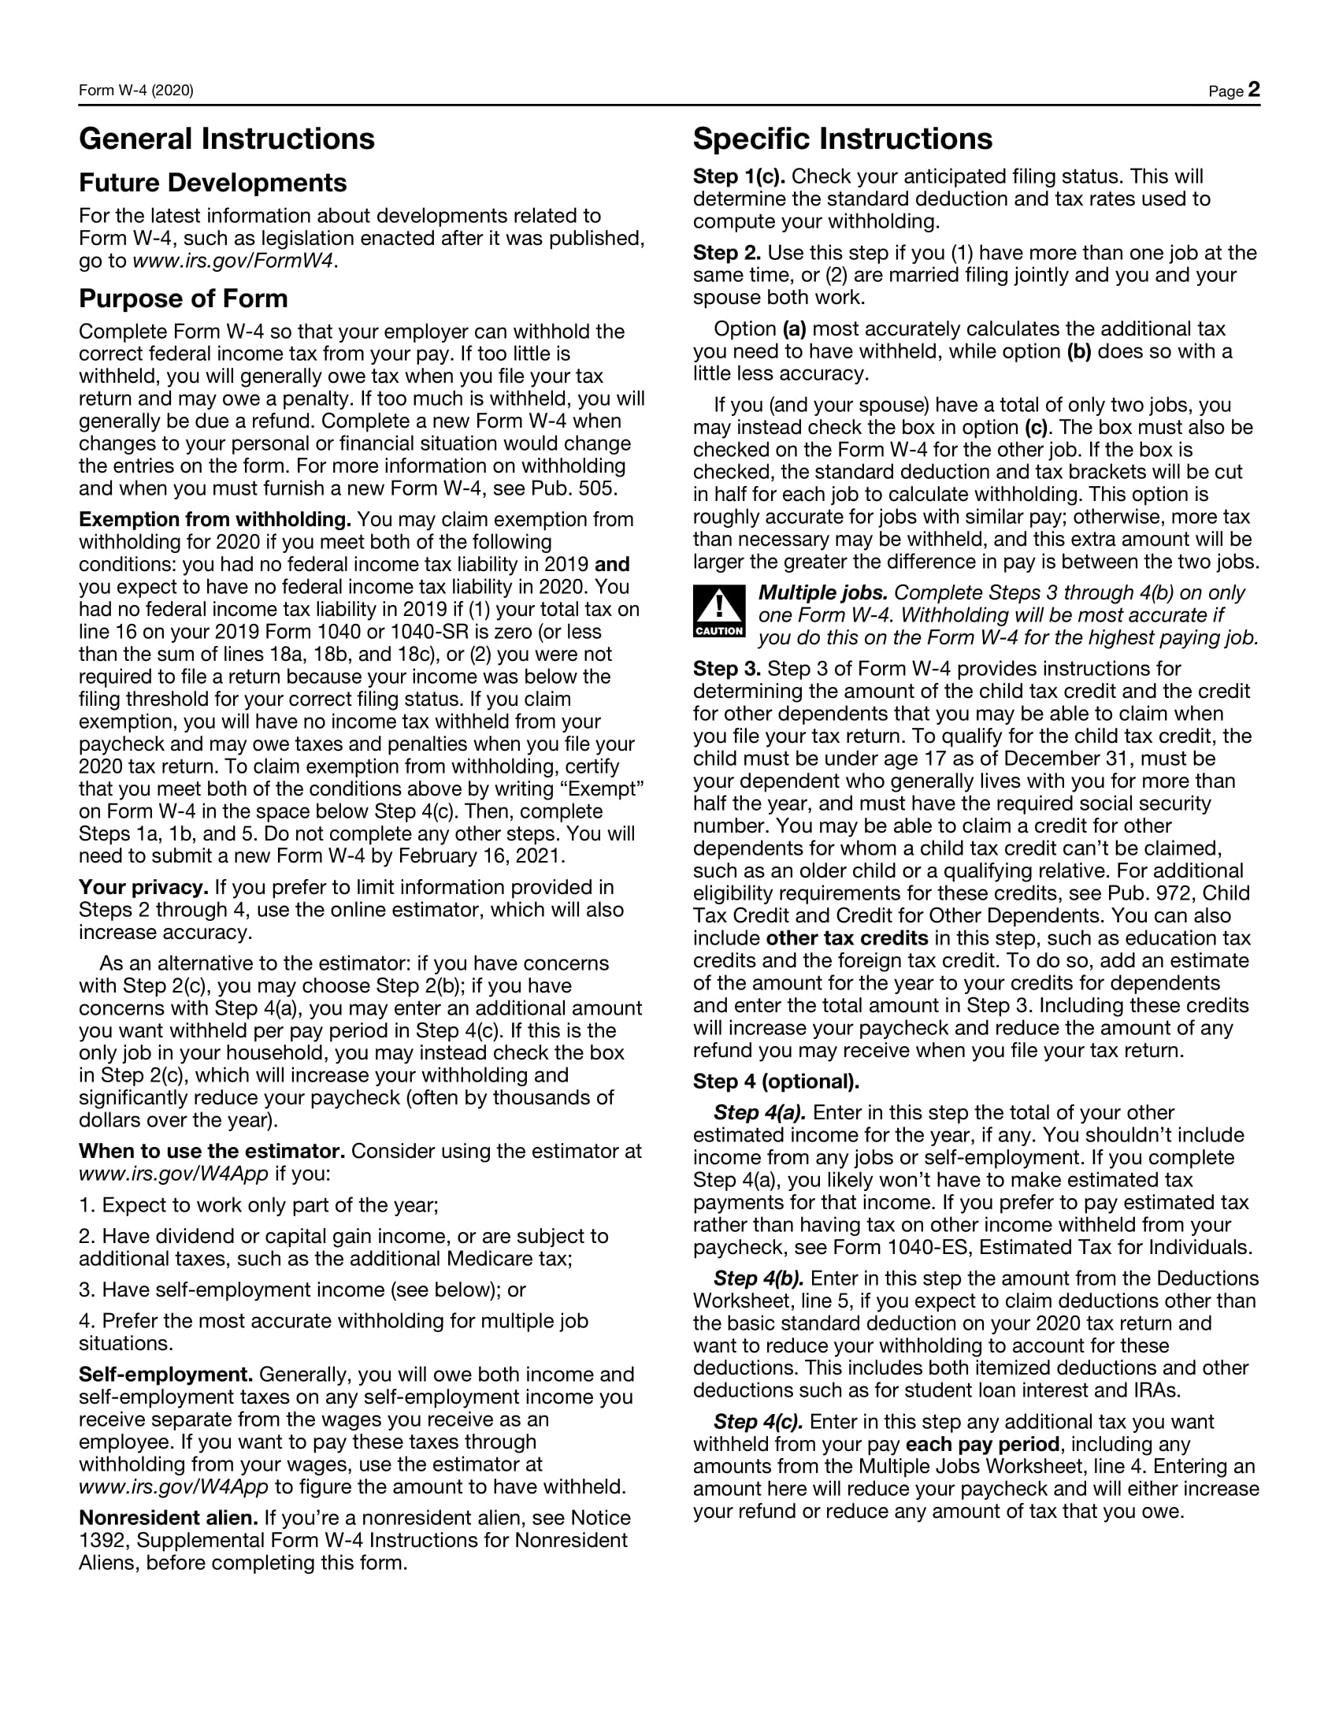
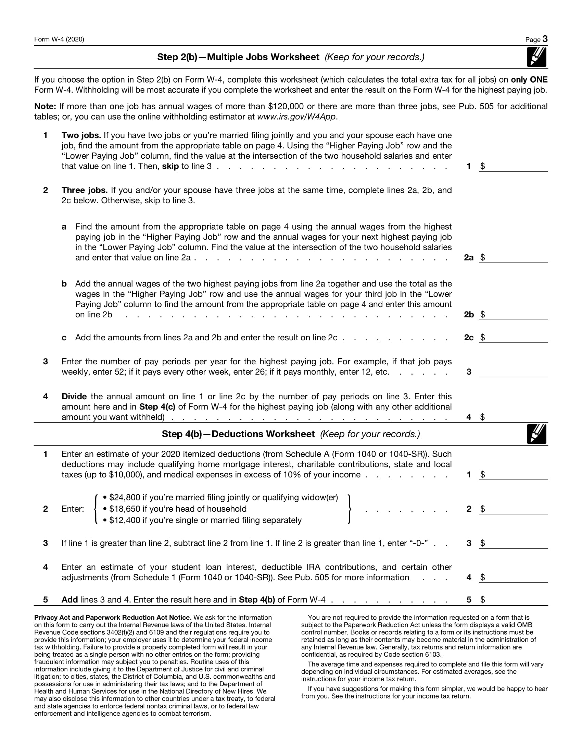

Direct Deposit Form
Please print and complete all the information below.

Name: __________________________________________________________________

Street Address: ____________________________________________________________

City, State, ZIP: ____________________________________________________________

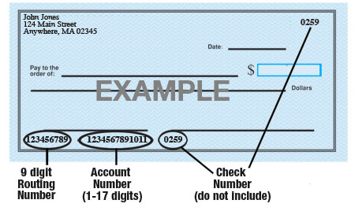

Name of Bank: ____________________________________________________________
Account Number: __________________________________________________________
9-digit Routing Number: _____________________________________________________
Amount: $ ____________ ____________% or Entire Paycheck
Type of Account: Checking Savings (Circle One)
Please attach a voided check for each bank account to which funds should be deposited.
ABC Company is hereby authorized to directly deposit my pay to the account listed above. This authorization will remain in effect until I modify or cancel it in writing.

____________________________________________________________ ___________________
Employee Signature Date

New Employee Announcement
Dear [insert department name]:
I am delighted to announce that [insert new employee’s name] is joining ABC Company as [insert job title of new employee] beginning [insert start date]. Please extend a warm welcome to our new colleague and do whatever you can to make [insert name] feel at home.
During the onboarding process, [insert mentor name] will be assigned as a mentor to [insert name]. Of course, help is welcomed from everyone. Please make a point of introducing yourself and welcoming [insert name] to the ABC Company team.
Sincerely,
[Insert supervisor’s name]

Employee Emergency Contact Form
Employee Name: __________________________________________________
Primary Phone Number: _____________________ Primary Email Address: ______________________
Full Address: ________________________________________________________________________
In Case of Emergency
Primary Contact Name: _____________________________________________
Relationship to Employee: ________________________
Primary Phone Number: ____________________ Alternate Phone Number: __________________

Secondary Contact Name: _____________________________________________
Relationship to Employee: ________________________
Primary Phone Number: ____________________ Alternate Phone Number: __________________

Primary Physician Name or Preferred Hospital: _____________________________________________
Primary Phone Number: _______________________________
Full Address: ________________________________________________________________________

Receipt of ABC Company Employee Handbook
I acknowledge that I have received a copy of the ABC Company Employee Handbook. I agree to read it thoroughly, including the statements describing the purpose and effect of the handbook.
I understand that this handbook is designed to introduce employees to the organization, familiarize them with Company policies, provide general guidelines on work rules, disciplinary procedures and other issues related to employment with ABC Company, and to help answer many of the questions that may arise in connection with employment at ABC Company.
I understand that this handbook and any other provisions contained in it do not constitute a guarantee of employment or an employment contract, express or implied. I understand that ABC Company is an “at-will” employer and as such, employment with ABC Company is not for a fixed term or definite period and may be terminated at the will of either party, with or without cause, and without prior notice. No supervisor or other representative of the company (except the President, in writing) has the authority to enter into any agreement of employment for any specified period of time, or to make any agreement contrary to the above.
In addition, I understand that this handbook states ABC Company policies and practices are in effect on the date of publication. I understand that nothing contained in the handbook may be construed as promising future benefits or a binding contract with ABC Company for benefits or for any other purpose. Personnel policies are applied at the discretion of ABC Company. ABC Company reserves the right to change, withdraw, apply or amend any of our policies or benefits, including those covered in this handbook, at any time. ABC Company may notify employees of such changes via email, by posting on the Company’s intranet, portal or website, or via a printed memo, notice, amendment to or reprinting of this handbook, but may, in its discretion, make such changes at any time, with or without notice and without a written revision of this handbook.
By signing below, I acknowledge that I have received a copy of the ABC Company Employee Handbook, and I understand that it is my responsibility to read and comply with the policies contained within it and any revisions made to it. Furthermore, I acknowledge that I am employed at will and that this handbook is neither a contract of employment nor a legal document.
_______________________________________ ______________________
Signature Date
_______________________________________________________________
Please print your full name
Please sign and date one copy of this notice, and then return it to Human Resources. Retain a second copy for your reference.

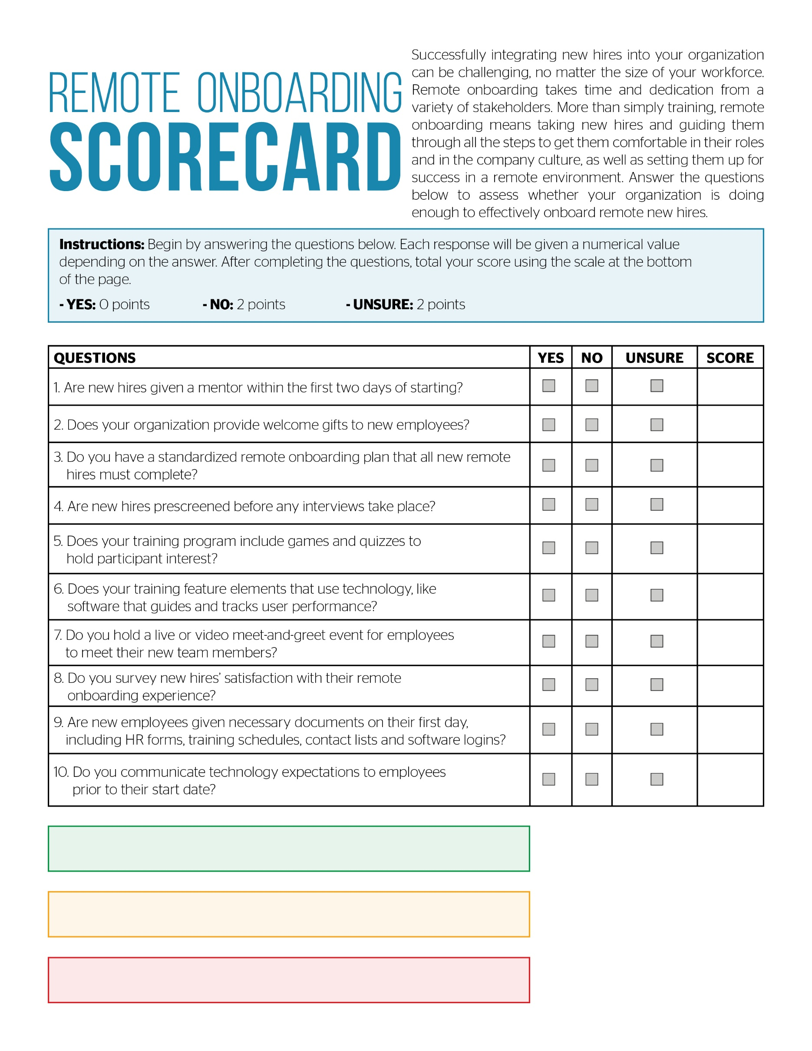
Remote Onboarding Scorecard
High risk. Contact Horst Insurance today: 15-20

Medium risk. Contact Horst Insurance today: 7-14

Low risk. Contact Horst Insurance to confirm: 0-6

COVID-19 Remote Work Policy
5/5/20
[Insert first name] [Insert last name]
[Insert home address]
[Insert city, state zip]

Dear ABC Company Employee:
At ABC Company, it is our priority to keep our employees and their families healthy. As the coronavirus disease 2019 (COVID-19) continues to spread globally, ABC Company is taking appropriate precautions to address the outbreak by following guidelines from the Centers for Disease Control and Prevention (CDC).
We have made the difficult decision to close our physical office and approve remote work for all employees. This closure will begin [insert date] and last through [insert date]. We believe that this decision is ultimately the best course of action to protect the health of our employees and their families. Plan on beginning remote work.
Given that this is a rapidly developing situation, we will continue to monitor developments and update our course of action as new information becomes available through the CDC. Contact your manager or HR with questions or to discuss any related issues.

Sincerely,

John Smith
VP
ABC Company
717-555-1212

Pandemic Flu Leave Policy
In the event of a pandemic flu outbreak, as declared by management, in conjunction with the U.S. Centers for Disease Control and Prevention (CDC), the following Pandemic Flu Leave policy applies to all employees, including temporary and non-benefit eligible.
This leave policy is above and beyond what is provided under the company’s Paid Time Off (PTO) and sick leave policies. Employees who qualify for Pandemic Flu Leave will not be required to use PTO or sick leave.
Confirmed Infection
Employees who are absent due to a confirmed pandemic flu infection will receive full pay for their normally scheduled work hours until a medical care provider has authorized their return to work. Each employee using Pandemic Flu Leave will be required to provide written documentation from a medical care provider. If the illness extends beyond 90 days, employees eligible for the Company’s Long-Term Disability (LTD) plan may qualify for LTD benefits. All plan provisions for LTD will apply.
Suspected Infection
If you suspect that you have the flu, or you are asked to leave work due to symptoms and you are subsequently found to be free of the virus, you will be paid in full for your normally scheduled work hours to cover the time it took for the medical evaluation. You will be required to provide a written medical care provider’s notification to return to work.
Immediate Family Member Infection
This leave policy applies to the employee’s own illness or for the employee to care for an immediate family member with an infection. The employee will receive full pay for normally scheduled work hours. A written medical care provider’s notification will be requested, confirming that the pandemic flu is the reason for the absence.
Abuse of this policy will result in disciplinary action. The company reserves the right to revise this policy without notice due to changing pandemic conditions.

