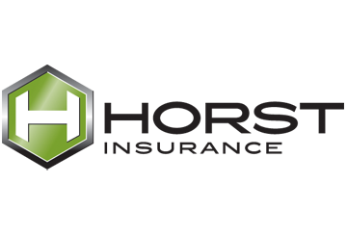
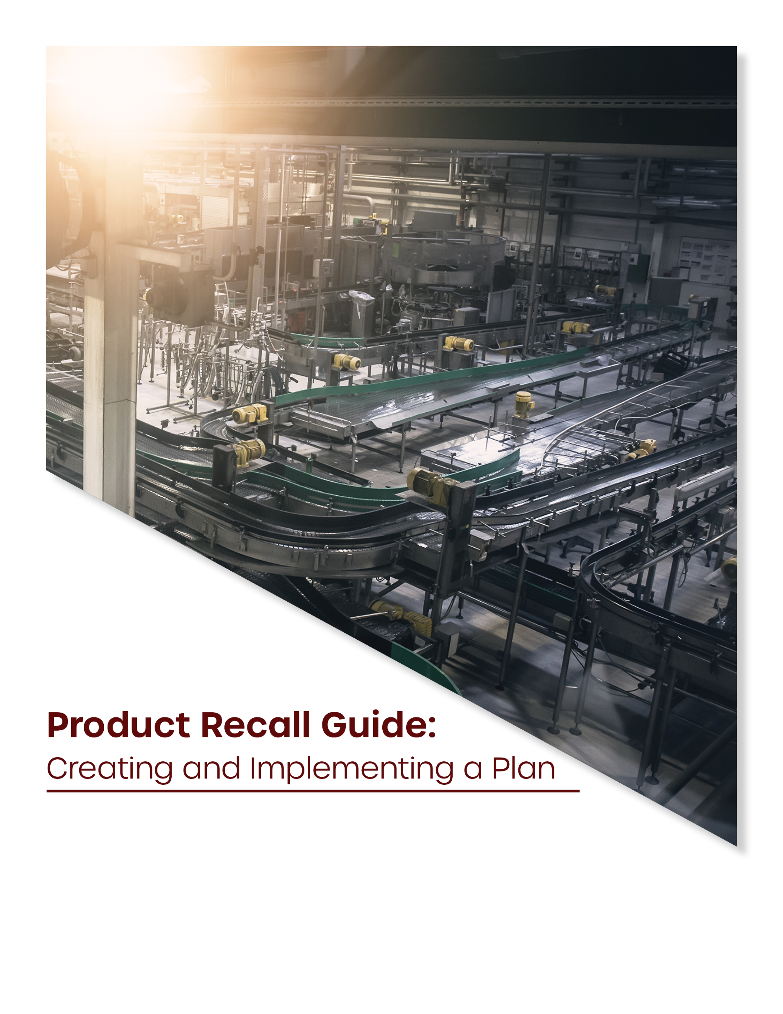
Table of Contents
INTRODUCTION 4
Product Recalls and the CPSC 4
OVERVIEW OF THE CPSC AND THE IMPORTANCE OF RECALL PLANNING 5
REPORTING REQUIREMENTS 6
Section 15 Reports 6
Section 37 Reports 7
Section 102 Reports 9
PREPARING FOR A PRODUCT RECALL 11
Developing a Product Recall Policy 11
Creating a Product Recall Team 11
Establishing Recordkeeping Practices 14
ASSESSING THE NEED FOR A PRODUCT RECALL 15
CPSC Methodology 15
Performing Your Own Recall Assessment 16
Incident Notification 16
Incident Investigation 17
Risk Assessment 18
Product Recall Decision 19
EXECUTING A PRODUCT RECALL 21
Develop a Recall Strategy 21
Recall Objectives 21
Recall Processes 22
Financial Considerations 22
Create a Communication Plan 23
Recall Notices 24
Communication With Regulators 24
Communication With Supply Chain 24
Communication With Consumers 25
Implement the Recall 25
Retrieving, Replacing and Repairing the Affected Product 25
Destroy or Dispose of the Affected Product 26
Monitor the Recall 26
Review and Adjust Your Recall Strategy 27
PREVENTING FUTURE INCIDENTS 29
APPENDIX 30

This guide is not intended to be exhaustive nor should any discussion or opinions be construed as legal advice. Readers should contact legal counsel for legal advice. © 2020 Zywave, Inc. All rights reserved.

INTRODUCTION
Whether you’re a manufacturer, supplier or retailer, your customers expect you to have safe and reliable products. And while you may do everything in your power to ensure your goods are fit for sale, exposures such as design flaws, manufacturing defects, inadequate warnings and unclear instructions can all negatively affect product safety.
In the event that one of your products harms a customer or other stakeholder, they can sue your business, leading to costly legal fees and settlements that can easily amount to six figures or more. What’s more, following a product issue, organizations must take corrective actions to curb losses and preserve their reputation. This can include carrying out a product recall, which is a complex and heavily regulated process.

Product Recalls and the CPSC
In general, a product recall refers to the act of returning, exchanging or replacing a product in the marketplace after a defect is discovered. These defects can be anything that hinders a product’s performance, harms consumers or creates potential legal issues for producers.
In the U.S., consumer product recalls are typically triggered when a manufacturer or other stakeholder reports an issue to the Consumer Product Safety Commission (CPSC)—the governing body responsible for developing uniform standards and addressing safety issues with consumer products. The CPSC, which has jurisdiction over approximately 15,000 different types of consumer products, was established after the Consumer Product Safety Act (CPSA) was passed in 1972. The act gives the CPSC the authority to pursue recalls and ban products under certain circumstances.
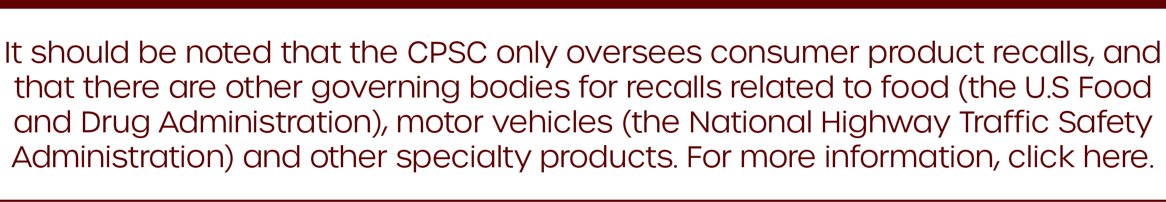

If you are a manufacturer, importer, distributor or retailer of consumer products, you’re likely subject to CPSA requirements. As such, it’s important to be prepared with a plan—one that allows you to mobilize quickly following a product recall, avoid substantial civil penalties and ensure the longevity of your business.
This guide is designed to help organizations of all kinds implement and execute a recall plan of their own. It contains a general overview of recalls, highlighting applicable compliance requirements and providing supplementary tools all manufacturers, suppliers and retailers should have at their disposal.
Please note, this guide is informative in nature and should not be used as a substitute for legal or compliance advice. For additional assistance, seek the help of legal counsel and a qualified insurance broker at Horst Insurance.

OVERVIEW OF THE CPSC AND THE IMPORTANCE OF RECALL PLANNING
Above all, the CPSC is responsible for protecting the public against injuries and deaths associated with consumer products. The CPSC accomplishes this in a number of ways, including the following:
- Developing voluntary standards to improve consumer product safety
- Issuing and enforcing mandatory standards
- Conducting research on potential product hazards
- Informing and educating consumers
- Mandating the recall of unsafe products, arranging for their repair or replacement
Empowered by the CPSA, the CPSC has authority over virtually all consumer products made, sold or imported into the United States. Businesses that fail to follow CPSC and CPSA guidelines are subject to a number of risks—particularly if they don’t have a recall plan in place, including:
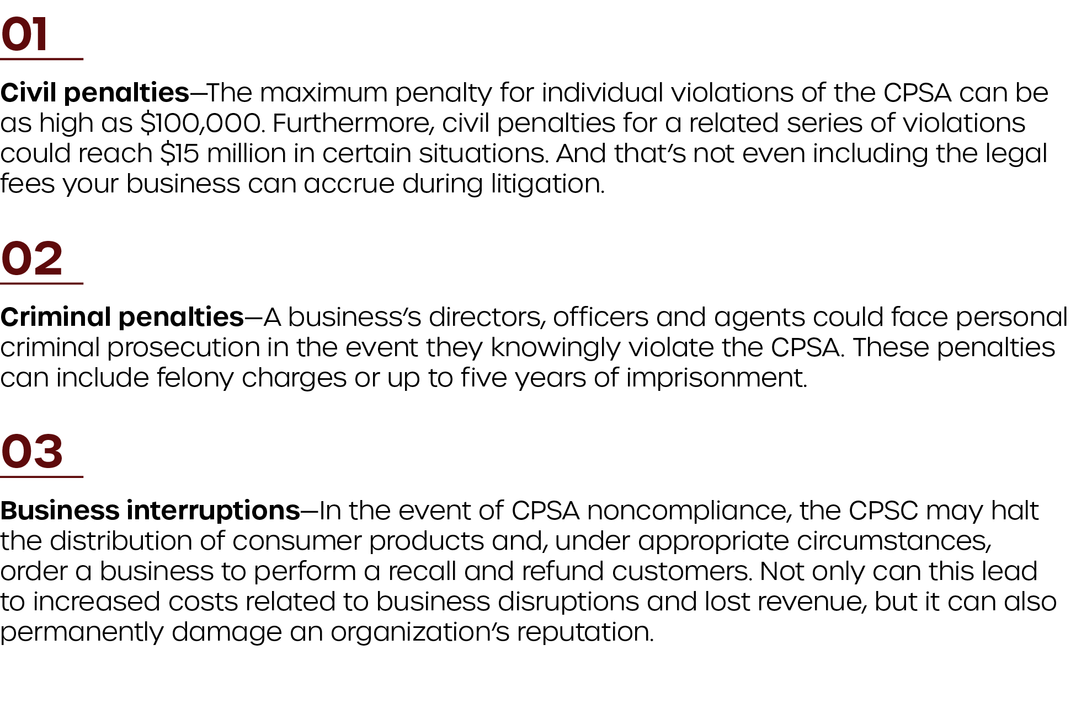

It’s important to have a basic understanding of CPSC and CPSA compliance, and have a recall plan in place. Doing so will ensure you are properly prepared for a product recall and can respond quickly to contain potential losses.

REPORTING REQUIREMENTS
To support the CPSC in its efforts to ensure public safety, all manufacturers, importers, distributors and retailers of consumer products must meet requirements laid out in the CPSA. One major requirement of the CPSA relates to reporting. Essentially, organizations subject to the CPSA have a legal obligation to immediately report the following to the CPSC:
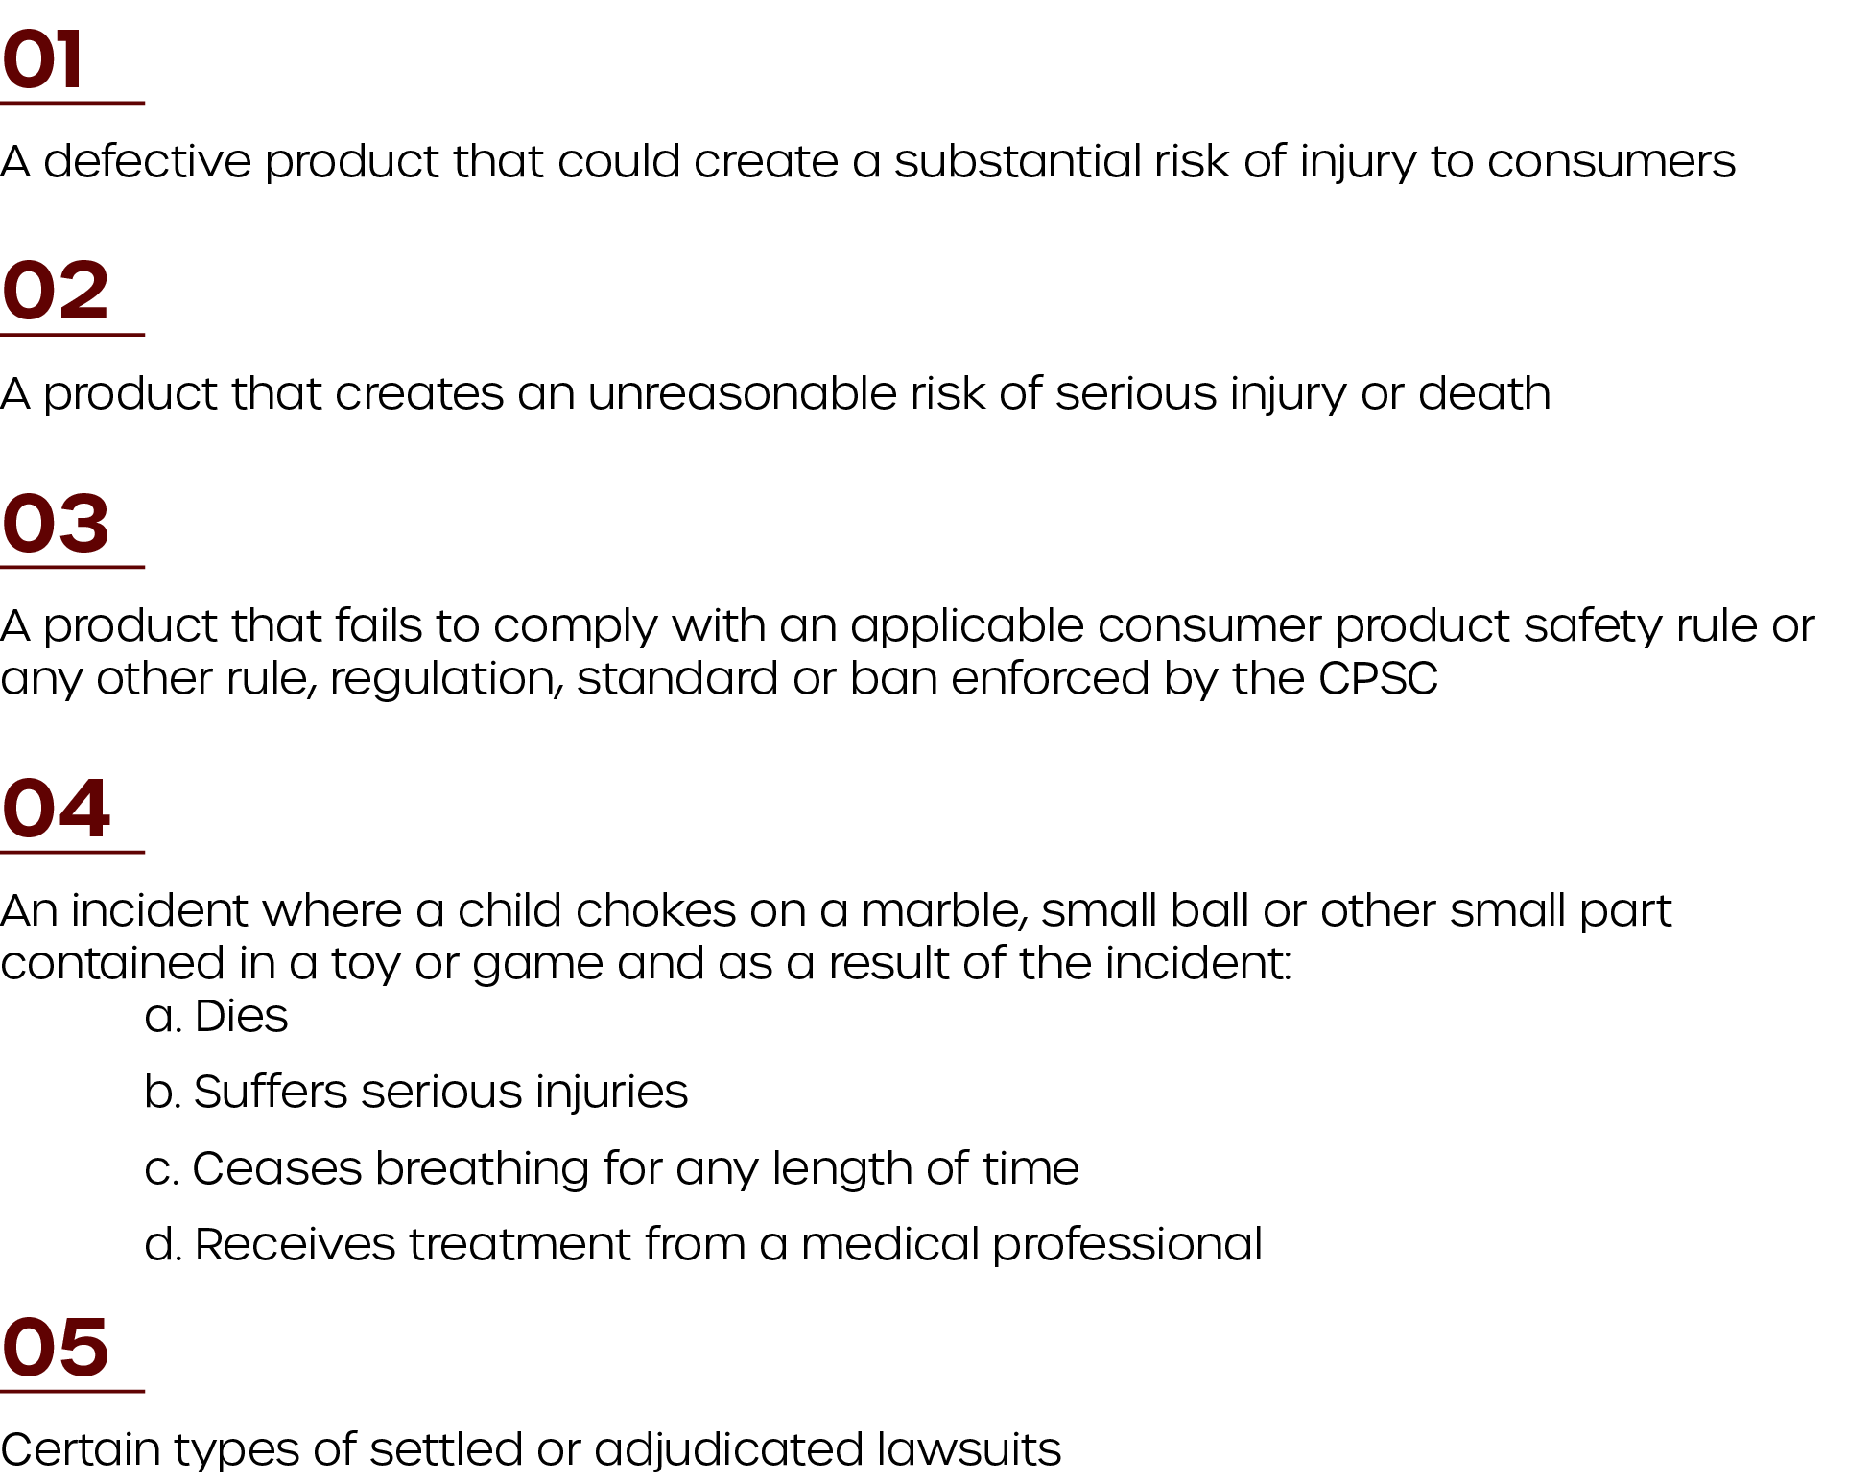

When reporting to the CPSC, there are specific guidelines as to what to report and when. The sections below provide a general overview of these reporting requirements. Please note that information provided in these sections are general in nature and do not substitute the counsel of legal professionals.
Additional guidelines for determining whether a product defect exists, a product creates an unreasonable risk of serious injury or death, or a report is necessary or appropriate can be found here.

Section 15 Reports
Section 15 of the CPSA establishes certain reporting requirements for manufacturers, importers, distributors and retailers of consumer products. Under this section, these entities must notify the CPSC within 24 hours of obtaining information that a product distributed in commerce:

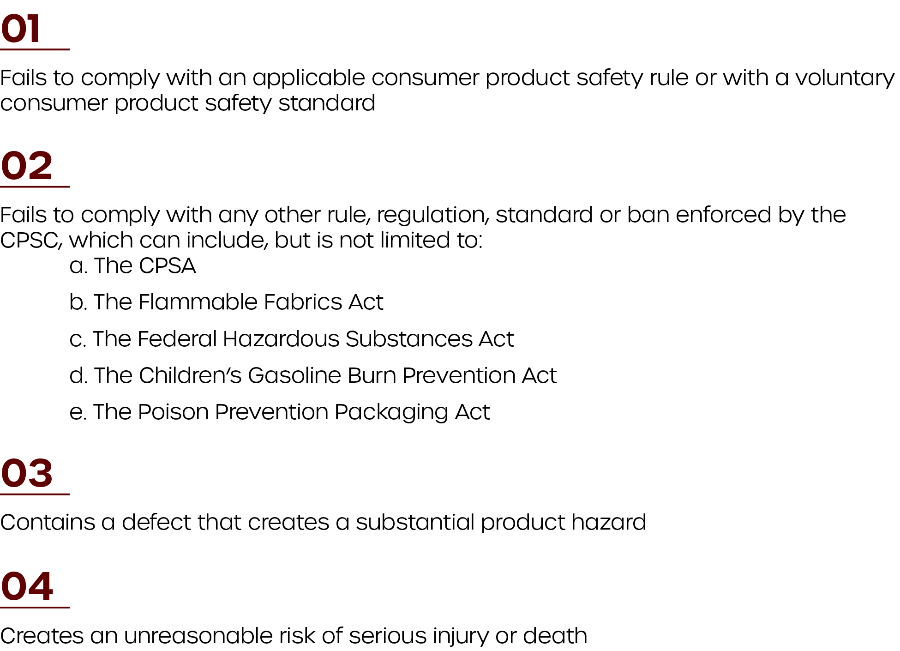

It should be noted that reporting a product under Section 15 does not automatically mean the CPSC will mandate corrective action or a full-scale recall. In general, Section 15 reports provide the most timely and effective information. This is because manufacturers, importers, distributors and retailers are often the first to learn of potential product safety issues through things like consumer complaints, product liability lawsuits, reports of production problems and product testing procedures.
The table below outlines specific considerations for Section 15 reports, including what to report, when to report it and the confidentiality of reports.
What to Report | Where to Report | When to Report | Confidentiality of Reports
- The identification and description of the product  - The name and address of the manufacturer, importer, distributor or retailer of the product (if known)  - The nature and extent of the possible defect, failure to comply or risk  - The nature and extent of injury or risk of injury associated with the product  - The name and address of the person providing the report to the CPSC  - A timetable for providing information not immediately available | - Reports should be filed electronically with the Office of Compliance and Field Operations through the CPSC website | - Reports should be filed within 24 hours of obtaining reportable information  - The CPSC encourages companies to report potential product hazards even while they are conducting their own investigations | - Organizations can claim information provided is confidential during the report submission process  - The CPSA prohibits the release of reported information unless:  - A remedial action plan has been accepted in writing  - A complaint has been issued  - The organization reporting to the CPSC provides consent  - The CPSC requires public disclosure

Section 37 Reports
This section of the CPSA applies specifically to manufacturers of consumer products. These entities are required to report information related to settled or adjudicated lawsuits if all of the following are true:
- A particular model of a product is the subject of at least three civil actions filed in federal or state court.
- Each of the three lawsuits alleges that the product in question was involved in a death or grievous bodily injury (e.g., disfigurement, dismemberment, injuries that require extended hospitalization and severe burns).
- Each of the three lawsuits resulted in either a final settlement involving the manufacturer or a court judgment in favor of the plaintiff over the course of a two-year period specified in the CPSA. Click here to view the applicable two-year periods.
- The manufacturer is involved in the defense of or has notice of each of the three lawsuits before the entry of the final order and—as a result of the settlement or judgement—is involved in discharging any obligation owed to the plaintiff.
The table below outlines specific considerations for Section 37 reports, including what to report, when to report it and the confidentiality of reports.
What to Report | Where to Report | When to Report | Confidentiality of Reports
- The name and address of the manufacturer of the product  - The model and model number or designation of the product  - A statement as to whether the civil action alleged death or grievous bodily injury  - A statement as to whether the case resulted in a final settlement or a judgment in favor of the plaintiff  - The name of the case, case number and court in which the case was filed (for cases where a judgment was ruled in favor of the plaintiff) | - Companies must file reports in writing to the Office of Compliance and Field Operations, U.S. Consumer Product Safety Commission  - Organizations should email a copy of the report to Section15@cpsc.gov | - A manufacturer must report no later than 30 days after a final judgment or settlement has been reached in the last of the three lawsuits  - The 30-day reporting timeline applies to any additional lawsuits involving the same model of product that are settled or adjudicated in favor of the plaintiff during the same two-year period | - The CPSC and its employees may not disclose information reported under Section 37, except where such information may be submitted to the reporting manufacturer or congress

Section 102 Reports
Under the CPSA and Child Safety Protection Act, companies are required to report certain choking incidents to the CPSC. The table below details what manufacturers, distributors, retailers and importers are subject to Section 102 requirements as well as the situations in which those reporting requirements take effect.
Who Section 102 Reports Apply To | When Reporting Requirements Take Effect
- Organizations are subject to Section 102 reporting requirement should they manufacture, distribute, sell or import the following products:  - A marble  - A ball with a diameter of 1.75 inches or less  - A latex balloon or other small part  - A toy or game that contains a marble, ball, balloon or other small part | - Manufacturers, distributors, retailers and importers of the products listed in “Who Section 102 Reports Apply To” must report to the CPSC if both of the following are true:  - A child—regardless of their age—chokes on one of their products, such as a marble, small ball, balloon or small part.  - As a result of the choking incident, the child died, suffered serious injuries, ceased breathing for any length of time or was treated by a medical professional.

Furthermore, similar to Section 15 and Section 37 reports, there are other considerations to keep in mind when submitting information to the CPSC. The table below provides an overview of these considerations, including what to report, when to report it and the confidentiality of reports.
What to Report | Where to Report | When to Report | Confidentiality of Reports
- The name and address of the child who choked and the person who notified the reporting organization of the incident  - A detailed description of the product involved in the choking incident  - A description of the incident, including any resultant injuries or medical treatment  - Information about any changes made to the product, its labeling or warnings to address the risk of choking  - Details regarding any public notices or other corrective actions planned | - Reports should be sent to the Office of Compliance and Field Operations by mail, telephone (301-504 -7520) or fax (301-504 -0359) | - Reports should be filed within 24 hours of obtaining reportable information | - Organizations can claim information provided is confidential during the report submission process  - The CPSA prohibits the release of reported information unless:  - A remedial action plan has been accepted in writing  - A complaint has been issued  - The organization reporting to the CPSC provides consent  - The CPSC requires public disclosure

PREPARING FOR A PRODUCT RECALL
If and when a product you produce has caused or has the potential to cause significant harm to consumers, you may need to perform a product recall. This process can be involved, and organizations that take the time to properly prepare will be better equipped to respond to product issues and manage their overall losses.
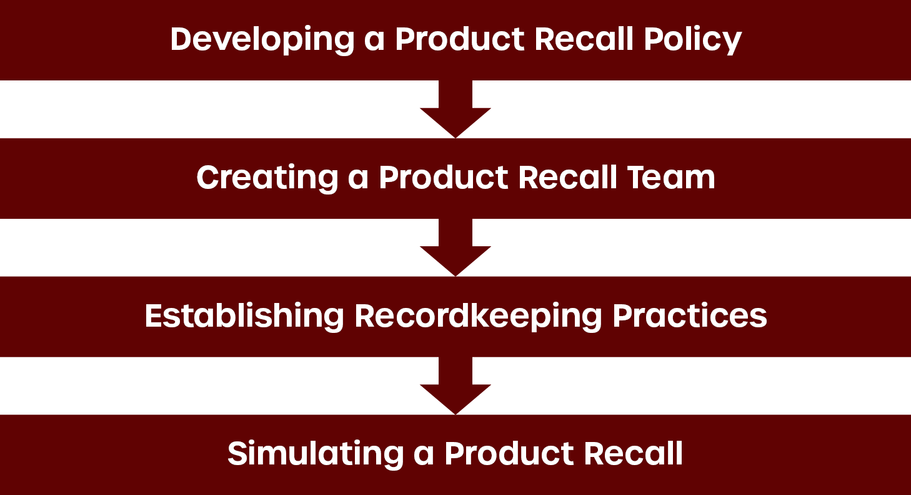
When it comes to preparing for a recall, four of the most important steps include developing a product recall policy, creating a product recall team, establishing recordkeeping practices and simulating a product recall.

Developing a Product Recall Policy
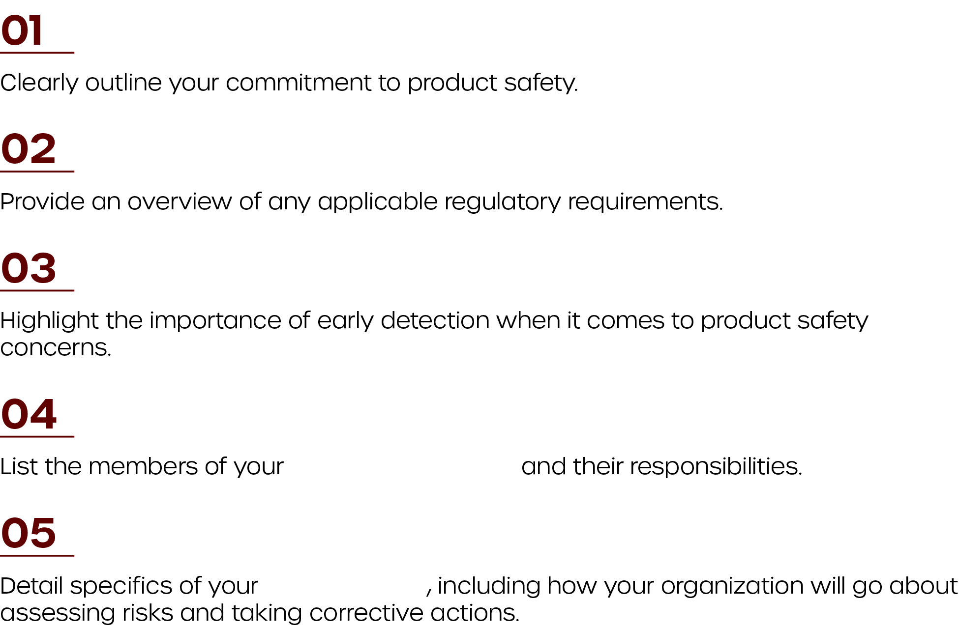
To remain organized, address compliance-related concerns and ensure internal processes are well documented in the face of a recall, companies need to develop a product recall policy. These policies will likely differ from business to business, but should:

product recall team

recall strategy
Again, it’s important to tailor product recall policies to your business’s unique needs and internal processes.

Creating a Product Recall Team
To ensure CPSC compliance and effective recall procedures, every manufacturer, distributor, retailer and importer must first create a product recall team. Above all, product recall teams help organizations develop a recall plan that’s customized to their business and its needs. What’s more, creating a product recall team allows organizations to:
- Review available information and determine the steps needed to:
  - Protect the health and safety of consumers.
  - Maintain positive relationships with key stakeholders, including consumers and business partners.
  - Safeguard the organization’s reputation.
  - Meet any applicable regulatory obligations.
- Create and manage a product recall plan.
- Ensure effective communication with consumers, relevant government and industry authorities, and other key stakeholders before, during and after a recall.
- Execute recall decisions and actions effectively, ensuring that, if a recall is necessary, it causes limited business disruptions.
When establishing a recall team, organizations must assign clear duties to each person involved. The table below outlines the roles, expertise and responsibilities of a product recall team. Please note that how you divvy up these roles and responsibilities will depend largely on your organization. For instance, smaller organizations may task one person to handle multiple aspects of a recall, whereas larger organizations may be able to spread out jobs more evenly.
Roles/Expertise Required | Activities and Responsibilities
Recall Coordination and Leadership | - Acts as the main point of contact following an incident notification  - Has a high-level authority to make key decisions regarding a recall, which can include:  - Determining the scope of a recall and making a final determination regarding recall strategies and execution  - Notifying members of your supply chain of a recall incident  - Putting product production on hold in order to conduct an investigation  - Preventing the sale of a product at any point in the supply chain  - Notifying applicable regulatory bodies of a product incident, providing reports and documentation per relevant requirements  - Assessing the effectiveness of a recall and making recommendations about its progress  - Ending recall operations as necessary  - Assesses and escalates incidents as needed  - Ensures that, in the event of an incident notification, the appropriate parties are informed and decisions are made in a timely manner  - Oversees the creation and management of the product recall team  - Facilitates meetings and action steps  - Ensures that, in the event of an incident notification, all relevant information is properly collected and reported  - Oversees communication following an incident notification, ensuring they are consistent and controlled  - Facilitates all relevant follow-up processes
Technical and Engineering | - Leads incident investigations  - Reviews internal processes, including recordkeeping procedures, quality control and traceability systems  - Leads the risk analysis or risk assessment process  - Communicates with laboratories, testing authorities and other experts involved in risk analysis  - Acts as the intermediary with suppliers  - Provides technical advice about the product to the recall team  - Participates in the recall decision
Operations | - Gathers distribution records, ensuring their accuracy  - Oversees the retrieval, replacement, repair and disposal of a defective product  - Keeps accurate records to support the continual improvement of the recall process  - Participates in the recall decision
Sales and Marketing | - Establishes communication with affected consumers following an incident  - Addresses consumer questions and concerns in a timely manner  - Arranges refunds and replacement products  - Participates in the recall decision
Finance and Risk Management | - Establishes a budget and estimates the costs of proposed actions (e.g., recall decisions)  - Notifies insurers as needed and keeps records of any claims  - Works closely with sales and marketing to arrange refunds and replacement products  - Participates in the recall decision
Legal Counsel | - Ensures the organization meets applicable regulatory requirements  - Ensures the organization meets contractual requirements  - Advises the organization, helping to minimize liability concerns wherever possible  - Participates in the recall decision
Communications | - Identifies key audiences and stakeholders, paying close attention to the most vulnerable consumer groups  - Assists in the development of the communication strategy  - Manages the resources required to handle consumer questions  - Recommends changes to communication plans post-recall as needed

It should be noted that recalls can happen outside of regular business hours. As such, organizations should prepare a list of alternates in case key individuals can’t be reached at the time of a recall. The list of people who make up your team should be well-documented, reviewed and updated on a regular basis.

Establishing Recordkeeping Practices
Successful product recalls involve the retrieval, repair or replacement of defective products. This task is substantially more difficult for organizations that fail to keep accurate records of internal processes as well as the design, production, distribution and marketing of their products.
Generally, to help them identify product defects and continually improve recall procedures, organizations should maintain the following records and documentation:
Type of Record | Records to Maintain
Product-related Documentation | - Customer complaints and incident notifications  - Warranty returns  - Insurance claims  - Lawsuits  - Risk assessments  - Records related to recall decisions  - Product records, including lot numbers, product codes, manufacturing volumes and component parts  - Distribution records, including the location of each product broken down by product line, production run, shipping quantities, sales quantities, and dates and destinations of deliveries  - Quality control records  - Product registration information
Internal Policies and Processes | - Copies of your recall policy and procedures  - Records related to employee training  - Communication plans and materials  - Financial records

Your firm may have to keep specific records based on applicable legislative requirements. As such, it’s important to review your product recall recordkeeping practices with your legal representatives.

Simulating a Product Recall
Once you have a policy in place and the expertise required to execute a product, it’s important to conduct a mock recall. This not only helps your product recall team understand the steps required to perform an effective recall, but it also affords you opportunities to adjust and improve your strategy ahead of a full-scale recall.
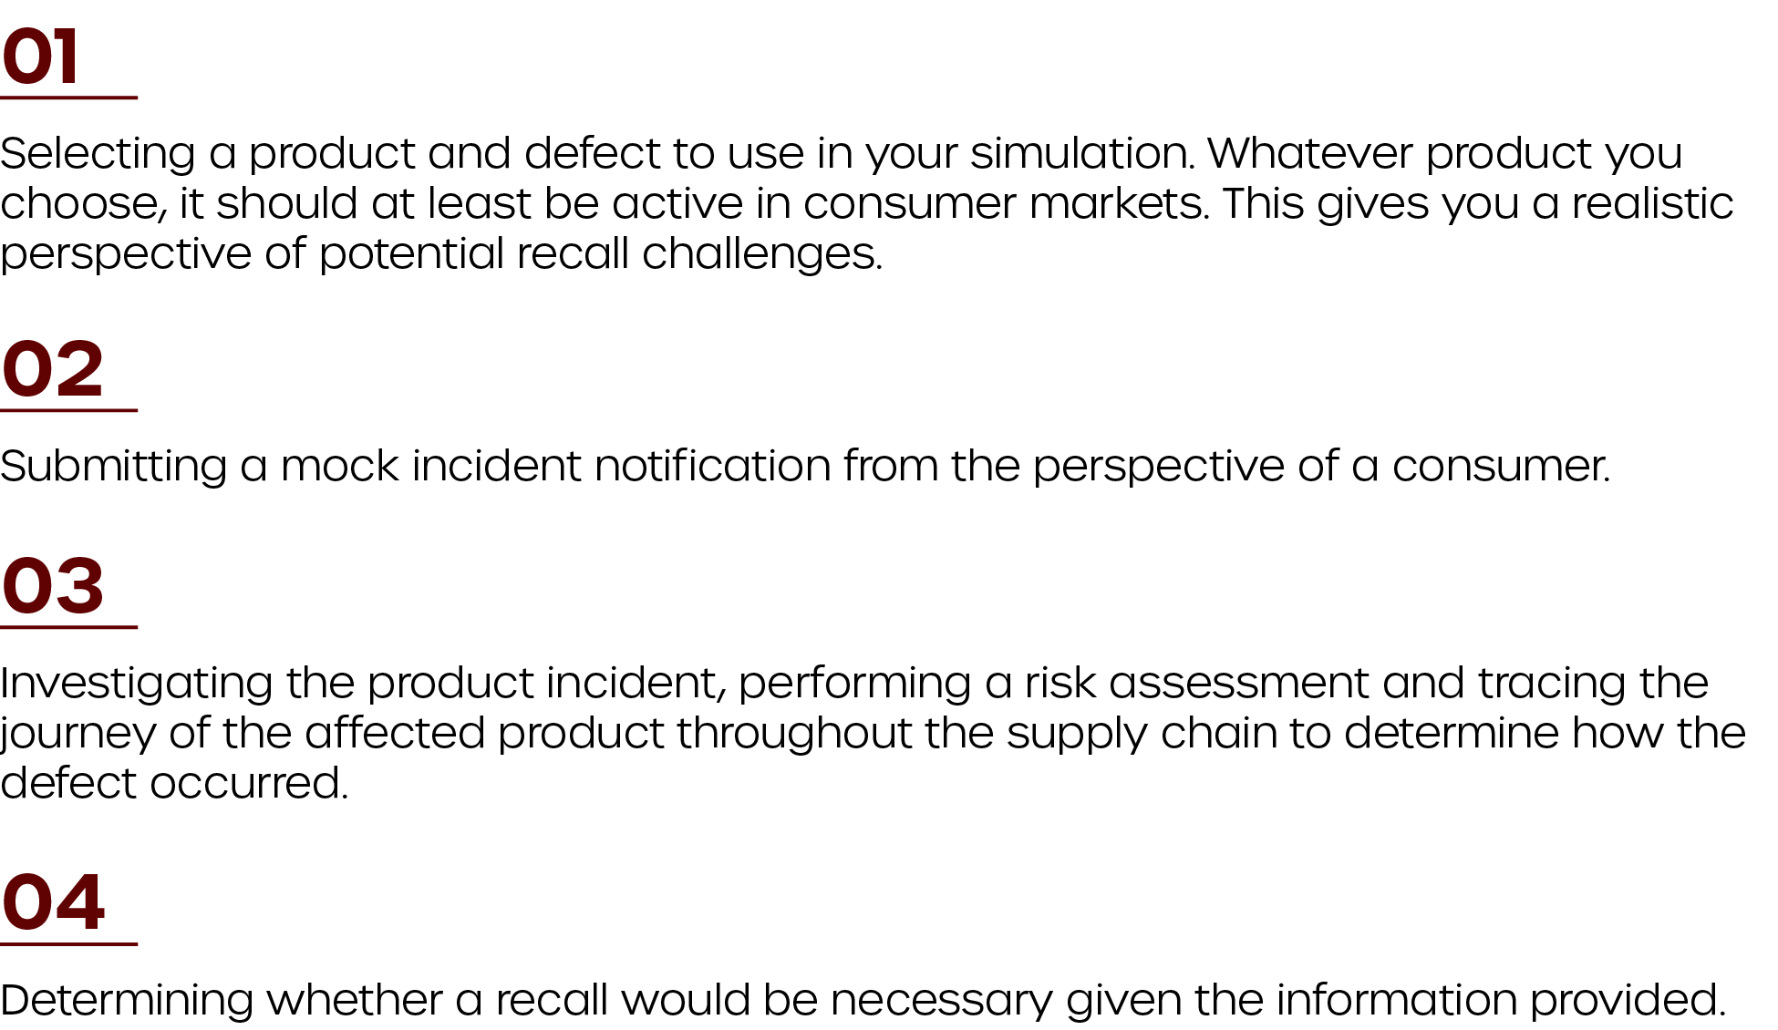
While recall simulations will differ from organization to organization, they generally include the following steps:

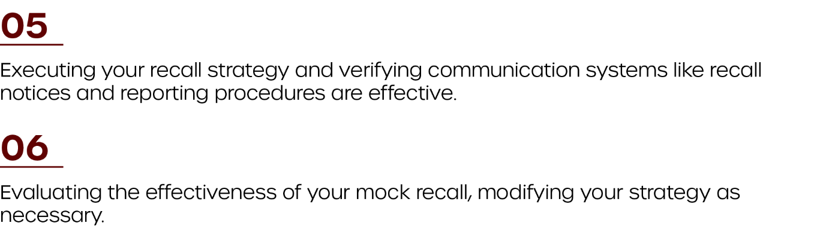

You should simulate a recall at least annually or whenever you make significant changes to your recall strategy. Above all, your product recall team and organization need to be trained on recall processes to ensure a smooth and successful recall.

ASSESSING THE NEED FOR A PRODUCT RECALL
In general, the CPSA’s reporting requirements help the CPSC determine whether corrective actions—including a full-scale recall—are necessary. However, these requirements aren’t all-encompassing, and the CPSC takes a number of factors into account when determining if a product contains a defect that creates a substantial risk of injury to the public. Additionally, it’s important for organizations to have their own criteria in place to assess whether a report to the CPSC or a product recall is needed.

CPSC Methodology
Defective products have the potential to create substantial risks and, in turn, require the attention of both the CPSC and the original manufacturer, distributor, retailer or importer. Per the CPSA, the definition of a defect is relatively broad, and can relate to:
- A manufacturing or production error
- A product’s design
- The materials used in a product
- A product's contents, construction, finish, packaging, warnings or instructions
Complicating matters further, not all products that present a risk of injury are defective. For example, a kitchen knife—while sharp enough to cause injuries—is not considered a product defect. To clarify these distinctions and to guide their evaluation of defects, the CPSC considers the following:
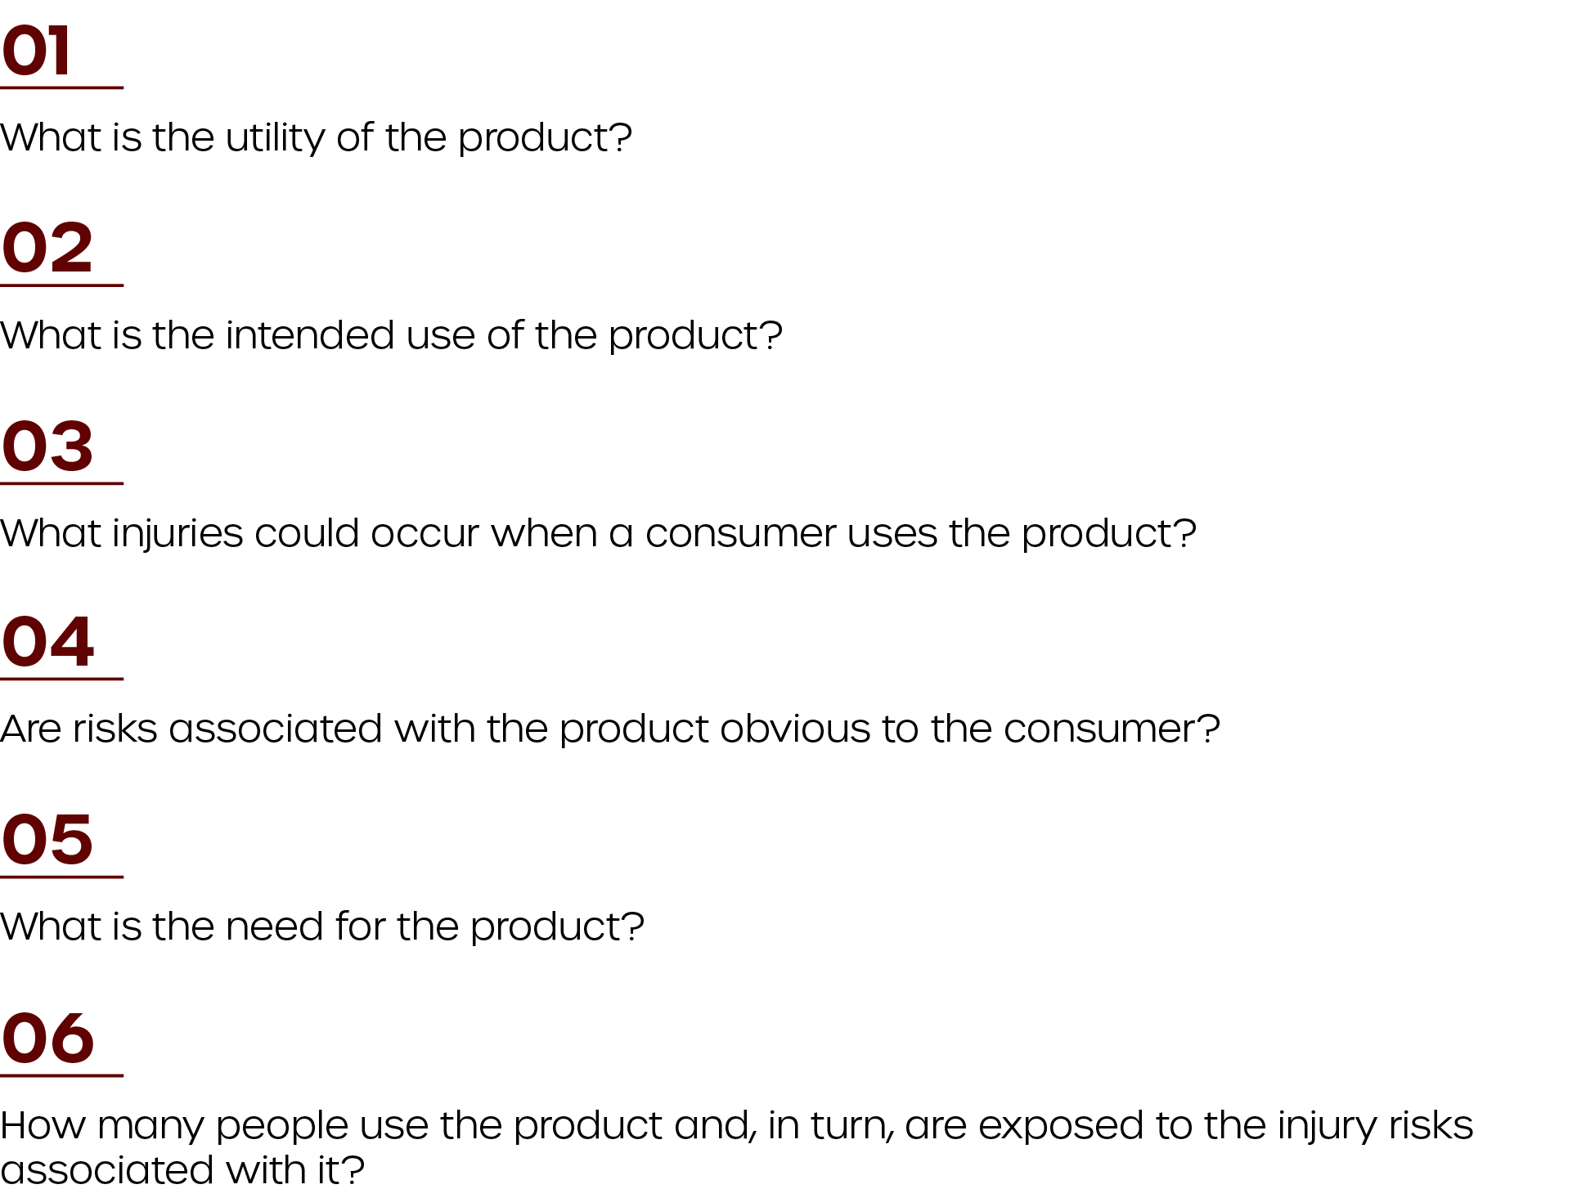

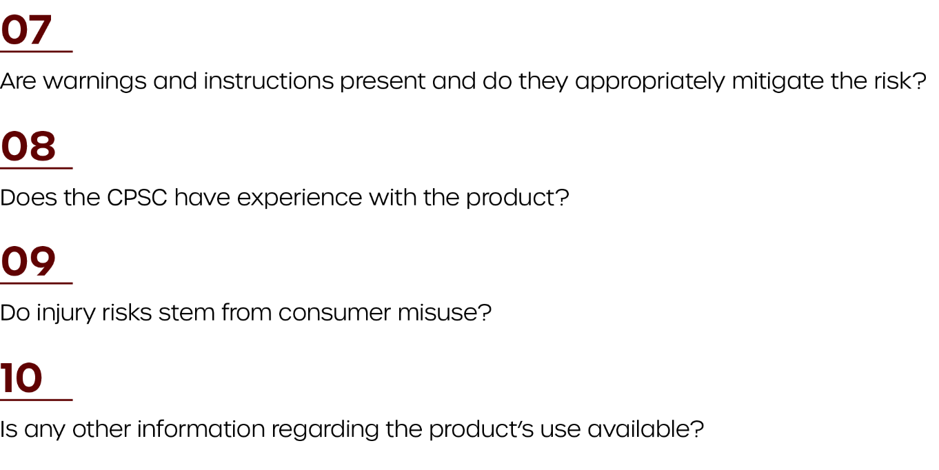

Generally, a defective product creates substantial hazards and requires corrective action when consumers are exposed to a significant number of units or if potential injuries are serious and extremely likely to occur. However, organizations won’t typically be aware of public exposure or injury risks until a defect is first reported. As such, the CPSC recommends that organizations provide a report if they’re ever in doubt.
While the CPSC has its own methodology for determining whether corrective action is necessary, it’s equally important for manufacturers, distributors, retailers and importers to perform their own assessments.

Performing Your Own Recall Assessment
To determine whether a product recall is needed, manufacturers, distributors, retailers and importers need to have internal processes in place. These processes should give firms the tools they need to evaluate individual products and determine if a consumer good has created harm or has the potential to create harm.
While the assessment process may differ from organization to organization, it typically involves the following steps:
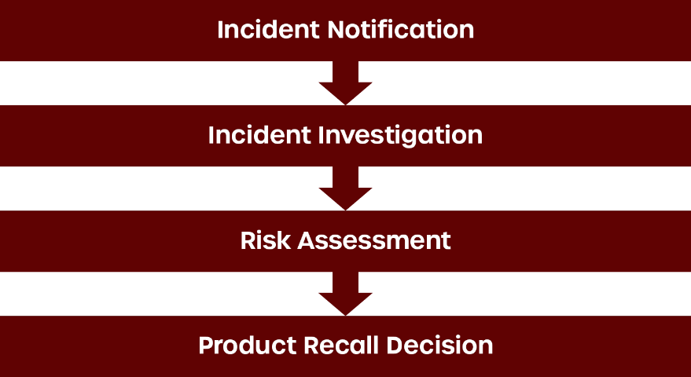

Incident Notification
Manufacturers, distributors, retailers and importers need to have a system in place for collecting information on product incidents. This ensures they stay on top of product issues and are able to respond quickly should a recall be necessary.
The way organizations are notified of incidents will likely differ based on the business’s size, the way it handles customer service and whether the CPSC has already flagged a product issue. Furthermore, while the specific information you gather from incident notifications will depend on your unique CPSA reporting requirements, it’s important to maintain at least the following information whenever a customer complaint is received:
- The contact information of the customer filing the complaint
- The date and location of the purchase
- The product’s reported issue
- Specific information regarding the product, including product identification numbers and supplier information
- Any information regarding illnesses and injuries
Again, following an incident notification, it’s important to consider all applicable legislative and contractual obligations. As part of these obligations, you may be required to notify regulators, certification bodies and third-party vendors, particularly if the product in question has created harm or has the potential to create harm.
After you have received an incident notification, and all the relevant information is gathered and reported to the appropriate organizations, you will need to provide the complaint to your recall coordinator for an initial investigation in addition to potentially notifying the CPSC within 24 hours of notification of a defect.

Incident Investigation
Once an incident is escalated to the recall coordinator, it’s important to complete an initial investigation. When beginning your investigation, you will need to meet with key persons and entities who have a deep understanding of your company’s products and operations. Who you consult will depend on whether you’re a manufacturer, importer, distributor or retailer:
Type of Business | Stakeholders to Consult
Manufacturers | - Design engineers  - Operations managers  - Quality assurance managers  - Logistics supervisors  - Any other individuals with knowledge of a product’s design and manufacturing processes
Importers and Distributors | - Individuals and entities with a deep knowledge of the supply chain of the defective product
Retailers | - Individuals and entities with a deep knowledge of their products and operations

After you have consulted key stakeholders, you can perform an initial investigation. This process typically includes the following steps:
- Assign a competent staff member to conduct the investigation. This will typically be your recall coordinator.
- Examine the incident notification to ensure its validity and accuracy. This may involve acquiring a sample of the affected product for testing and review purposes.
- Identify the root cause of the product defect, examining the harm or potential harm it creates. Suppliers should be able to determine the scope of the defect and whether it affects other products.
- Determine whether there have been any other incidents regarding the product in question, including those related to similar products.
- Document the key elements of the investigation, including key findings and proposed actions your organization will take.
Performing these investigation procedures will help you more accurately examine potential defects. If, following your initial investigation, you determine a recall may be necessary, it’s important to perform a full risk assessment.

Risk Assessment
Organizations can utilize a variety of methods when it comes to performing a risk assessment of a defective product. Many of these methods will depend largely on industry or regulatory requirements. For instance, the CPSC has its own risk assessment procedures that will dictate how organizations conduct their own hazard review process. Those procedures are as follows:
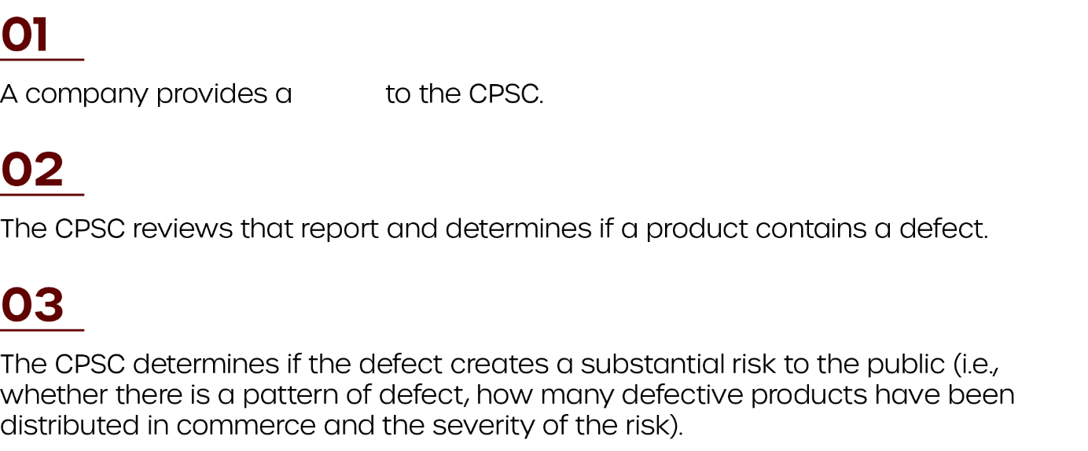
report

To aid their risk assessment, the CPSC uses its own set of hazard priority standards to classify the severity of the problem. This system ensures that, when evaluating product defects, the CPSC uses uniform standards. The CPSC’s hazard priority standards are based on three classes of hazards as follows:
- Class A hazards—These hazards are most severe and are used when death, injuries or illnesses are likely or very likely to occur as a result of a product defect. Class A hazards require the immediate attention of organizations, and warrant comprehensive and expansive corrective action measures to:
  - Identify and notify consumers, retailers and distributors of the defective product.
  - Remedy the defect by repairing or replacing the product, providing refunds or using a similarly effective method.
- Class B hazards—This distinction is used when death, grievous injury or illness is not likely to occur, but may occur, as a result of a defect. It is also used when serious injury or illness is likely, or moderate injury or illness is very likely.
- Class C hazards—Class C hazards are when a risk of serious injury or illness is not likely, but is possible. It is also used when moderate injury or illness is not necessarily likely, but is possible.
In addition to working alongside the CPSC to determine a defect’s risk to the public, organizations need to perform their own risk assessments. This is generally more involved than the initial investigation, and it’s a best practice for firms to complete the following steps:
- Identify the defective product and make note of key details, including the product’s:
  - Name
  - Brand
  - Model number
  - Type
  - Unique global identifier
  - Lot
  - Batch
  - Source of components
  - Date of production
- Identify vulnerable consumers and population groups that will likely use or come into contact with the product. Consider the following questions when determining the level of risk for user groups:
  - How vulnerable are users?
  - Are at-risk populations knowledgeable of the risk?
  - Is it possible for consumers to take precautionary steps to protect themselves from the risk?
  - How obvious is the risk?
  - What safety measures (e.g., warnings and notices) are in place to protect against the risk, and how effective are those safety measures?
- Identify the number of defective products in the marketplace to determine the overall risk to society.
- Determine how the incident occurred. For instance, did it occur due to the foreseeable use or misuse of the product?
- Assess the hazards that may result during the installation, use, maintenance, repair or disposal of the product.
- Determine the probability of harm related to the use of the product. Be sure to take consumer behavior and the frequency and duration of use of the product into consideration.
- Document your assessments and conclusions, and have them verified by independent experts.
Together, the classification of hazards and independent risk assessments provide organizations with the tools they need to make a recall decision. Again, organizations that are unsure of a product’s risk of harm should provide a report to the CPSC.

Product Recall Decision
Once you have appropriately assessed the risk of harm associated with a defective product, you will need to determine whether a recall is necessary. This is often easier said than done, as recall decisions must be made on a case-by-case basis and be based on all available information. Further complicating the issue, it’s rarely obvious that a specific level of risk automatically warrants a recall.
To help you make your recall decision, you will need to determine if the level of risk associated with the defective product exceeds your organization’s appetite for risk. This involves considering all relevant facts as well as the nature and severity of the potential harm. Specific things to consider when making a product recall decision may include:
- The potential risks of a product recall
- The practicality of a product recall
- The anticipated success of a product recall, including your organization’s ability to maintain or sustain the product recall
- How easy it will be for the supply chain to adequately identify the affected product
- Whether there is an alternative means for reducing the risk of harm
In general, in instances where serious injury or substantial property damage could result from a product defect, you should consider implementing a product recall—even if the scope of the risk is difficult to determine. Above all, it’s important to consult experts when making your recall decision. This includes the CPSC and any other relevant regulators.

EXECUTING A PRODUCT RECALL
Product recalls can be complex, but a thorough product recall plan can help you navigate potentials risks and challenges more effectively.
While no two recalls are the same, aspects of recall plans can be standardized to ensure you assess and respond to product concerns consistently and practically. In general, a recall plan involves the following steps:
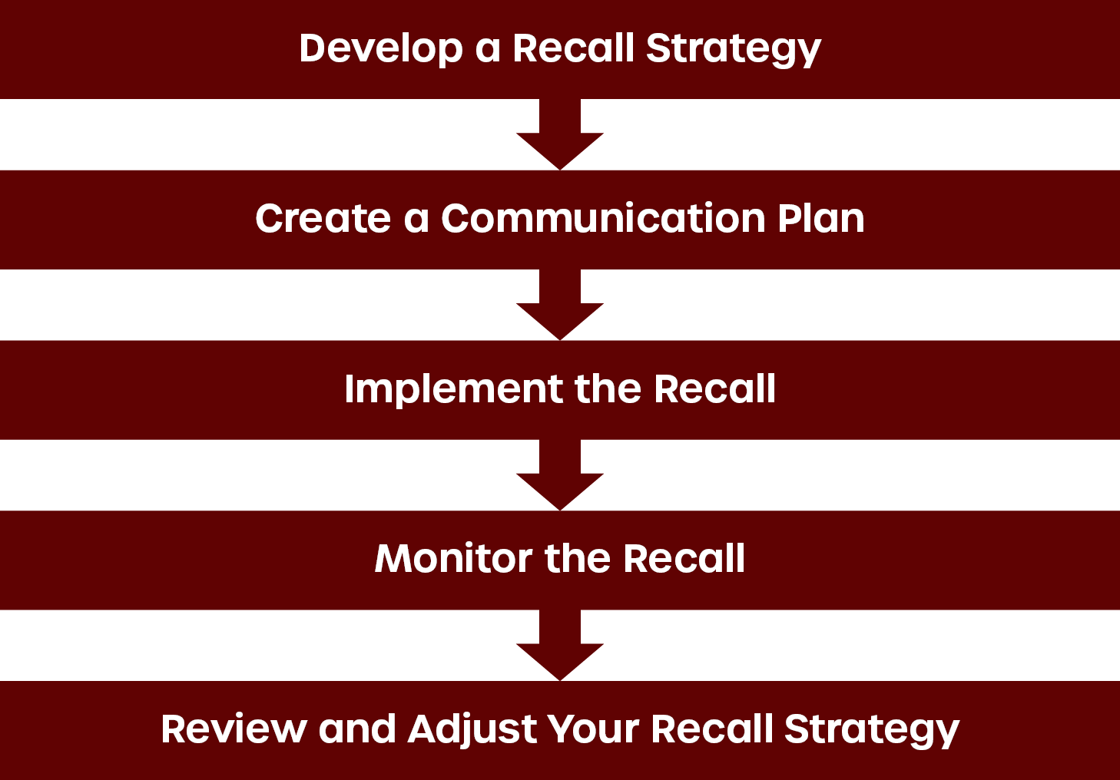

Develop a Recall Strategy
Every organization is going to approach product issues differently. However, a well-thought-out recall strategy based on proven best practices will set your organization up for success should product issues arise.
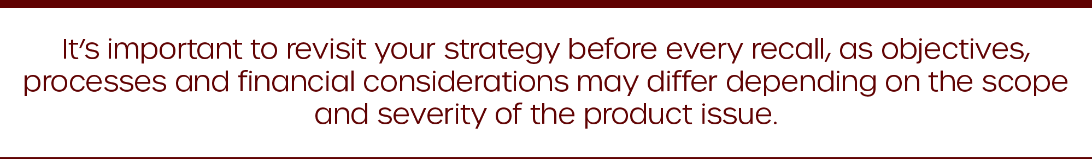

Your organization’s recall strategy should allow you to clearly understand why the recall is necessary, what you plan to achieve by recalling affected products and how you plan to reduce the risks associated with the affected products. As such, developing an effective recall strategy involves establishing clear objectives, formalizing your recall process and taking financial considerations of the recall into account.

Recall Objectives
When it comes to product recalls, setting objectives is a great way to ensure your organization is aligned. Overall, recall objectives should include:
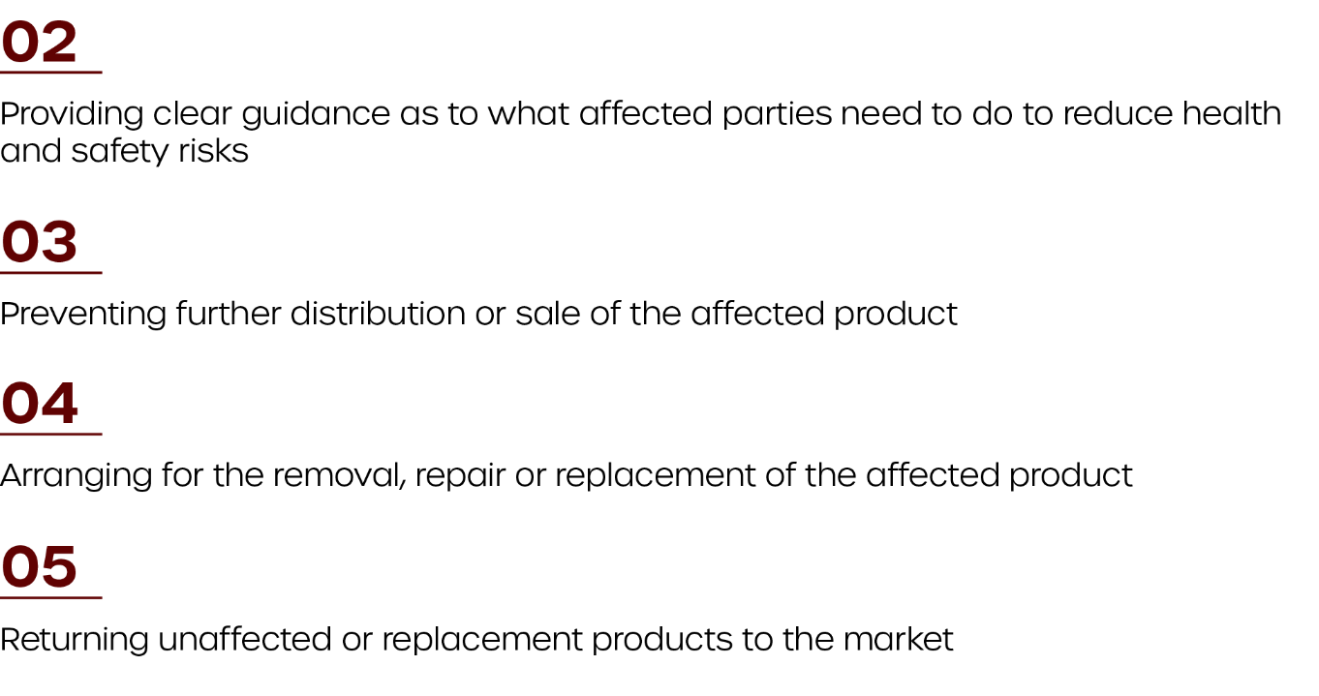

Recall Processes
The recall process refers to your methods for removing defective products from the marketplace and should be designed with your objectives in mind. Overall, your recall process needs to make retrieving, repairing, modifying or replacing an affected product as easy as possible. Some best practices for establishing a strong recall process include the following:
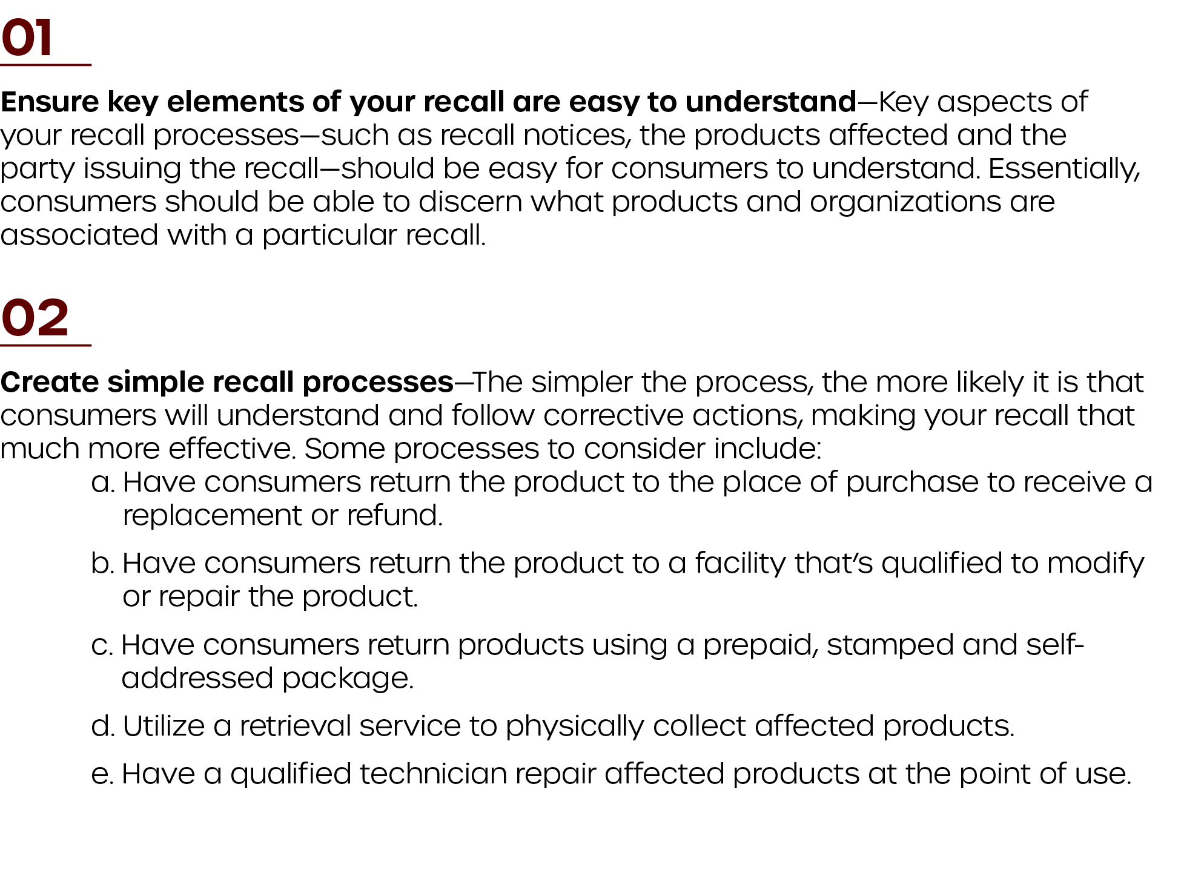

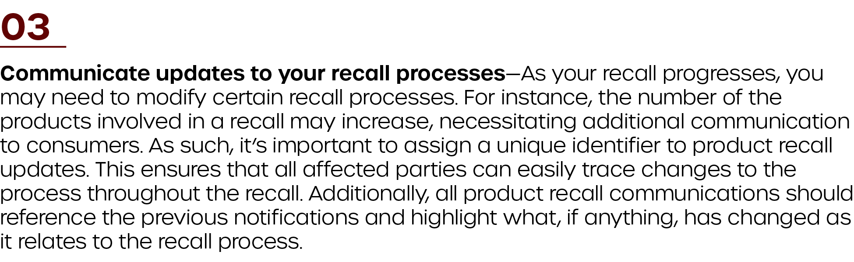

Remember, processes may differ from product to product, so it’s important to review them before every new recall. Your product recall team can serve as the initial reviewers of these processes.

Financial Considerations
The associated costs of a recall can differ depending on how many products were affected and your organization’s specific recall processes. However, as part of your recall strategy, it’s important to clearly document the potential costs of a recall to ensure you have the resources necessary to address all product concerns.
In general, the primary costs associated with a product recall can include, but are not limited to, the following:
- Advertising and communication costs
- Costs associated with the retrieval, repair, modification, installation and disposal of affected products
- Costs associated with the production and distribution of replacement products
- Costs associated with compensating consumers
- Costs associated with business interruptions and lost income
- Consultation costs
- Investigation costs
- Communication costs
- Legal costs
- Staffing costs
Consider having your product recall team evaluate these costs and the ways your organization can appropriately allocate the necessary funds. Additionally, it’s important to speak with a qualified insurance broker, as they can recommend risk management strategies and customized policies to help manage product recall costs.

Create a Communication Plan
Clear, consistent, concise and accurate communication provides a strong foundation for effective product recalls. As such, it’s important to develop and document a communication plan that’s designed to meet the needs of various stakeholders affected by the recall.
Strong communication plans allow stakeholders to easily understand product hazards and the actions they need to take to minimize the risk. Furthermore, your plan should give affected parties the information they need to communicate with the organization implementing the recall. This information will likely come from your recall strategy and recall notice.
The following are some considerations to keep in mind when creating a communication plan:
- Communication plans should clearly identify your recall processes, listing the steps consumers need to follow to ensure their health and safety. Plans should also include the means by which consumers can contact you for questions regarding the recall.
- Communication plans should establish how your organization will deal with the increase of consumer inquires you are likely to get as a result of the recall. For many firms, this involves leveraging the services of a call center or other third party.
- Communication plans should take internal stakeholders and compliance considerations into account. Above all, ensure your recall team, applicable regulatory bodies and internal stakeholders are aware of the recall and your overall strategy.
- Communication plans should break down the list of audiences and the potential communications they could receive.
- Communication plans should include a proposed distribution schedule. Remember, recall communications should be launched soon after you make your recall decision.
In general, your communication plan must account for how you will interface with regulators, your supply chain and consumers. Each of these stakeholders will have their own communication needs and considerations.

Recall Notices
To best reach key stakeholders such as regulators, your supply chain and consumers, you will first need to create and distribute a recall notice. The recall notice should include the following:
- An identification number that’s unique to your recall communications and will be used as you continue to provide updates
- A clear description of the affected product, including key identifiers (e.g., makes, models, part numbers, serial numbers, and batch or lot codes)
- A photograph or image of the affected product
- Where and when the affected product was sold and distributed
- A description of why the product is being recalled, including the risks it poses to consumers
- A clear explanation of the actions consumers should take to reduce the potential risks
- Contact details for the organization responsible for the recall
- Where to direct inquiries regarding the recall
Once you have released your recall notice, you will need to consider your communication plan for regulators, your supply chain and consumers.

Communication With Regulators
Depending on the jurisdiction your business operates in, you may have specific communication regulations to consider. For instance, the CPSA’s reporting requirements provide guidelines on what organizations need to communicate. As such, it’s important to work alongside your legal representatives to determine your firm’s specific communication requirements and to adjust your plan accordingly.

Communication With Supply Chain
When your organization or the CPSC deems a recall necessary, you will need to take steps to notify members of the supply chain. Specifically, you will need to communicate who received the affected products and make a record of:
- When members of your supply chain are contacted regarding product issues
- How much affected product members of your supply chain have in their control
- Whether members of your supply chain have quarantined the affected product or taken other measures to prevent further distribution
It’s also important to educate your supply chain on your recall strategy, as they will need to record and communicate how affected product will be retrieved, replaced or destroyed.

Communication With Consumers
When developing your plan, establishing and auditing communications for consumers are some of the most involved processes. Communications with consumers need to be all-encompassing, and you’ll need to ensure they understand the risks associated with the affected product and what actions to take.
The means by which you communicate to consumers should be appropriate for the audience. Some channels to consider include:
Type of Communication/Channels | Best Practices
News Releases | - News releases should be distributed jointly with the help of the CPSC. The CPSC will help you craft the language of your release.  - News releases should have a targeted distribution. Typically, the CPSC sends news releases through national wire services, major metropolitan newsletters, and television and radio networks.  - News releases must use the word “recall” in the heading and should begin with the following phrasing:  - In cooperation with the U.S. Consumer Product Safety Commission (CPSC)  - News releases should include key information regarding your company and the recall, including the following:  - Your company’s legal and commonly known trade name  - The city and state your company’s headquarters is located  - Whether your company is the manufacturer, importer distributor or retailer of the product  - The country in which the product was manufactured if your firm is not the original manufacturer (including the location of the manufacturer’s headquarters)  - A list of significant retailers  - The number of units implicated in the recall, including the number of units manufactured, imported or distributed  - A detailed description of the product, which can include, but is not limited to, its name, intended consumer population, color, date of manufacture, retail price, size, model number, SKUs and retail locations  - Photographs that help consumers better identify the product and the defect  - A clear description of the product defect and its related hazards  - A summary of incident notifications your firm has received that have prompted the recall  - Instructions for how consumers can participate in the recall and reduce their exposures
Video News Releases | - Video news releases should be a visual version of your written news release.  - Organizations should work alongside the CPSC to create and distribute video news releases.  - Video news releases need to communicate basic information regarding the recall to key stakeholders. Information included should match your written news release and accompany video images of the product and defect.  - Video news releases should feature brief statements from company officials.
Social Media | - Be sure to notify consumers using all available social media platforms, such as Facebook, Twitter, Instagram and YouTube.  - Ensure social media messaging:  - Includes the words “recall” and “safety”  - Contains relevant recall information available in other communication channels (e.g., news releases and posters)  - Links consumers to a landing page where they can read more about the recall and take further action to remedy the product issue
Recall Posters | - Information on recall posters should be kept brief.  - Consider using posters that are 8.5 by 11 inches in size. This size is the easiest to print and mail in bulk quantities.  - Posters should be eye-catching and clearly describe the hazard and steps consumers need to take to reduce their risk. Consider using fonts and colors that stand out and don’t distract from your recall messaging.  - You should include the terms “safety” and “recall” in the heading of your poster.  - Your posters should include a high-quality image of the product and defect. In addition, your posters should provide key product information similar to content in your news and video releases.  - Your posters should describe how consumers can get in contact with your organization to learn more about the recall.  - Consider using a QR code on your poster for improved response rates.  - When providing posters to retailers, ensure they place them in locations where customers are likely to see them. This can include places like store entrances or service counters. Ensure retailers are given an adequate number of posters for display.
Toll-free Numbers | - Toll-free numbers need to provide your consumers a direct means to respond to the recall notice and take further action.  - Ensure you are equipped to handle an influx of calls and inquiries regarding product issues. Consider utilizing a third-party vendor to ensure you are addressing all consumer inquires via phone calls in a timely and efficient manner.  - Prepare scripts for calls that provide an overview of the recall and the steps consumers need to take to remain safe. Automated phone messages can help streamline this process and free up much-needed resources.
Other Channels:  - Product Catalogs  - Service Bulletins  - Blogs  - Newspapers  - Magazines  - Direct Mail  - Loyalty Programs  - Advertisements | - Recall communication needs to be tailored to the appropriate audience. Information included in these communications should be specific and motivate the target audience to take action.  - All communications should outline the reasons for the recall and the products implicated.  - It’s important to include phrases like “Important Safety Notice” or “Safety Recall” in all of your communications. These words are not only eye-catching, but may help elicit a response.

When developing your communication plan, consider consumers with unique needs (e.g., those that live in isolated areas or who have limited access to traditional communication channels). Additionally, consider partnering with third-party vendors who specialize in consumer communication. These organizations may be able to help reach a wider audience, making your recall that much more effective.

Implement the Recall
After you create your communication plan and send a recall notice, it’s time to implement the recall. Most of all, you will need to provide clear instructions to your supply chain as it pertains to halting the sale of affected products.
When it comes to implementing a recall, many of your organization’s specific action steps will come from your unique recall strategy. However, as a best practice, implementing a recall should involve:
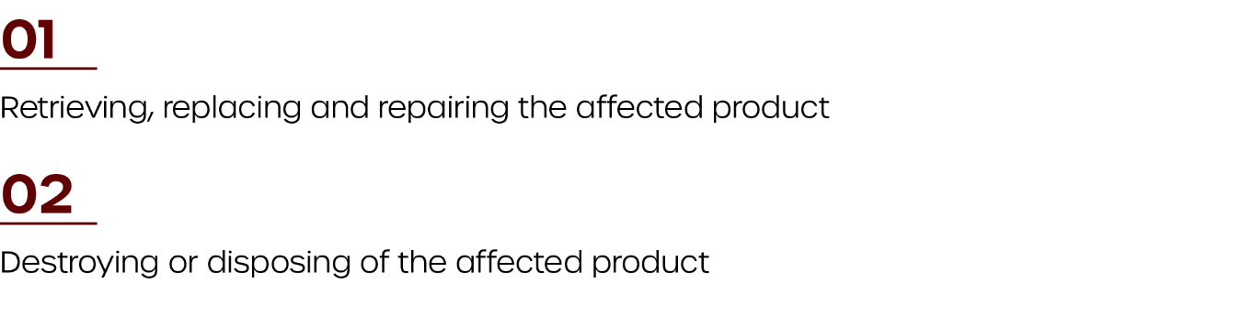

Retrieving, Replacing and Repairing the Affected Product
It may sound obvious, but once you’ve sent out a recall notice, you must identify any and all products that are subject to the recall. Firms can go about this in many ways, but it’s best to investigate lot numbers and follow the distribution path of impacted products. Be thorough in this step, as you don’t want to misidentify affected products.
If you catch a recall early enough, you can greatly reduce or even eliminate the impact on the public. Once you have identified potentially harmful or violative products, you must take steps to quarantine them. Above all, it is your firm's responsibility to ensure that any recalled products in your firm's control are not distributed.
When retrieving affected product, it’s important to keep in mind how you will handle replacing additional stock, parts and other components. Furthermore, you may need to assign authorized maintenance personnel to perform modifications or repairs of affected products as necessary.
If your recall strategy calls for consumers to return affected product to the point of sale, ensure that retailers understand how to properly secure the product and prevent resale. Additionally, if consumers are to return affected products by mail, suppliers need to arrange for prepaid stamped self-addressed packaging, and secure a means for collecting and disposing of defective products.

Destroy or Dispose of the Affected Product
In the event that affected products can’t be repaired, reworked and redistributed, you should destroy them. This prevents potentially harmful products from being reused, resold or redistributed.
When destroying and disposing of affected product, it’s important to follow any applicable environmental regulations and recycle component parts as appropriate. You should also document how you destroyed the affected products.

Monitor the Recall
As you implement your recall strategy, you will need to continually monitor its effectiveness. This allows you to make adjustments and ensures you are meeting your specific recall objectives. When monitoring your recall, the data you collect can include, but is not limited to, the following:
- How and when recall communications were distributed
- How and when consumers were contacted about the recall
- The response rate for communications (e.g., consumer enquiries, number of calls received and website views)
- How many consumers reported injuries or requested compensation
- Information regarding affected product, including:
  - The amount of affected product identified
  - The amount of affected product returned, replaced, repaired, modified or disposed of by members of your supply chain
  - The amount of affected product returned, replaced, repaired, modified or disposed of by your consumers
It’s also crucial to evaluate your recall critically throughout the monitoring process. The table below outlines the specific aspects of your recall to evaluate and what criteria needs to be met to ensure an effective recall:
Recall Topic | Measures of Effectiveness
Locating Affected Product | - Recall notice was distributed in a timely fashion.  - Recall notice was received and understood by consumers.  - The organization implementing the recall is able to identify where affected products were distributed.
Return Rate | - Affected products was easily and successfully retrieved, repaired, modified or removed from the supply chain and marketplace.  - The return rate is similar or better than the return rates of similar products implicated in past recalls.
Disposal Rate | - Products are disposed of in a timely fashion.  - Products are disposed of in accordance with environmental regulations and any other applicable legislation.
Injury Rate | - The number of injuries related to the affected product decrease over time.
Inquiry Rate | - Inquiry rates are high in the early stages of the recall, but decrease over time.
Communication | - Stakeholders receive communications in a timely fashion and are able to understand recall action items.

Depending on your jurisdiction, there may be specific requirements related to monitoring your recall and reporting recall progress. As such, be sure to review all applicable legislation to ensure continued compliance.

Review and Adjust Your Recall Strategy
After you have finished monitoring your recall, you may be ready to halt recall operations. However, before officially concluding the recall, you will need to ensure:
- Recall objectives have been met.
- Affected consumers have received the recall notice, and many have taken the corrective actions necessary to reduce their risk of harm.
- Reports of injuries and illnesses related to the affected have ceased or significantly decreased.
- Return rates are appropriate given the type of affected product and the nature of the risk.
- Applicable regulations related to the recall have been met, and the appropriate governing bodies have no additional actions to recommend.
Before ceasing recall operations, it’s important to ensure that you can resume recall actions should you later determine product risks weren’t sufficiently reduced. Additionally, consumers should still have a means for reporting and returning potentially harmful products long after the initial recall has concluded.
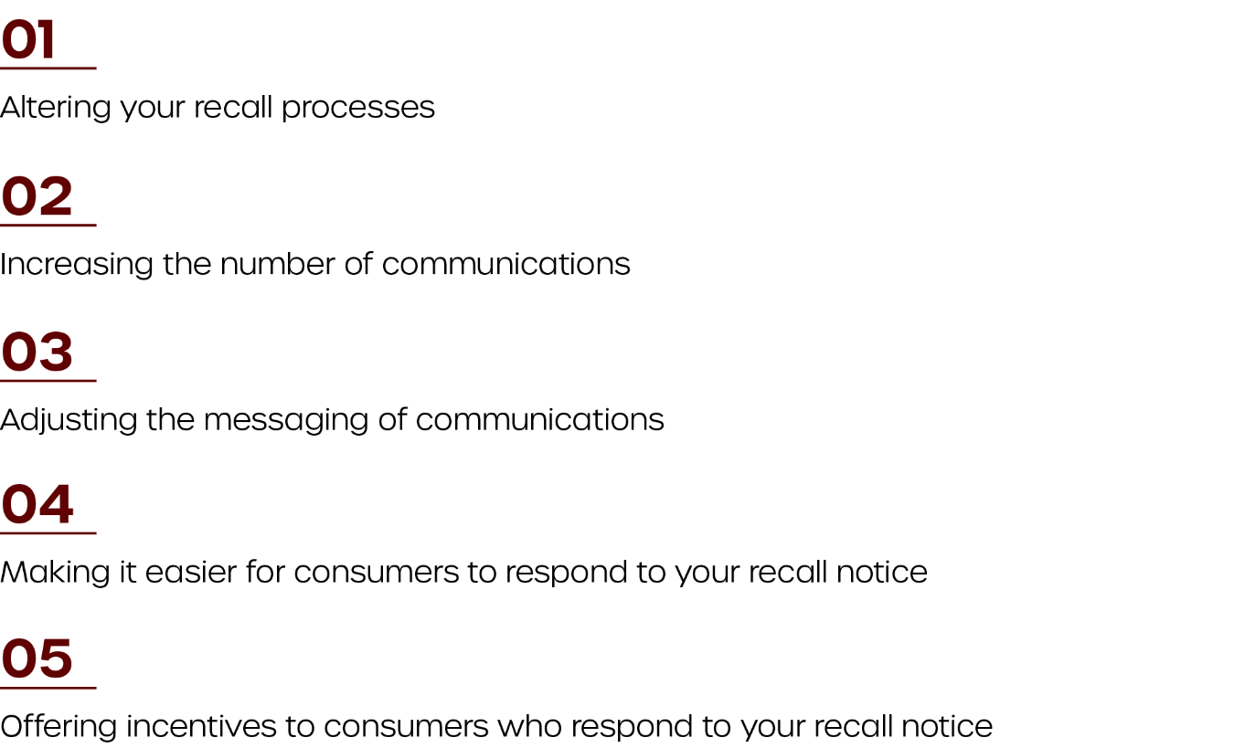
Above all, following every recall, it’s important to re-evaluate your strategy. This is particularly true if you find you aren’t meeting your recall objectives. Potential adjustments to your recall may include:

Your product recall team will typically be the ones monitoring and evaluating your recalls. However, it’s important to gather feedback from key stakeholders when determining how to improve your recall. This may include members of your supply chain, consumers or regulatory bodies.

PREVENTING FUTURE INCIDENTS
While it’s important to have a plan in place for responding to product issues, it’s equally important to prevent future product issues whenever possible. Continual improvement should be a constant goal, and you should review your organization’s communication plan, risk assessment procedures, recall strategy and similar activities on a regular basis.
It’s also important to use what you learned throughout your recall to improve upon product design, production, safety, packaging, shipping and marketing processes.
For further protection, the right insurance policy can be invaluable. For instance, product liability insurance protects organizations from a variety of liability concerns, even if a defect is caused by an outside supplier. To learn more about your options, contact Horst Insurance today.

This checklist is designed to help organizations initiate a consumer product recall in accordance with Consumer Product Safety Commission (CPSC) standards. Please note that this checklist may not account for all regulatory requirements related to a product recall, and it’s important to review procedures alongside legal counsel. In addition, not all items on this checklist will apply in every situation.

BEFORE A RECALL
Consider completing the following before a recall is necessary:
Develop a product recall policy. | ☐
Create a product recall team. | ☐
Designate a key company official to be the point of contact for the recall. | ☐
Establish recordkeeping practices. | ☐
Simulate a product recall. | ☐
Review compliance concerns alongside a legal representative. | ☐

INITIATING A RECALL
Perform one or more of the following steps to halt the production and distribution of defective product:
Stop production of defective product. | ☐
Identify the affected product using Universal Product Codes (UPCs), date codes and model numbers. | ☐
Isolate inventory, and notify your supply chain to prevent further distribution. | ☐
Identify goods-in-transit, and contact recipients to give them notice of the affected product. | ☐
Determine how you will remedy the defective product (i.e., providing a full refund, repairing the product or replacing the product). | ☐
Test your replacement or repair as applicable. | ☐
Reduce future hazards by redesigning the product and enhancing quality control measures. | ☐
Adjust the labels, model number and serial numbers of redesigned product. | ☐
Determine how you will handle returns of affected product. | ☐

RECALL NOTICE DOCUMENTS AND RELATED ITEMS
Prepare one or more of the following to promote communication of the recall:
A toll‐free number | ☐
A joint press release with the CPSC | ☐
A recall poster | ☐
A script and FAQ for customer service representatives | ☐
A social media plan | ☐
A webpage highlighting all relevant recall information | ☐
Individual notices to each member of your supply chain | ☐

AFTER THE PUBLIC ANNOUNCEMENT
Consider doing the following after you have communicated your recall:
Monitor the recall by contacting retailers or consumers. | ☐
Provide reports and updates on the status of your recall participation as needed. | ☐
Keep recall notice information posted on the firm’s website throughout the entirety of the recall. | ☐
Keep posters up in retail locations throughout the duration of the recall. | ☐
Consult with legal personnel throughout the recall to ensure you are meeting any and all applicable requirements. | ☐

Presented by Horst Insurance

This checklist is designed to help you proactively evaluate product liability concerns. It takes into account various departments, policies and procedures. For more information on product liability and to secure the proper coverage to transfer your product liability risk, contact your insurance broker today.

ADMINISTRATION | YES | NO | N/A
Have you created and communicated a product safety policy? | ☐ | ☐ | ☐
Do you have a committee or group that proactively addresses product safety and liability? | ☐ | ☐ | ☐
Do you have a designated individual with proper authority, who is responsible for coordinating product safety activities? | ☐ | ☐ | ☐

PRODUCT RISK EVALUATION | YES | NO | N/A
Do you have a process in place for identifying and evaluating product hazards? | ☐ | ☐ | ☐
Are hazard analysis reports reviewed by your product safety group? | ☐ | ☐ | ☐
Do you regularly evaluate products to ensure they meet regulatory requirements? | ☐ | ☐ | ☐
When evaluating risks, do you take the potential environmental impact of the product into account? | ☐ | ☐ | ☐

RESEARCH, DEVELOPMENT AND ENGINEERING | YES | NO | N/A
Do you use up-to-date standards for all of your product lines? Are they used as minimum design criteria? | ☐ | ☐ | ☐
Are your in-house design criteria documented and supported by research, calculations or other scientific analysis? | ☐ | ☐ | ☐
Do you use system safety techniques to evaluate product designs? | ☐ | ☐ | ☐
Do you account for possible misuse and human error as part of the product design process? | ☐ | ☐ | ☐

PURCHASING | YES | NO | N/A
Does your legal counsel review your purchase documents? Do suppliers, vendors and subcontractors hold your company harmless in these documents? | ☐ | ☐ | ☐
Does your company obtain certificates of product liability insurance from suppliers? | ☐ | ☐ | ☐

QUALITY ASSURANCE | YES | NO | N/A
Do you use a quality assurance program? | ☐ | ☐ | ☐
Does your quality assurance program meet applicable standards? | ☐ | ☐ | ☐
Is your quality assurance program accurately reflected in your company’s policies and procedures? | ☐ | ☐ | ☐
Are all quality control procedures documented? | ☐ | ☐ | ☐
Do you seek the assistance of third parties (e.g., outside laboratories or consultants) periodically to audit your quality assurance procedures? | ☐ | ☐ | ☐

INSTRUCTIONS AND WARNINGS | YES | NO | N/A
Do you verify that product labels meet applicable industry and government safety standards? | ☐ | ☐ | ☐
Do labels and other warnings address hazards related to product misuse? | ☐ | ☐ | ☐
Do you have a process in place to ensure instruction manuals and package labels are useful, understandable and readily available? | ☐ | ☐ | ☐
Does your product safety committee and legal counsel review all labels, warnings and instructions? | ☐ | ☐ | ☐

SALES AND ADVERTISING | YES | NO | N/A
Do you regularly review advertising materials, warranties, guarantees and sales representation agreements alongside legal professionals? | ☐ | ☐ | ☐
Do you provide product liability prevention training to marketing and sales representatives, distributors and dealers? | ☐ | ☐ | ☐
Are sales personnel instructed to report product safety problems to the appropriate parties? | ☐ | ☐ | ☐

PACKAGING AND SHIPPING | YES | NO | N/A
When selecting packaging, do you take product safety and liability into account? | ☐ | ☐ | ☐
Does product packaging meet applicable shipping and transportation safety requirements? | ☐ | ☐ | ☐
Does legal counsel review packaging, particularly any included warnings and safety? | ☐ | ☐ | ☐

INCIDENT AND CLAIM HANDLING | YES | NO | N/A
Does your company have effective procedures for handling the following concerns?  - Customer complaints and product incidents  - Product abuse and misuse  - Product liability claims | ☐ | ☐ | ☐
Do you periodically analyze incident, complaint and claim data to pinpoint trends and potential concerns? | ☐ | ☐ | ☐

PRODUCT RECALL AND DISPOSAL | YES | NO | N/A
Are your critical materials, components and packaging coded and traceable to the original manufacturer? | ☐ | ☐ | ☐
Are production and sales records created, reviewed and retained? | ☐ | ☐ | ☐
Do you have procedures in place for product recalls? | ☐ | ☐ | ☐

PROGRAM AUDITS | YES | NO | N/A
Does your company regularly audit product safety programs? | ☐ | ☐ | ☐

SAMPLE NOTICE OF RECALL
Urgent—Recall of [Name of product]
[Name and address of your company]
[Date]
Dear Customer,
[Your company name] is recalling the products listed below because [elaborate on the issue – include description of actual/potential hazards and incidents/injuries]. The table below details the specific products affected by the recall. Please discontinue selling or distributing these products immediately by counting your inventory and storing them in a secure place away from the public.
Product Name | Brand | Size | Code, UPC, etc.

Please contact all accounts that you sell these products to immediately and inform them of this recall. [Your company name] staff will credit you for the recalled product. Please mark the product "Recalled," and [Your company name] staff will call you to arrange pickup.
Important
Please record the time and date you received this recall notice. Acknowledge receipt by signing and sending this document to [Your company name] at [Your company email/fax number].
Date/Time Received: ______________________________________________
Signature: _______________________________________________________
Name of Store/Distributor: _________________________________________

Thank you for your cooperation.
[The name of your company's contact]
[Their position]
[Your company name]

PRODUCT RECALL TEAM CONTACT INFORMATION
NAME | BUSINESS PHONE | AFTER-HOURS PHONE | RESPONSIBILITIES | ALTERNATE

SAMPLE RECALL NOTICE POSTER
RECALL - [Company Name]
- Product name
- Product brand
- Model number
- Other identifiers

Hazard: [Description of the hazards caused by the defective product(s)]
Recalled product(s): [Description of the recalled product(s)]
Remedy: [Description of what affected stakeholders need to do in response to the recall]

FOR MORE INFORMATION:
[Toll-free number consumers should call]
[Company’s website]

SAMPLE PRESS RELEASE
FOR IMMEDIATE RELEASE
Recall Notice—Undeclared [Summary of Risk] in [Name of product]
[City], [Date]—In cooperation with the U.S. Consumer Product Safety Commission (CPSC), [Company name], [Location] is warning consumers not to use [Brand name and product name] because it may contain [Describe the issue]. This issue was not declared on the label.
The product being recalled is:
[Describe the product, including the brand name, original manufacturer, product name, packaging, sizes, lot code number and universal product code (UPC)]. The product is distributed in [Name of states/areas affected]. Below is hi-resolution picture of the products affected by the recall:
[Name the product] may cause serious or life-threatening injuries due to the following [Detail the hazard]. Consumers should [Tell consumers what to do with the recall product, for instance, return to point of sale for a refund]. There have been of reported issues associated with this product.
Consumers can learn more about the recall by [Include phone number or other relevant contact information]. For additional media inquiries, please contact:
[Company contact name]
[Company name]
[City, state, country]
[Daytime phone]
[After-hours phone]
###

