Performance Reviews
Provided by: Horst Insurance

Table of Contents
Introduction 4
Reviews at a Glance 5
How the Practice Has Evolved 5
Choosing the Right Performance Review 6
Self-assessment 6
Rating Scale 6
360-degree Reviews 6
Personal Development 7
Performance Reviews: Arguments for and Against 8
Pros 8
Cons 8
Deciding What’s Best 8
17 Best Practices for Perfecting Your Performance Reviews 9
Avoid These Top Performance Review Mistakes 11
Appendix 13
Notice of Upcoming Performance Review 14
Performance Review Audit Form 15
Manager Post-review Checklist 18
Employee Performance Evaluation Form – Rating Scale 20
Employee Performance Evaluation Form – Narrative 22
Employee Self-evaluation 24
360-review Feedback Request Form 26
Employee Performance Goal Sheet 32
Performance Review Walk-through 33
Reviewer Do’s and Don’ts 35

Introduction
Receiving performance feedback is a fundamental part of any job. Without some sort of reflection, how would your employees know what they’re doing well or what needs improvement? They likely wouldn’t—at least not in any formal capacity.
Although most employers agree that performance reviews are important, the reviews themselves become trickier when put into practice. It’s easy to say that an employee must be reviewed, but when? Based on what criteria? How often? These aspects are often debated by employers.
Surveys show performance reviews are one of the most disliked features of any workplace. Not only do employees not want to endure them, but neither do their managers. This toolkit examines why this is, explains how to determine the right review process for your company and offers resources for ensuring neither party wastes their time.

Reviews at a Glance
What does the term “performance review” mean to you? To many people, it means sitting down at the end of the year with a manager to discuss how you conducted yourself over the past 12 months. To others, it might mean chatting with a manager every quarter. To some, it could mean a biweekly conversation to discuss personal goals.
The point is, not all businesses approach performance reviews the same way. This section details those variations and suggests guidance for deciding the best approach for your business.

How the Practice Has Evolved
The modern performance review is largely based on a merit system devised by the U.S. military in World War I, according to research by the Harvard Business Review. The system was originally intended to identify poor performers, but it later became a way of flagging soldiers with leadership potential. After World War II, over half of all U.S. companies were using a similar system to track worker performance and dole out rewards.
Back then, it was hard to find a business that didn’t preach the benefits of performance reviews. Workers were abundant, so employers needed a way to decide whom to let go. Individual accountability was more important than personal development in the eyes of employers.
However, that trend later shifted when worker demand outgrew supply. Today, employees are more likely to be coached toward improvement instead of being quickly dismissed for poor performance. While performance is still monitored, employee development is now a much higher priority.

Choosing the Right Performance Review
Every business has its own way of conducting performance reviews. What works for one company will not necessarily work for another. With this in mind, your business should consider its culture and how employees best receive feedback. What communication methods worked well in the past? What kind of rapport do managers have with employees? How much is your company focused on personal development versus stats and metrics? How often should reviews be conducted?
Reflecting on these questions will help you determine the kind of performance review that will resonate most with your employees. Or better yet, you could solicit feedback from employees about how they prefer to be reviewed. Consider sending a survey or asking employees individually during their current performance reviews.
Keep in mind the below examples are merely a starting place. Pick any aspects you would like to include in your own review process. Most importantly, you want to devise a system that works for your employees.

Self-assessment
This type of review involves an employee identifying how they view their own performance. For instance, the employee might be asked to rank various job responsibilities in order of proficiency. This kind of review empowers employees to take an objective look at their performance and make their voices heard.
Self-assessment can be paired with manager assessments as well. This means an employee and manager would both complete assessments of the employee then compare how those assessments align. Pairing the two assessments allows both parties to candidly discuss any discrepancies and determine areas for improvement.

Rating Scale
This review process focuses on preset criteria and offers a score for each. The criteria can be based on company or department goals, certain metrics, individual behaviors or anything else you wish to assess. In this method, the criteria and rating standards are the same for all employees.
Having a consistent set of criteria and ratings allows you effectively judge employee performance against one another. This allows you to see who is doing well and who needs improvement, and in what specific area. Some organizations even tie their reward systems into their rating scales. In other words, receiving a low score would mean getting fewer rewards.
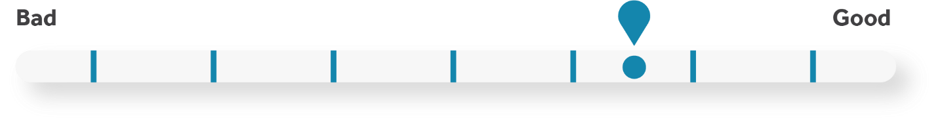

360-degree Reviews
This form of review solicits feedback from everyone who interacts with a given employee, not just managers. This means peers, direct reports and supervisors all submit feedback, which is then compiled and sent to the employee. The idea is that diverse feedback will help employees get a better sense of their performance.
The 360-review also allows the employee to submit their own personal assessment, then speak about the results with their manager. All the feedback is used to help develop the employee and identify any improvement areas. It can also be used to record problem behaviors noticed by co-workers that persist between review periods. Conversely, it can also highlight exceptional behaviors if multiple people praise the employee for the same reasons.

Personal Development
This review style zeroes in on employees’ personal goals, and then assesses them based on the goal progress. Setting personal goals makes employees feel more engaged and gives them a “purpose” throughout the year.
Goals should be aligned with both company and employee interests. For instance, an employee’s goal might be revamping a training curriculum for new hires. After a predetermined period, their manager would check in on their progress and offer an assessment.

Performance Reviews: Arguments for and Against
As we said earlier, employers are more concerned about employee development these days. The goal of performance reviews is to help employees grow and stay on track, not to scare them. At the very least, they offer a platform for employees to have a productive discussion about their career progress.
Yet, despite their good intentions, performance reviews have their flaws. Some estimates suggest over a third of U.S. employers have done away with traditional performance reviews, according to the Harvard Business Review. Others are using traditional reviews, but their employees are not feeling the benefits.
This section offers brief arguments for and against traditional performance reviews.

Pros
Evaluating employee performance is critical for many reasons, not least of which is determining raises and promotions. Employers must have at least one method for assessing how well an employee is faring at the company. Without one, where is the accountability? How do you identify poor performers?
Traditional, rating scale reviews may not work for every organization, but they can be the best option for employees in sales or other metric-based roles. Rating scales are objective and look solely on whether an individual hit a particular mark. Based on that, employers can dole out rewards to top performers and work with poor performers to up their game.

Cons
According to management research firm CEB, 95 percent of managers are not satisfied with their company’s performance review process. What’s more, 90 percent of HR leaders believe the information isn’t always accurate. Even employees are dissatisfied—42 percent said annual reviews are ineffective, according to a WorldatWork survey.
The biggest reason for dropping annual reviews is the time it takes. Beyond meeting with each employee and compiling all the individual feedback, the time between “performance” and “review” can be months. How effectively can you assess performance on a task that an employee finished 10 months ago? How useful would that information even be at this point? Considerations like these are making employers rethink when and how they review employees.

Deciding What’s Best
You should consider what would be most effective for your employees before committing to a particular review process. In fact, you may want to include elements from several different approaches. For instance, using a rating scale review, but conducting it multiple times a year. When deciding what is best for your organization, the two big questions to ask are: “What do I hope to accomplish with this review?” and “How can I make this useful for employees?”

17 Best Practices for Perfecting Your Performance Reviews
- Perform formal evaluations at the same time for everyone each year. While this increases the workload of managers and supervisors during review time, it forces direct comparisons of employees and establishes a nonbiased system.
- Have regular meetings with supervisory staff. Supervisors will learn from each other’s experiences. Provide adequate training and insist on candid observations.
- Clearly communicate to employees what their duties are and what satisfactory performance is. Accomplish this through periodic reviews of job descriptions, training, and both formal and informal reviews.
- Tell employees the criteria upon which their performance will be reviewed. Develop standards and establish reasonable goals for employees. Make sure that employees understand the consequences of their failure to improve.
- Don’t wait until the annual evaluation to provide feedback; offer it throughout the year. Give both positive and negative feedback regularly.
- Document poor performance in writing. This can be done in the form of coaching, training, discipline or assessment.
- Ask employees to complete a self-assessment in addition to the review completed by the manager. This can identify areas where the employee and manager disagree on performance or expectations.
- Give employees the opportunity to review, challenge and comment on the evaluation.
- Meet with employees to discuss all evaluations and expectations. Keep a record of the meeting and what was discussed.
- Have employees sign the evaluation. While the employee may not agree with their evaluation, it provides evidence that the employee has seen it and has been given a copy. If the employee refuses to sign it, the individual giving the evaluation should sign it along with a witness noting that the employee was given a copy.
- Establish a review process for evaluations. This will keep managers honest and ensure that supervisory staff is performing reviews consistently.
- Give employees time to improve, and offer resources and assistance if appropriate.
- Follow established procedures strictly. Apply all procedures and standards equally to all employees.
- Use other supervisory personnel in the process, if possible, to mitigate claims of personality conflict. This will enhance credibility if all evaluations point to the same conclusion.
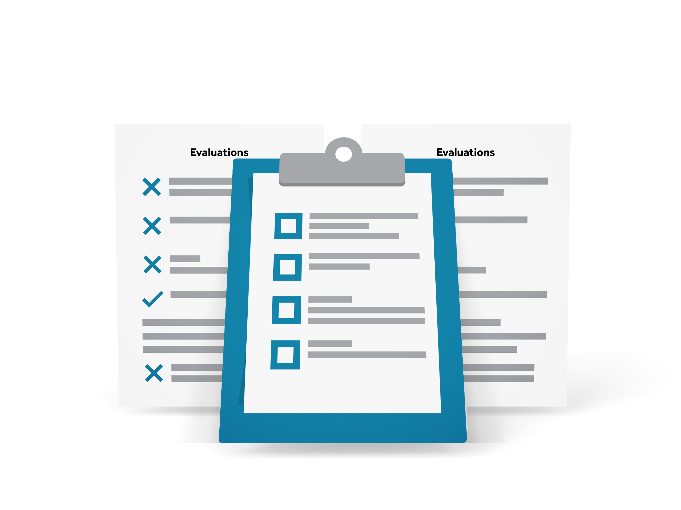
- Make sure employees understand the consequences for failure to perform at an acceptable level. There should be no surprises in employee supervision and evaluation.
- Hold managers responsible for helping subordinates develop and improve.
- Maintain confidentiality in employee performance evaluations.

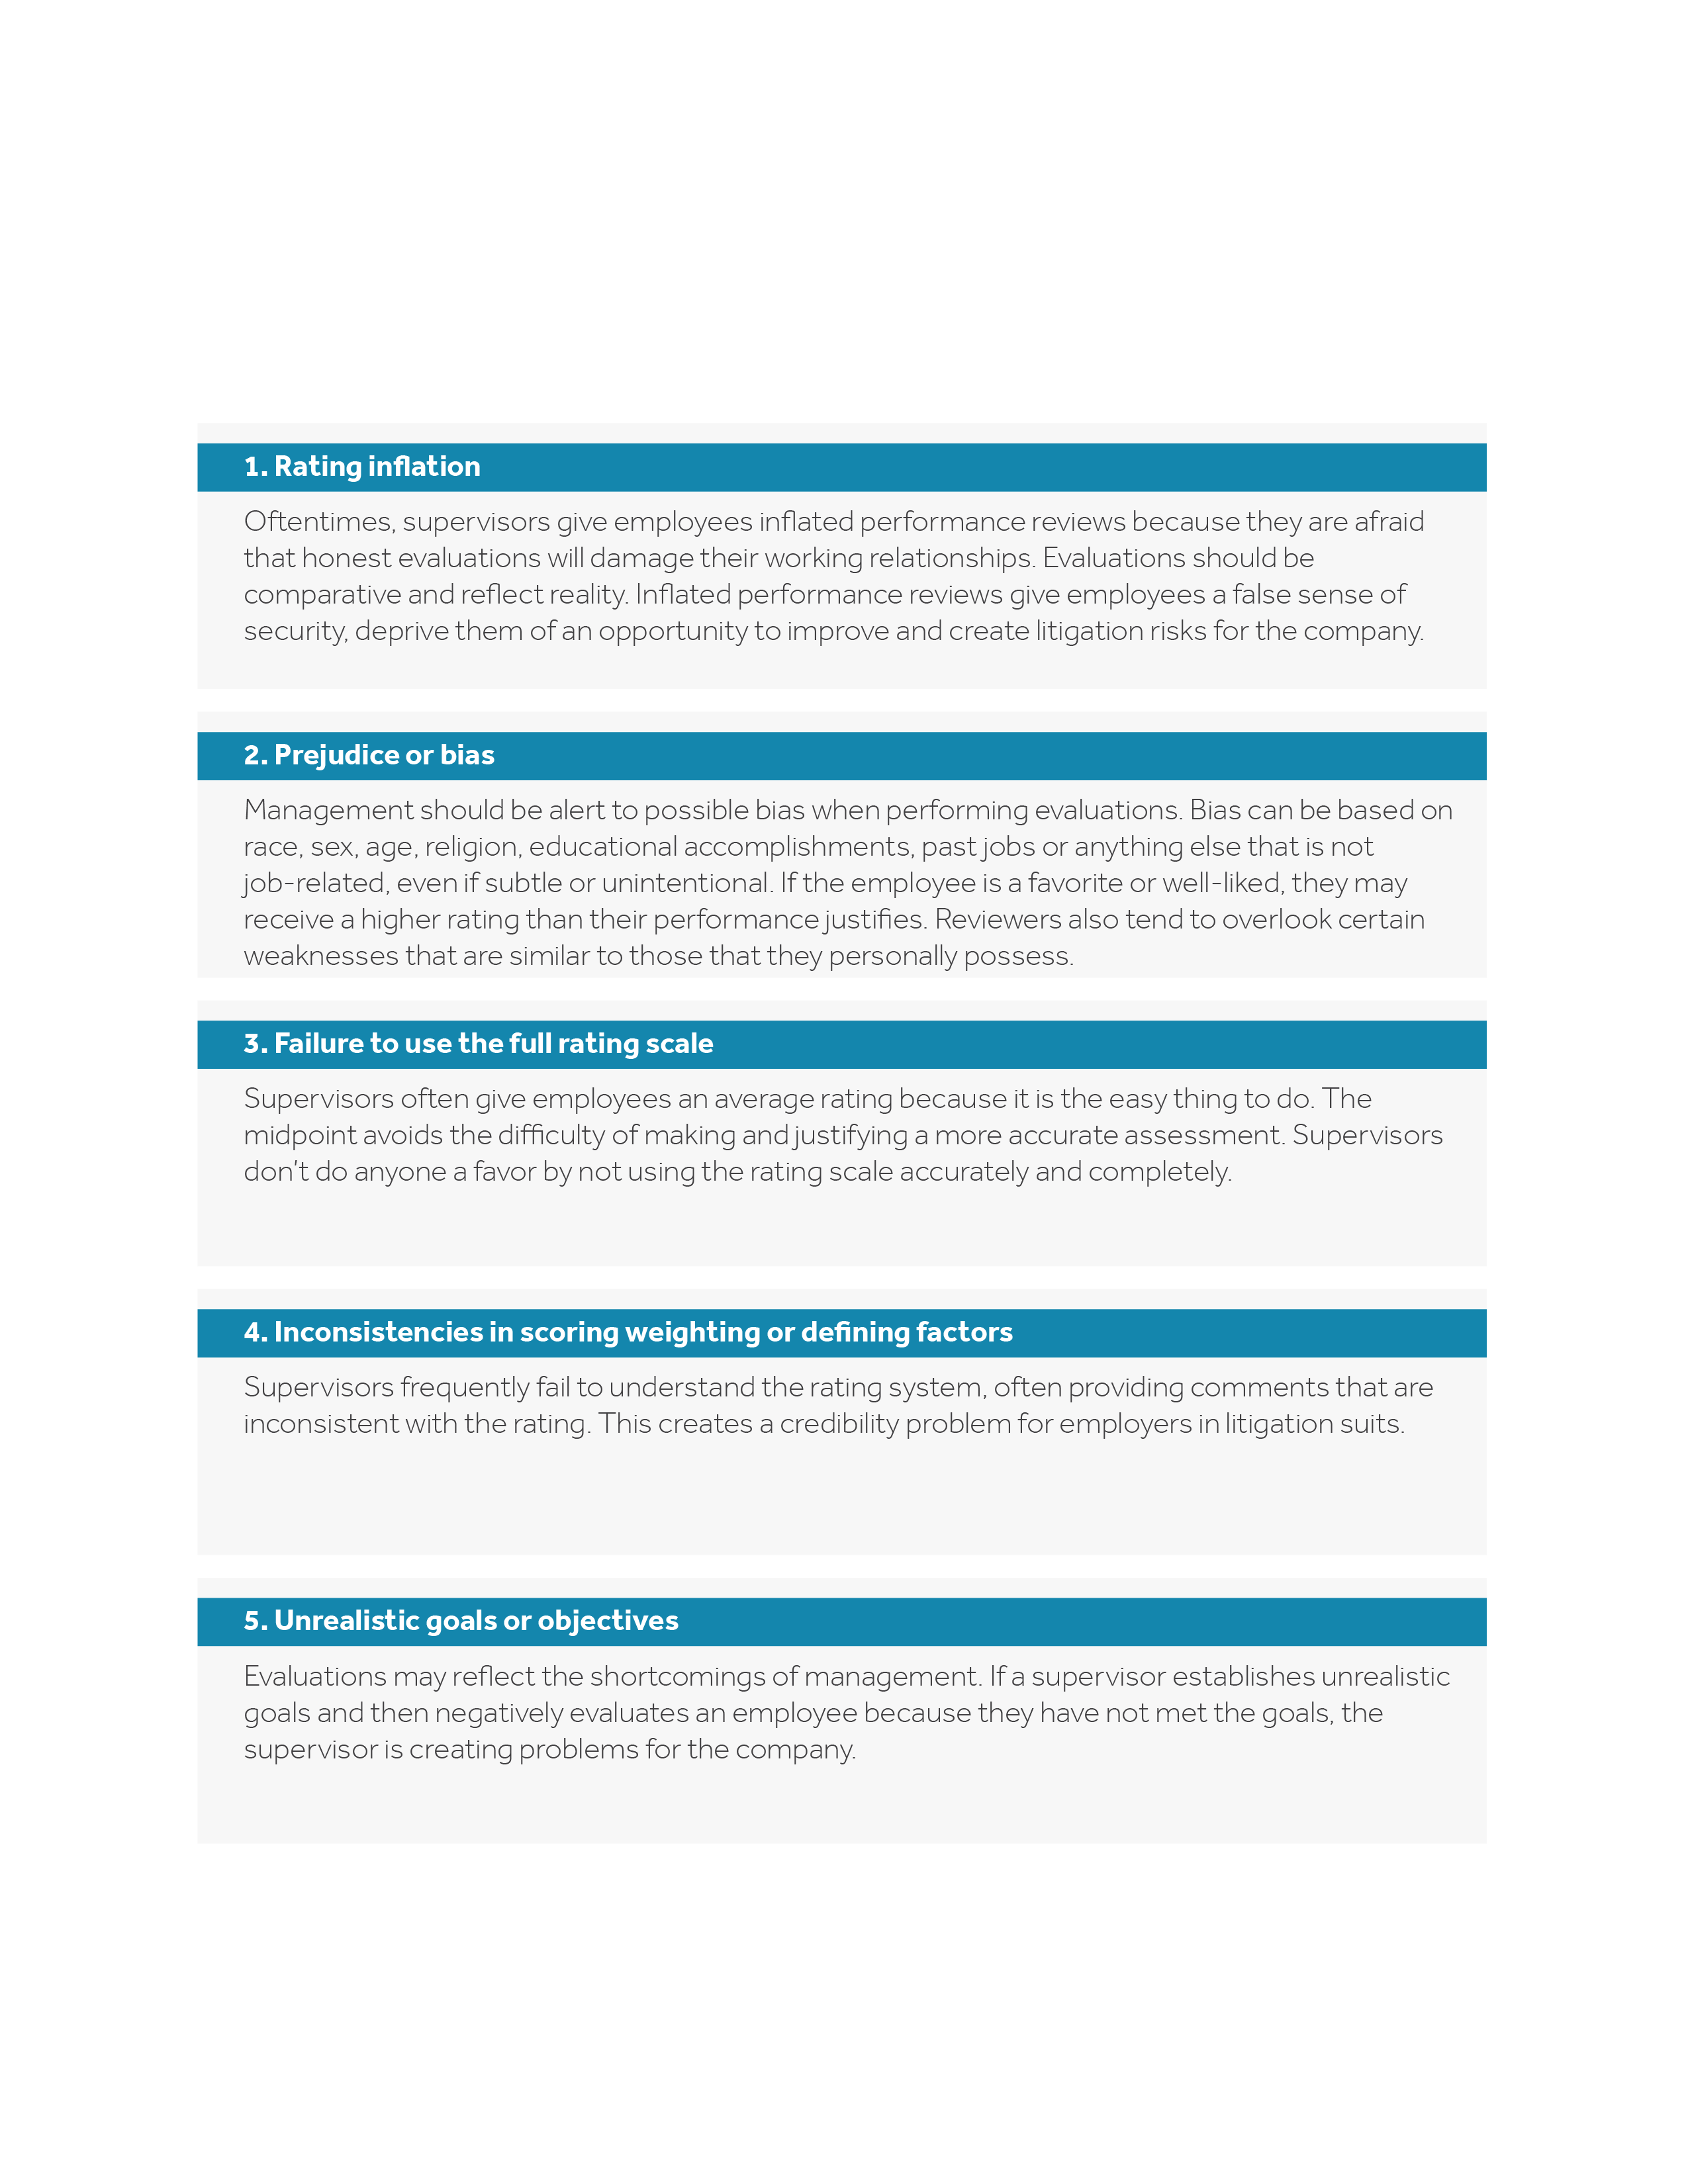
Avoid These Top Performance Review Mistakes
There are a variety of common issues that supervisors should be aware of when evaluating employees. Training supervisors properly is an essential step in avoiding lawsuits and other problems.

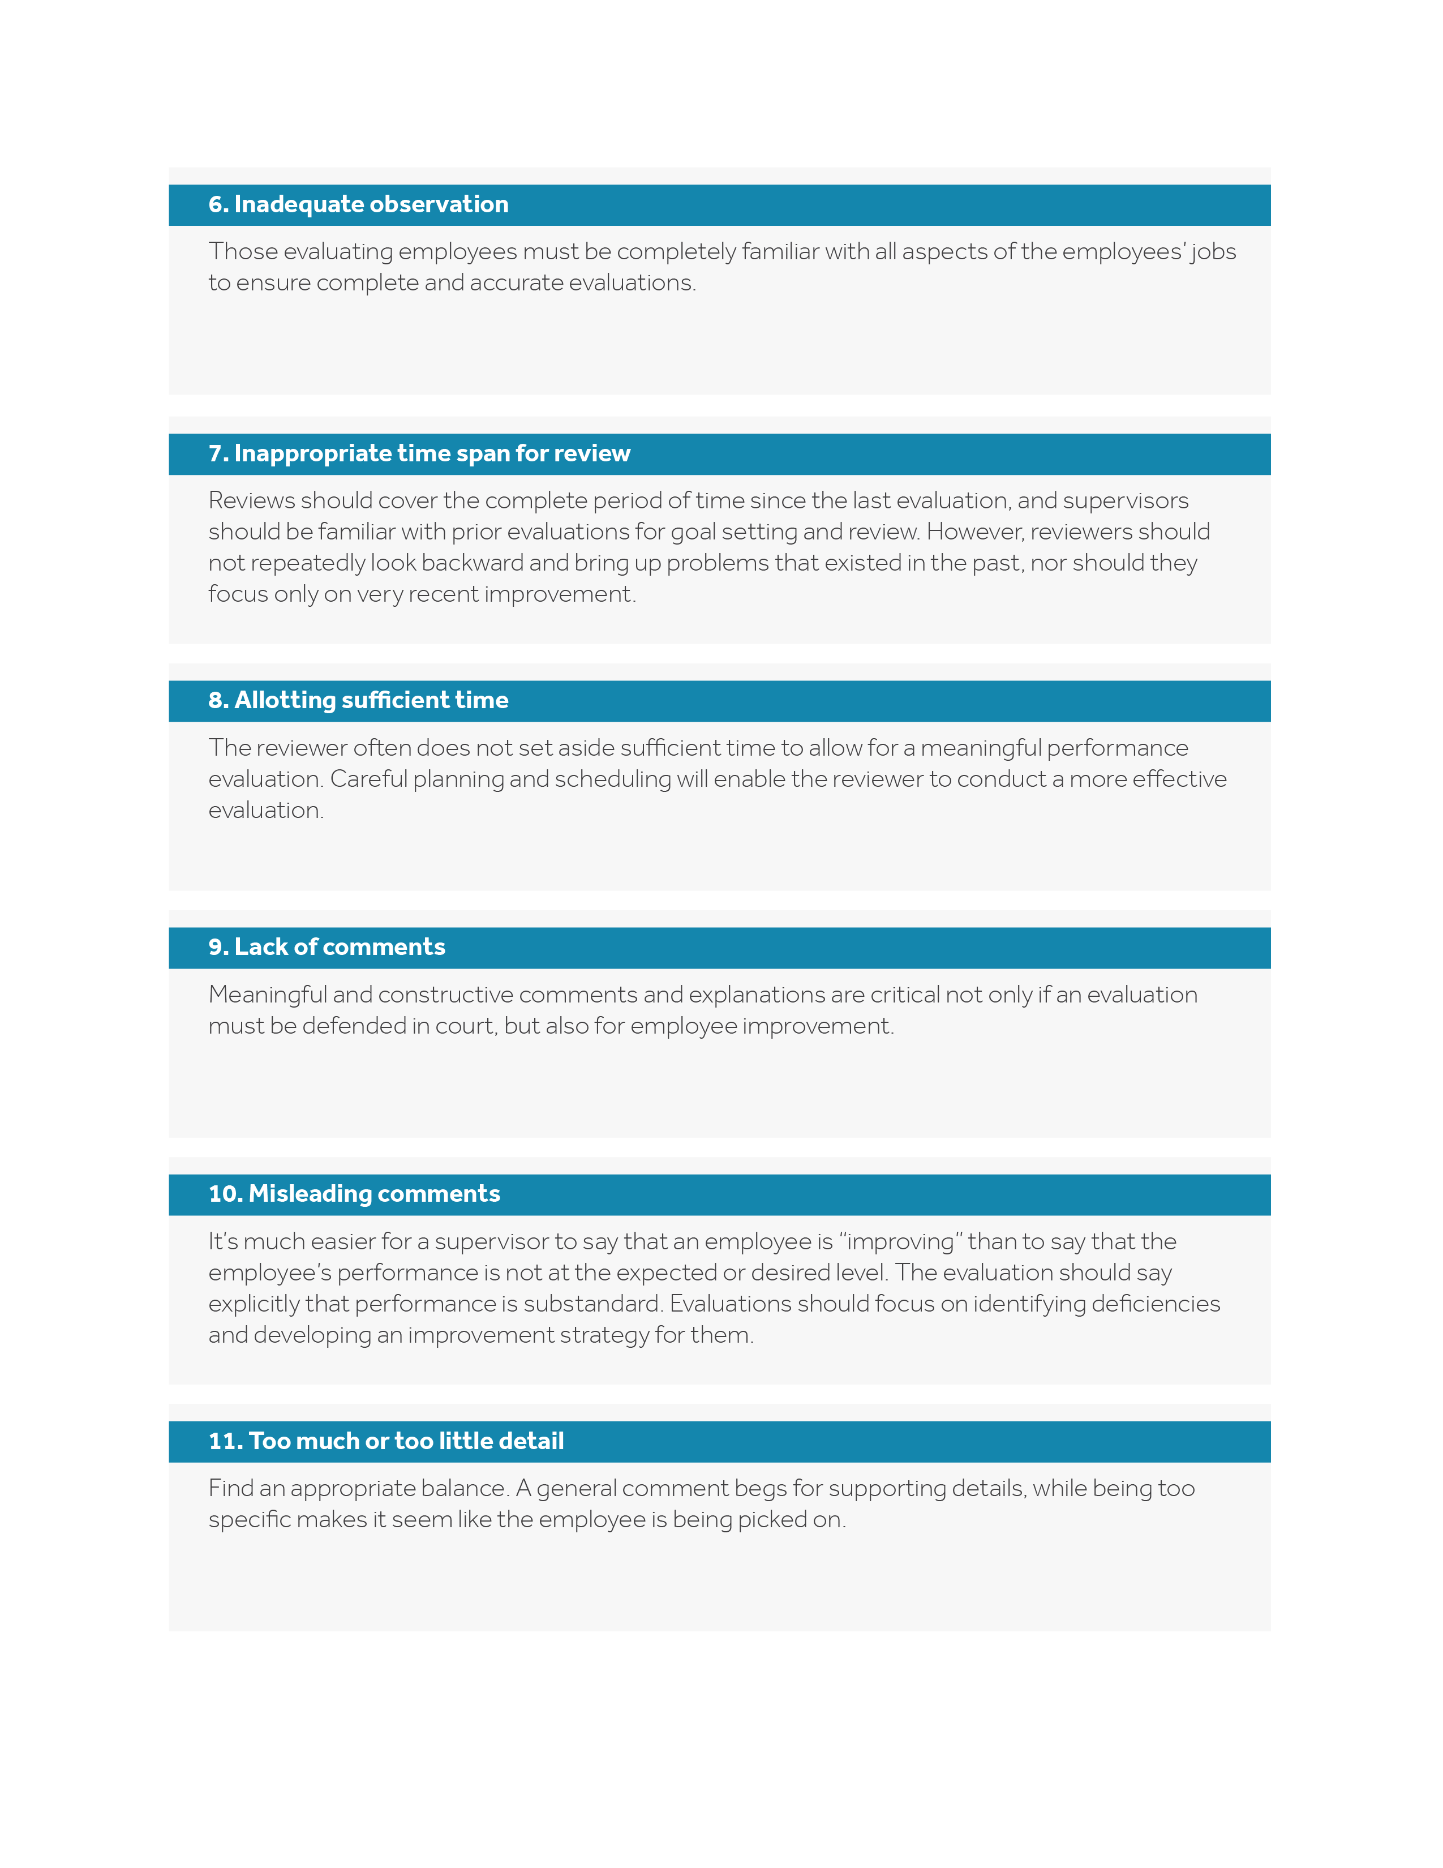

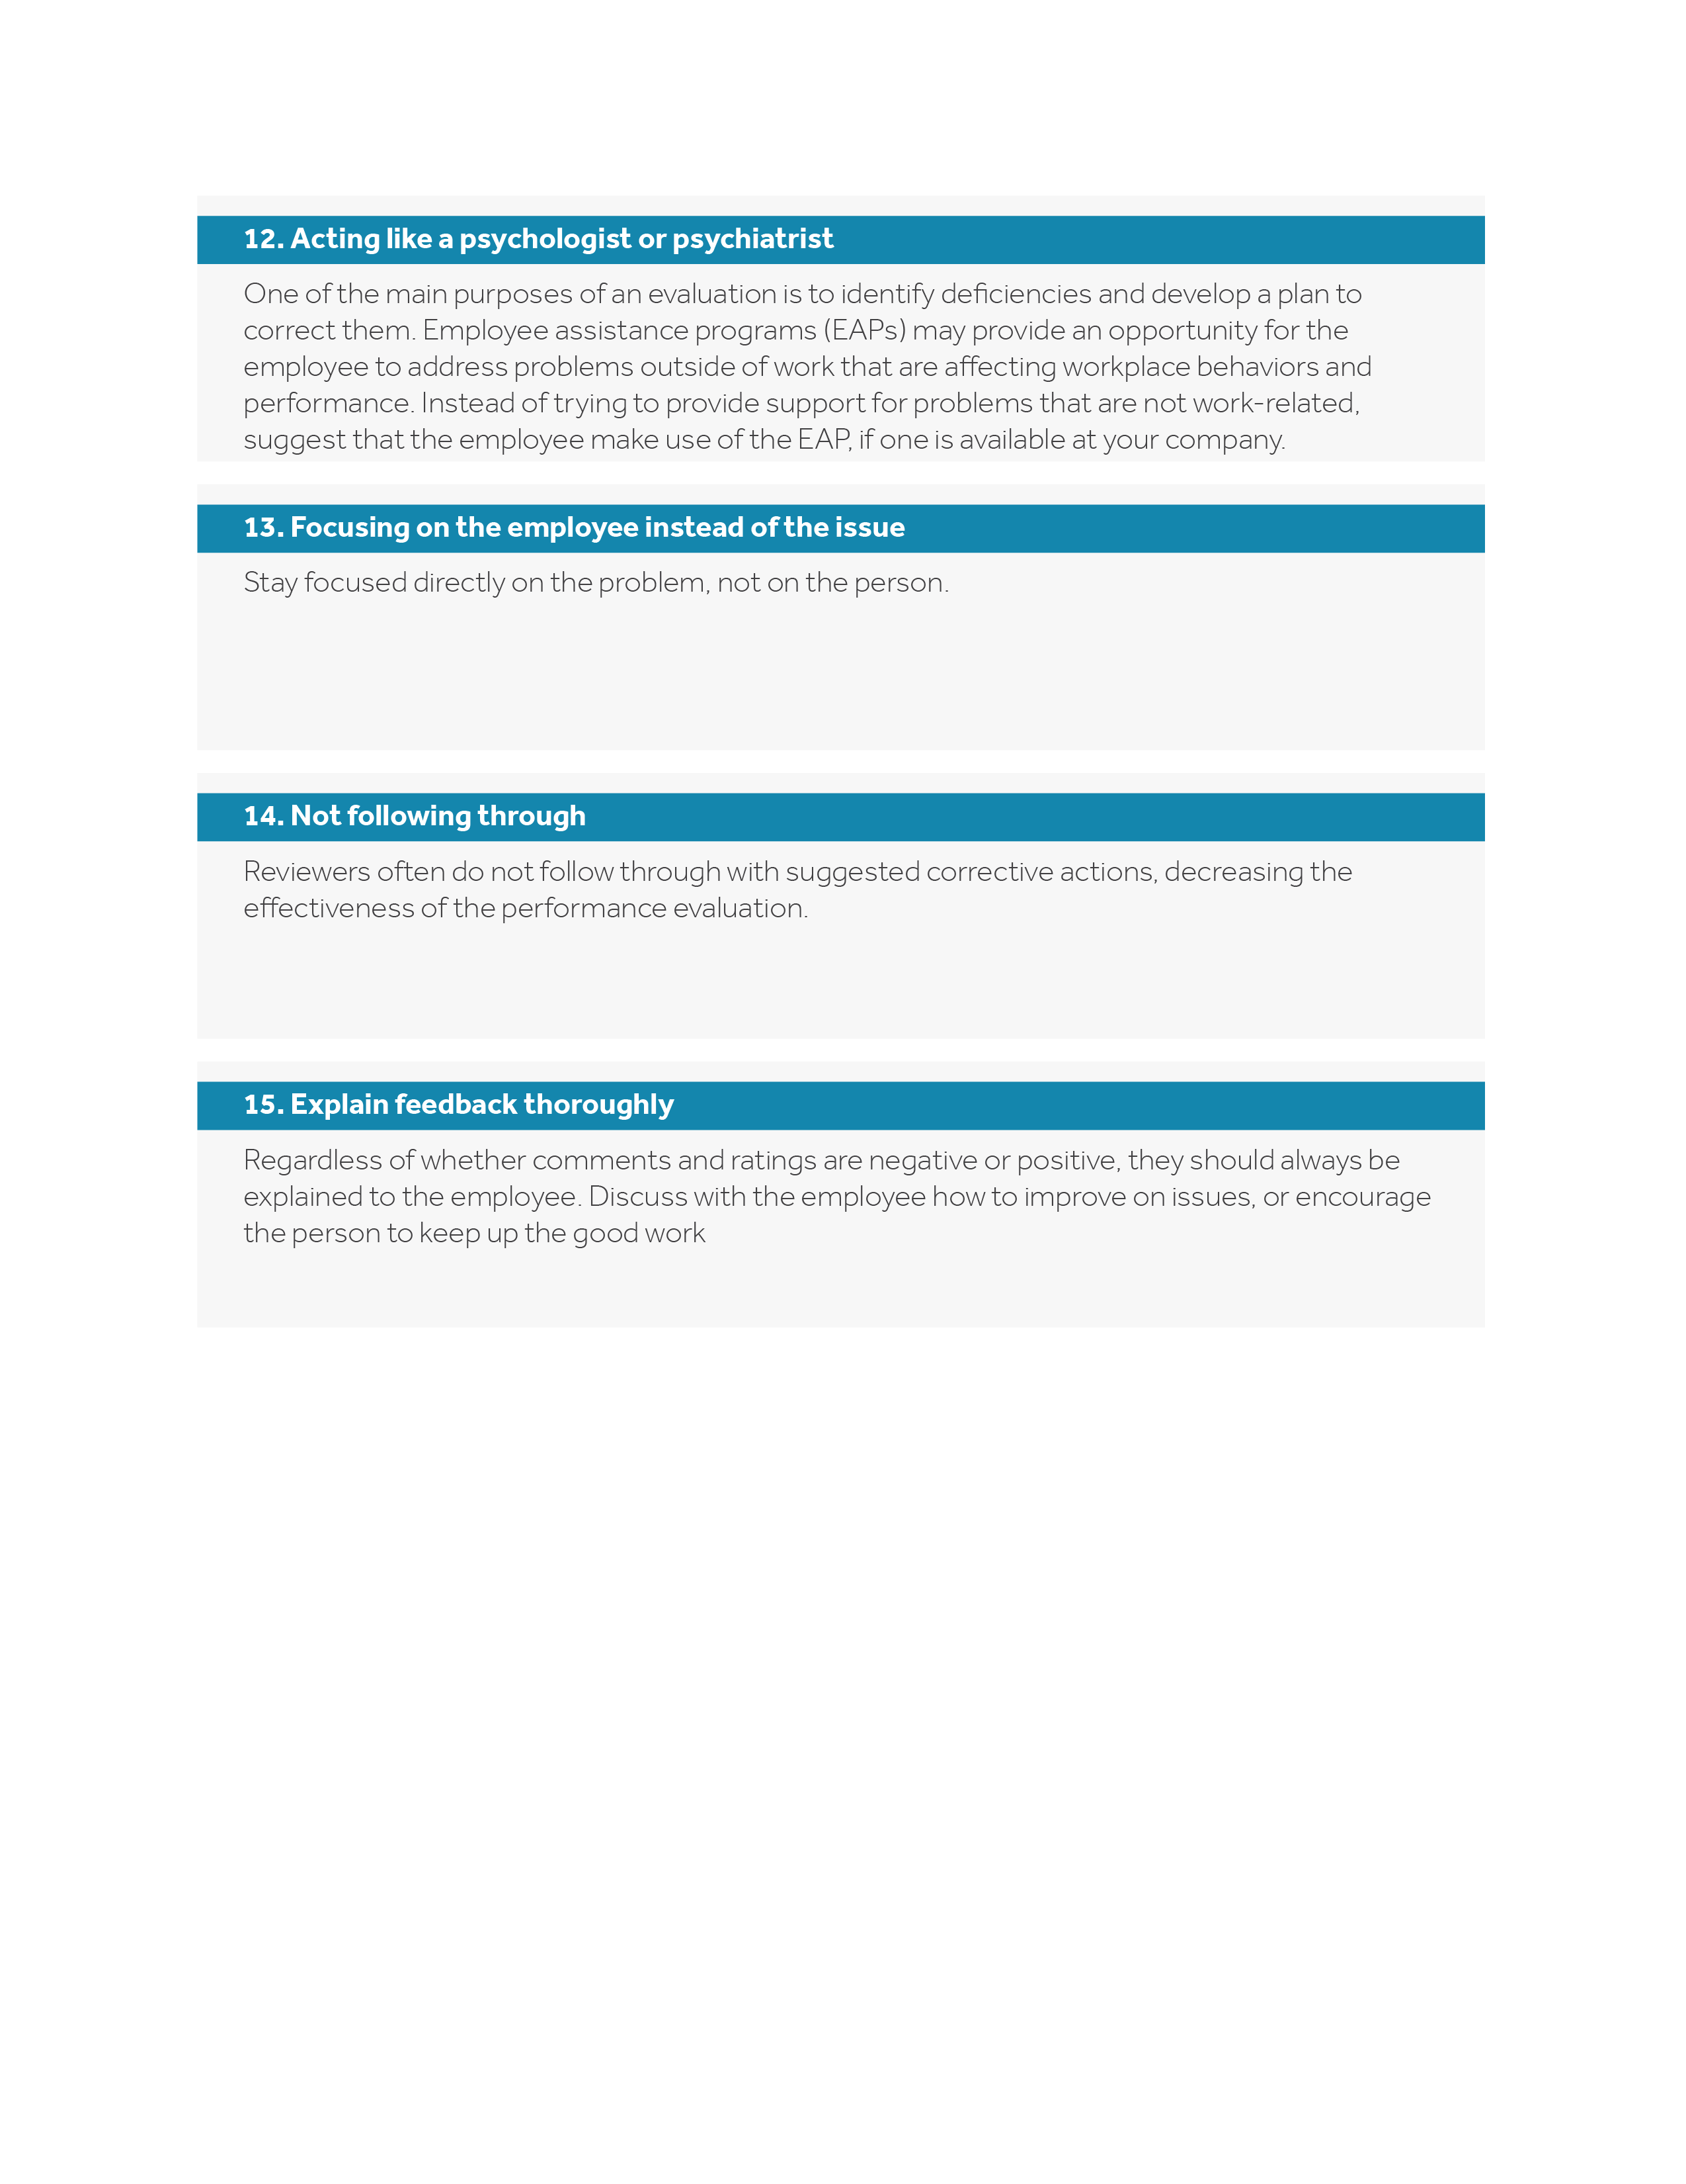

Appendix
This appendix is full of printable forms and resources to help you effectively conduct performance reviews. Only you know which process is right for your company and its employees. Keep this in mind when browsing the forms below as there are several options to choose from.

Printing Help
There are many printable resources in this appendix. Please follow the instructions below if you need help printing individual pages.
- Choose the “Print” option from the “File” menu.
- Under the “Settings” option, click on the arrow next to “Print All Pages” to access the drop-down menu. Select “Custom Print” and enter the page number range you would like to print, or enter the page number range you would like to print in the “Pages” box.
- Click “Print.” For more information, please visit the Microsoft Word printing support page.

Notice of Upcoming Performance Review
Dear [insert employee name],
We’ll be meeting on [insert date] to:
- Review your performance over the past [insert time frame].
- Discuss your strengths and areas of improvement.
- Brainstorm plans for enhancing your skills and potential with our company.
Your input is very important in this meeting. Please prepare for it by reviewing your performance standards and results, and bring them with you to the meeting.
During the meeting, we’ll discuss your performance on each of your review points, especially those we’ve targeted in the past for improvement. Please be ready to present your evaluation of your performance in each of these areas. I want to listen to your input, comments, problems, suggestions, etc.
We’ll go through each area in this manner, one at a time, and we’ll discuss our agreements and disagreements.
We’ll conclude the meeting with our ideas for the future. For example, what we can do to solve your problems, meet your needs and help you grow. I want to hear any of your ideas so that we can plan for the future together.
If you have any questions about our meeting or have any topics that you’d like to discuss, please see me in advance.
See you on [insert date], at [insert time]. I look forward to speaking with you.
Warm regards,
[Insert name]
[Insert title]

Performance Review Audit Form
You can use this form to assess the performance review process at your company. If you think it’s important to add one of the points below to your performance review policy, write down the name of the person you should speak to about making the change under “Coordinator” or make plans to pursue the matter on your own by filling in a deadline under “Investigate.” If you want to consider changing or eliminating one of your own policy points, but not right now, put an appropriate date to do so under “Future Action.”
 | OK for Now | Investigate (Deadline) |  | Coordinator | Future Action (Date)
Do you review all of your job descriptions and performance standards every year to make sure employees have the training, equipment and time to do the jobs for which they are being evaluated?

Do all performance reviews follow the schedule described in your employee handbook and company policy manual? If reviews have not taken place as planned, can you explain why?

Are supervisors familiar with the job duties and actual performance of the employees they are rating?

Do you clarify the differences between objective and subjective ratings, comments and goals, before supervisors even sit down to write a performance review?

Have you gone over the review form with an employee if they have a disability, to make sure they understand the process? Have you confirmed the time and date of the review to enable them to make special accommodations?

Do supervisors get up-to-date training at least once a year on how to evaluate performance?

Do you discuss with supervisors the danger of using performance reviews as a retaliatory weapon? Do you look for personal attacks and other clues when you evaluate the reviews they write?
Do you require supervisors to explain sudden drops in performance review ratings?

Do supervisors understand how a lowered performance rating can trigger a discrimination suit, and how to prevent it from happening?

Have you discussed with supervisors the type of statements made in a performance review that might be considered defamatory?

Do you have a system in place to make sure employees who do not meet standards are given goals to correct the deficiencies within a specified time period?

Do you give employees who challenge their reviews a hearing with a higher-level manager?

Do supervisors understand the confidential nature of performance reviews and know not to disclose the information therein except with those who have a need to know?

Is there an appeals process for employees who are not satisfied with their ratings?

Do you keep all employee performance reviews in a locked file, accessible only to those with a need to know?

Manager Post-review Checklist
- Discussed each goal or objective established for this employee.
- Explored areas of agreement and disagreement.
- Covered positive skills, traits, accomplishments and growth potential.
- Reinforced the employee’s accomplishments.
- Discussed the employee’s potential for growth.
- Covered areas where improvement is required, expected, demanded or desired.
- Gave the employee goals to correct any gaps within a specified time period.
- Made training and development recommendations.
- Discussed consequences for noncompliance, where applicable.
- Listened attentively to the employee.
- Communicated the main message clearly.
- Was completely honest with the employee.
- Stuck to performance issues, not personality issues.
- Filled out forms properly and promptly.
- Conducted progress reviews as promised.
- Received positive feedback from the employee.
- Understood the employee’s performance challenges better.
- Obtained accurate performance data from records and from careful observation of the employee when performing the job.
- Employee’s performance was reviewed against the performance of all individuals who have performed the same job.
- Made sure that one or two employee weaknesses did not influence the review of other factors.
- Avoided rating the employee “sympathetically.”
- Avoided letting evaluations of people with the same job title fall into a rigid or routine pattern.
- Stuck to the facts and referred only to the available records.
- Had the employee sign the review to acknowledge having read it, and gave them an opportunity to comment on it in writing.
- Overall rating was not drawn in haste or rushed by other factors.
- Set objectives for next performance review.
- Set a date and time for next evaluation.
- Thanked the employee for their efforts.

Employee Performance Evaluation Form – Rating Scale
Employee: _______________________________ Department: _________________________
Reviewed by: ____________________________ Date: _______________________________

Instructions: Review each employee according to the following scale. Written comments should explain the factual basis of the rating in each category, including the overall review.
5: Exceptional Employee far exceeds requirements and expectations.
4: Outstanding Employee regularly exceeds the requirements of the job.
3: Good Employee meets all job requirements and may exceed them at times.
2: Needs training Employee needs additional training or other development to meet
job requirements.
1: Inadequate Employee has consistently been unable to do the job.

Performance Category | Rating
Quantity of work: Meets deadlines and output expectations. _______

Quality of work: Produces acceptable output and results. _______

Job knowledge: Understands duties and has required skills. _______

Initiative: Begins and completes assignments on own. _______

Dependability: Reliably completes assignments and responsibilities. _______

Adaptability: Accepts and understands new methods and approaches. _______

Overall score: _______

Employee’s Comments:

_______________________________________________ _________________
Reviewer’s Signature Date

_______________________________________________ _________________
Employee’s Signature Date

Employee Performance Evaluation Form – Narrative
Name of employee: _________________________________ | Date: __________________

List most successful job accomplishments since last performance period:

List least successful job accomplishments since last performance period:

Based on the employee’s successes, what are their key strengths?

Based on the employee’s least successful efforts, what areas need improvement?

What actions will we take to improve performance?
Action Plan | By Whom | Review Dates (Specify) | Completion Dates
Overall Performance:
In arriving at your opinion of overall performance, review the summary statements above. Place an “X” in the box that most closely reflects your opinion of how the employee’s performance has met the requirements of the position.
- Far exceeds normal requirements
- Exceeds normal requirements
- Meets normal requirements
- Meets some requirements
- Fails to meet minimum requirements

_________________________________________________ __________________
Supervisor’s Signature Date

_________________________________________________ __________________
Employee’s Signature Date

Employee Self-evaluation
Employee name: ____________________________

Identify your essential job functions.

What areas of your job do you like the most?

What areas of your job do you like the least?

Please identify at least one change you would recommend based on what you like least about your job.

In this position, what do you feel you excel most at?

What do you feel is your weakest area in this position?

What performance accomplishments have you achieved since your last performance review?

Have you experienced any major disappointments in job performance since your last review? If yes, please explain.

What steps are you planning on taking to further improve your job performance before your next review?

On a scale of 1 to 5, how would you rate your overall performance? (Please check one box.)
- (1) Unsatisfactory: Major improvements needed.
- (2) Fair: Less than satisfactory, could be doing better.
- (3) Satisfactory: Performing duties as directed with minimal supervision.
- (4) Very good: Performing all duties in a cost-effective manner with positive, measurable results.
- (5) Excellent: Performing at a level above and beyond the duties of the current position’s requirements.

Manager’s Comments:

______________________________________________ ________________
Employee’s Signature Date

_________________________________________________ ________________
Manager’s Signature Date

360-review Feedback Request Form
You have been selected to provide feedback for the person identified below. Please use this form to provide feedback about the leadership behaviors that this person demonstrates on a regular basis. The recipient of this feedback will see only a summary of the results, not the actual feedback forms.

Name of feedback recipient: ____________________________
Name of evaluator (optional): ____________________________
Please return the completed form to: ____________________________ by _______________________

Relationship to feedback recipient (check one):
- Manager | - Peer | - Internal customer
- Direct report | - Below direct report

Instructions:
Please indicate the rating that corresponds to the degree to which you observe this person demonstrating the listed leadership behavior, according to the rating key at the top of each page. “N/O” should be used if you have not been in situations that would afford you the opportunity to observe the behavior.
At the end of each section, please provide comments and examples that support your ratings. If you need more space for comments, please attach an additional page. Please be sure to include examples for ratings below 3 or above 7. On the back panel, please answer questions 9 and 10 based on your experience and relationship with the feedback recipient.
If you have questions, please contact the manager of the feedback recipient.

Feedback Request for Leadership Behaviors
N/O = Not Observed 1 = Never 3 = Seldom 5 = Sometimes 7 = Most of the time 10 = Always

1. Inspires a Shared Vision
a) Provides direction around a vision | N/O | 1 | 2 | 3 | 4 | 5 | 6 | 7 | 8 | 9 | 10
b) Translates the corporate vision into actionable plans | N/O | 1 | 2 | 3 | 4 | 5 | 6 | 7 | 8 | 9 | 10
c) Creates enthusiasm about the future of your company | N/O | 1 | 2 | 3 | 4 | 5 | 6 | 7 | 8 | 9 | 10
d) Shows others how their long-term interests can be realized by enlisting in a common vision | N/O | 1 | 2 | 3 | 4 | 5 | 6 | 7 | 8 | 9 | 10
Note: Please provide examples for ratings below 3 and above 7.

2. Delivers Results
a) Makes appropriate decisions | N/O | 1 | 2 | 3 | 4 | 5 | 6 | 7 | 8 | 9 | 10
b) Acts after making a decision | N/O | 1 | 2 | 3 | 4 | 5 | 6 | 7 | 8 | 9 | 10
c) Takes risks | N/O | 1 | 2 | 3 | 4 | 5 | 6 | 7 | 8 | 9 | 10
d) Encourages others to take risks | N/O | 1 | 2 | 3 | 4 | 5 | 6 | 7 | 8 | 9 | 10
e) Supports the decisions of others | N/O | 1 | 2 | 3 | 4 | 5 | 6 | 7 | 8 | 9 | 10
Note: Please provide examples for ratings below 3 and above 7.

3. Focuses on the Customer
a) Anticipates customer needs | N/O | 1 | 2 | 3 | 4 | 5 | 6 | 7 | 8 | 9 | 10
b) Seeks customer feedback | N/O | 1 | 2 | 3 | 4 | 5 | 6 | 7 | 8 | 9 | 10
c) Responds to customer feedback | N/O | 1 | 2 | 3 | 4 | 5 | 6 | 7 | 8 | 9 | 10
d) Models customer focus in interactions with customers | N/O | 1 | 2 | 3 | 4 | 5 | 6 | 7 | 8 | 9 | 10
e) Helps remove barriers to excellent customer service | N/O | 1 | 2 | 3 | 4 | 5 | 6 | 7 | 8 | 9 | 10
Note: Please provide examples for ratings below 3 and above 7.

4. Challenges the Process
a) Pursues better ways to get things done | N/O | 1 | 2 | 3 | 4 | 5 | 6 | 7 | 8 | 9 | 10
b) Models breakthrough thinking | N/O | 1 | 2 | 3 | 4 | 5 | 6 | 7 | 8 | 9 | 10
c) Acts as a change agent | N/O | 1 | 2 | 3 | 4 | 5 | 6 | 7 | 8 | 9 | 10
d) Helps others manage through change | N/O | 1 | 2 | 3 | 4 | 5 | 6 | 7 | 8 | 9 | 10
Note: Please provide examples for ratings below 3 and above 7.

5. Values People
a) Shows respect for others and their ideas | N/O | 1 | 2 | 3 | 4 | 5 | 6 | 7 | 8 | 9 | 10
b) Encourages others' involvement in making things better | N/O | 1 | 2 | 3 | 4 | 5 | 6 | 7 | 8 | 9 | 10
c) Appreciates differences between people in thought and style | N/O | 1 | 2 | 3 | 4 | 5 | 6 | 7 | 8 | 9 | 10
d) Allows for flexibility in how work is accomplished | N/O | 1 | 2 | 3 | 4 | 5 | 6 | 7 | 8 | 9 | 10
e) Considers others' needs when making decisions | N/O | 1 | 2 | 3 | 4 | 5 | 6 | 7 | 8 | 9 | 10
Note: Please provide examples for ratings below 3 and above 7.

6. Develops Self and Others
a) Demonstrates personal growth and learning | N/O | 1 | 2 | 3 | 4 | 5 | 6 | 7 | 8 | 9 | 10
b) Encourages continuous growth and learning in others | N/O | 1 | 2 | 3 | 4 | 5 | 6 | 7 | 8 | 9 | 10
c) Acknowledges mistakes and learns from them | N/O | 1 | 2 | 3 | 4 | 5 | 6 | 7 | 8 | 9 | 10
d) Sets clear performance expectations in advance | N/O | 1 | 2 | 3 | 4 | 5 | 6 | 7 | 8 | 9 | 10
e) Shares positive performance feedback that is timely and direct | N/O | 1 | 2 | 3 | 4 | 5 | 6 | 7 | 8 | 9 | 10
f) Shares negative performance that is timely and direct | N/O | 1 | 2 | 3 | 4 | 5 | 6 | 7 | 8 | 9 | 10
g) Sends candid messages that are focused on the issue, not the person | N/O | 1 | 2 | 3 | 4 | 5 | 6 | 7 | 8 | 9 | 10
Note: Please provide examples for ratings below 3 and above 7.

7. Communicates with Candor
a) Communicates effectively and regularly | N/O | 1 | 2 | 3 | 4 | 5 | 6 | 7 | 8 | 9 | 10
b) Listens to what others have to say | N/O | 1 | 2 | 3 | 4 | 5 | 6 | 7 | 8 | 9 | 10
c) Shares opinions even when unpopular | N/O | 1 | 2 | 3 | 4 | 5 | 6 | 7 | 8 | 9 | 10
d) Expresses disagreement earlier than later | N/O | 1 | 2 | 3 | 4 | 5 | 6 | 7 | 8 | 9 | 10
e) Makes others feel safe in honestly expressing themselves | N/O | 1 | 2 | 3 | 4 | 5 | 6 | 7 | 8 | 9 | 10
Note: Please provide examples for ratings below 3 and above 7.

8. Acts in the Best Interest of the Company
a) Is visible, with positive presence | N/O | 1 | 2 | 3 | 4 | 5 | 6 | 7 | 8 | 9 | 10
b) Is highly ethical and professional | N/O | 1 | 2 | 3 | 4 | 5 | 6 | 7 | 8 | 9 | 10
c) Is an effective team member | N/O | 1 | 2 | 3 | 4 | 5 | 6 | 7 | 8 | 9 | 10
d) Instills effective team membership in others | N/O | 1 | 2 | 3 | 4 | 5 | 6 | 7 | 8 | 9 | 10
e) Models collaboration | N/O | 1 | 2 | 3 | 4 | 5 | 6 | 7 | 8 | 9 | 10
f) Gets involved in making things  better in the company and community | N/O | 1 | 2 | 3 | 4 | 5 | 6 | 7 | 8 | 9 | 10
Note: Please provide examples for ratings below 3 and above 7.

9. What 2-3 behaviors would you like to see this person do differently?

More of?

Less of?

10. What 2-3 behaviors would you like this person to continue?

Employee Performance Goal Sheet
Complete this form by writing down a goal and listing the action steps to achieve that goal. Fill in due dates for each action step.
Goal:
Action Steps | Due Date

Goal:
Action Steps | Due Date

Performance Review Walk-through
Set a calendar date and time in advance that is mutually convenient for both you and the employee, and that will allow enough time for each of you to prepare. A conference room is a good choice for privacy and no interruptions. Schedule enough time for discussion.
Preparation of Performance Review
- Focus on performance areas that are the most important.
- Prepare a potential development that can include training and special projects.
- Identify areas for concentration in setting goals for the next review period.
- Give the employee advance notice so that they can prepare for the discussion.
- Review mutually understood expectations with respect to job duties and standards.
- Observe job performance measured against these mutually understood expectations.
- Take notes and keep records so you don’t rely on memory.
- Avoid paying attention to some aspects of the job at the expense of others.
- Review the employee’s background, including skills, work experience and training.
Discussion of Performance
- Begin the discussion by creating a sincere, open and friendly atmosphere.
- Review the purpose of the discussion—mutual problem-solving and goal setting.
- Explain the agenda for the meeting.
- Discuss the employee’s primary responsibilities in the past year. (A written summary of responsibilities should have been provided to the employee.) Discuss how the employee’s responsibilities relate to overall team objectives.
- Discuss employee’s strengths and areas for growth in the performance categories.
- Discuss employee’s significant accomplishments from the past year.
- Discuss possible ways to improve performance.
- Discuss barriers to effective work performance and job satisfaction in the past year.
- Discuss employee’s goals and needs for the next review period.
- Discuss long-term career goals and what development needs to occur to achieve them.
- Discuss employee’s feedback and suggestions for supervisor.
- Discuss anything else the employee or supervisor would like to address.
- Complete review forms, as applicable.
The Follow-up
- Immediately record the plans made and points requiring follow-up.
- Provide a copy for the employee.
- Evaluate your own performance. What did I do well? What could I have done better? What could I have learned about the employee or myself?

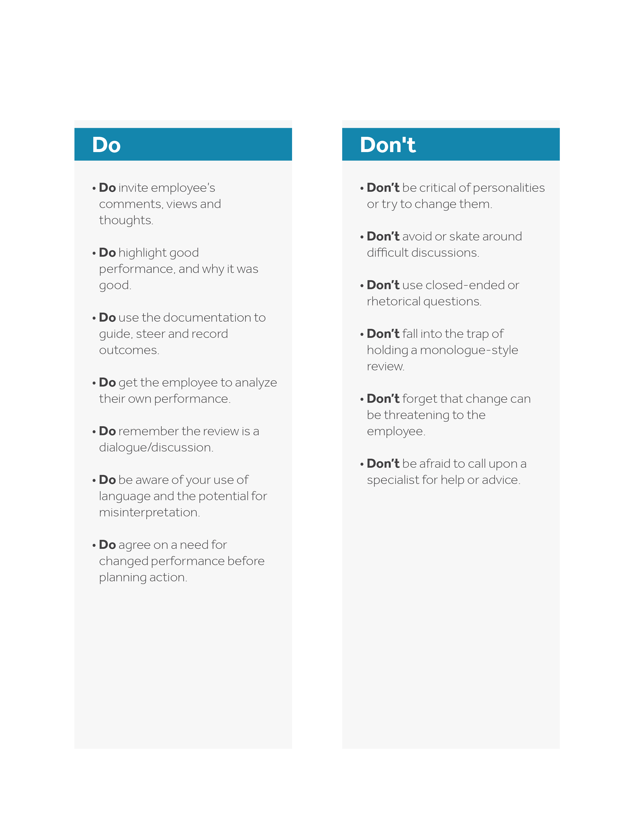
Reviewer Do’s and Don’ts

