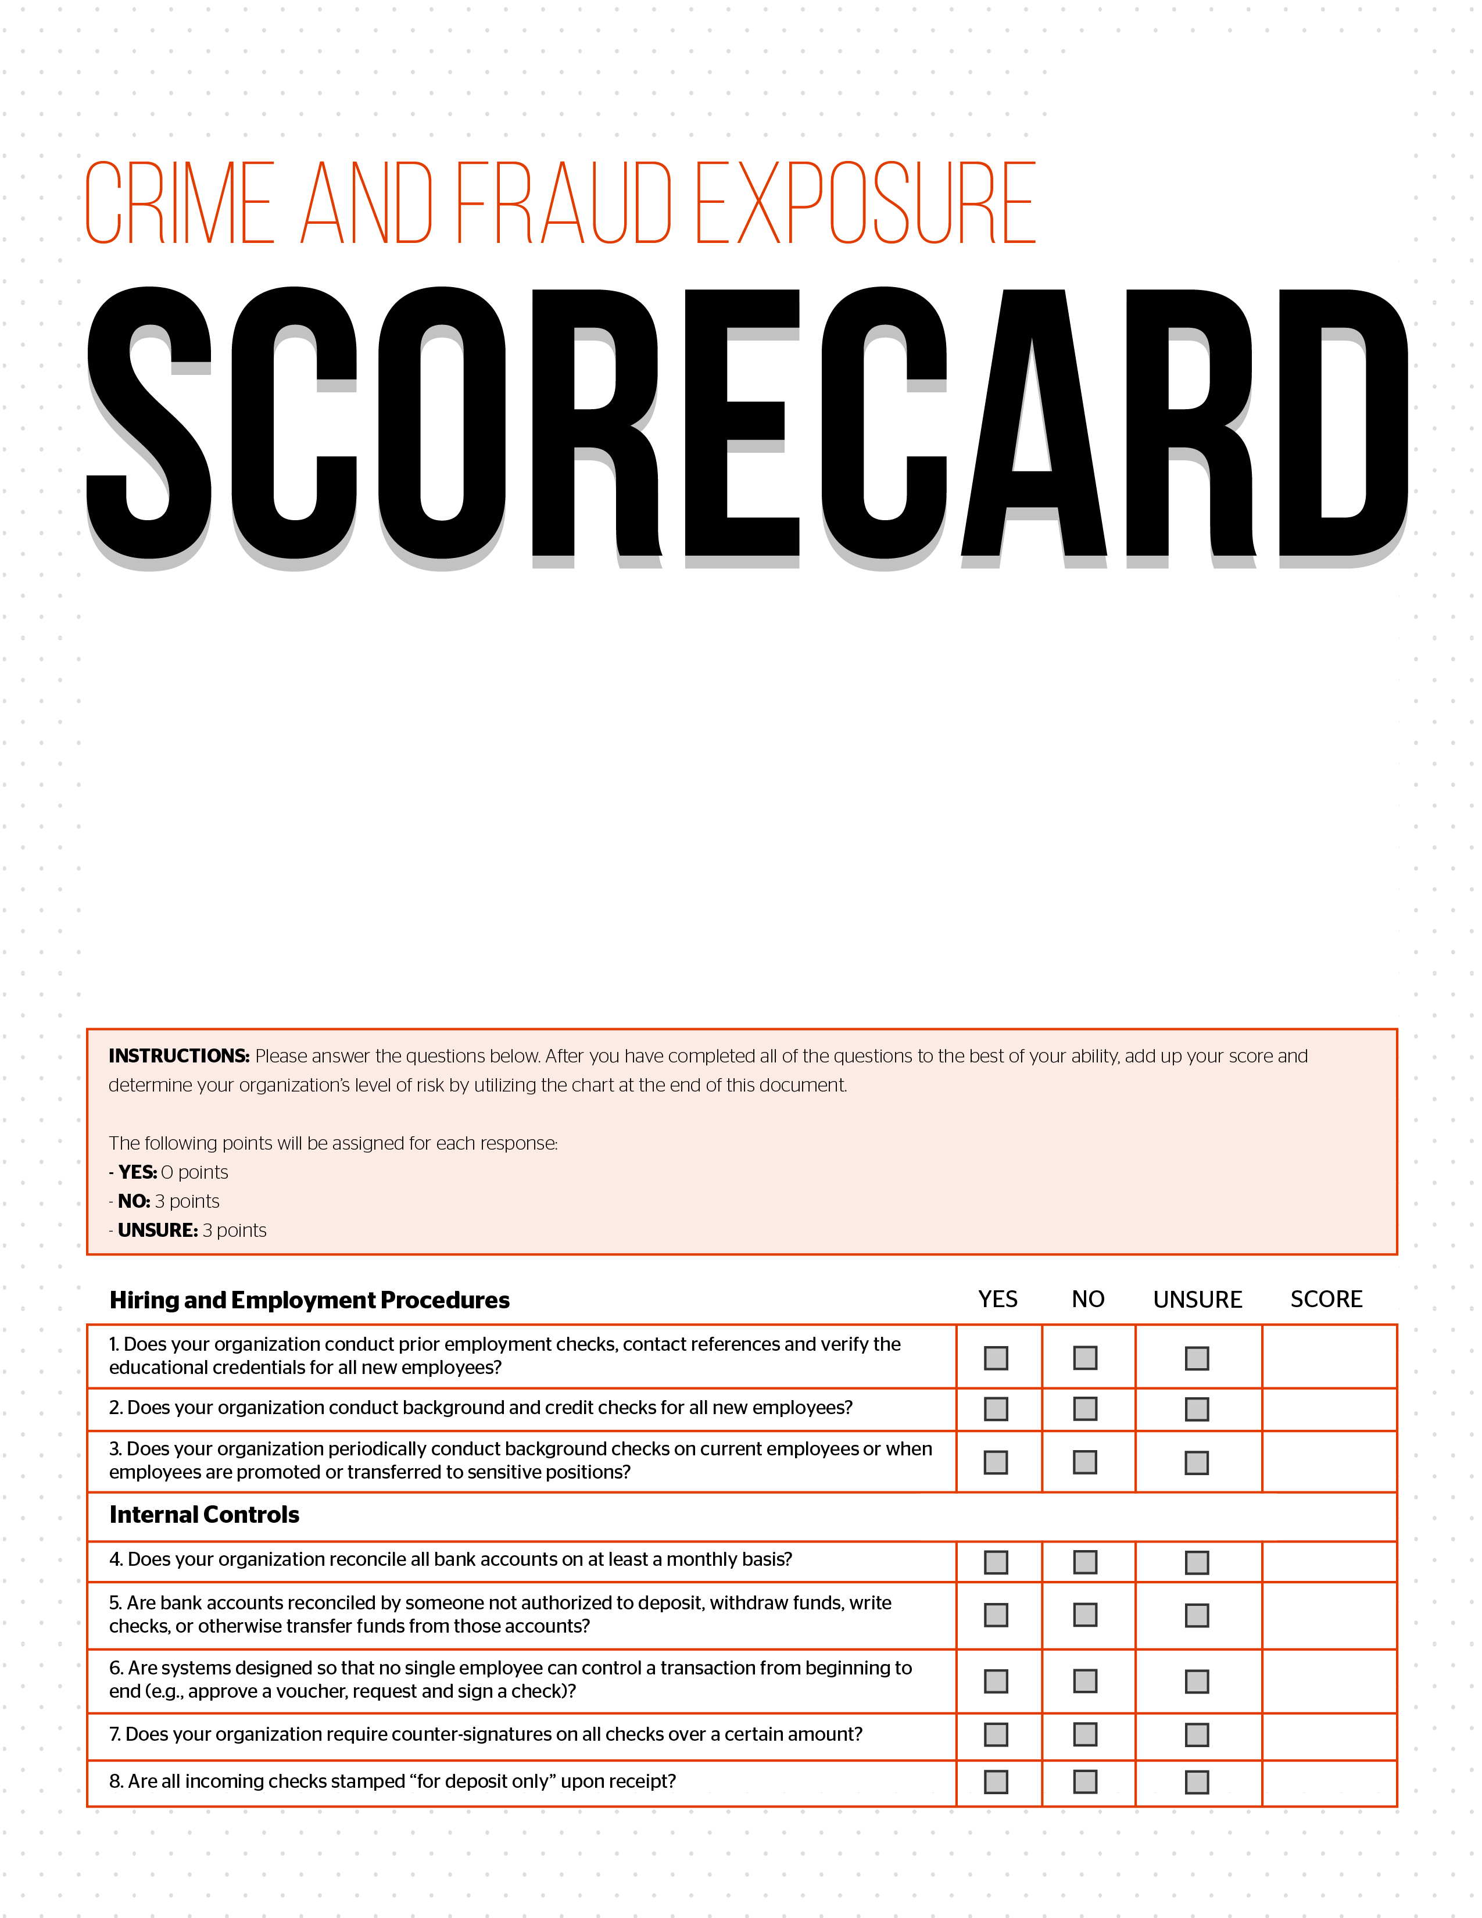
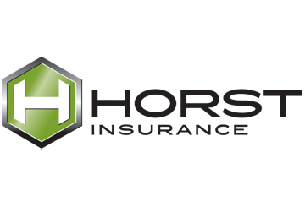
As a leader within your organization, you want to trust your employees and the people you do business with. However, the sad reality is that no organization is immune to the threat of crime and fraud. In fact, the Association of Certified Fraud Examiners estimates that organizations around the world lose approximately 5 percent of their annual revenue to illegal acts. Making matters worse, the average time before an organization discover that fraud has occurred is 18 months, long after the damage has been done.

Unfortunately, the need for crime insurance is often overlooked, with many organizations assuming that they have little to no risk at all. And, while maintaining strong internal controls should be a priority for any organization, crime insurance provides an important safeguard against the actions of dishonest individuals.

With crime insurance, organizations can protect themselves against financial loss arising out of dishonest and fraudulent acts committed by their employees as well as the actions of non-employees.

To help organizations understand the level of risk they face on a daily basis, Horst Insurance has developed the Crime and Fraud Exposure Scorecard.

