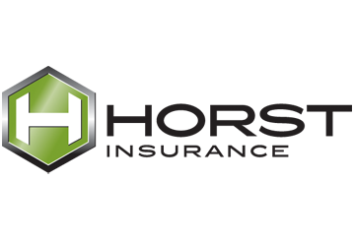

**Provided by: Horst Insurance**

320 Granite Run Drive, P.O. Box 3320

Lancaster, PA 17604-3320

Tel: (800) 533-2011