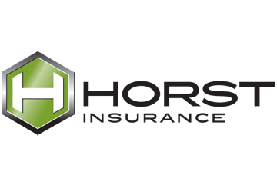

Provided by: Horst Insurance
320 Granite Run Drive, P.O. Box 3320
Lancaster, PA 17604-3320
Tel: (800) 533-2011

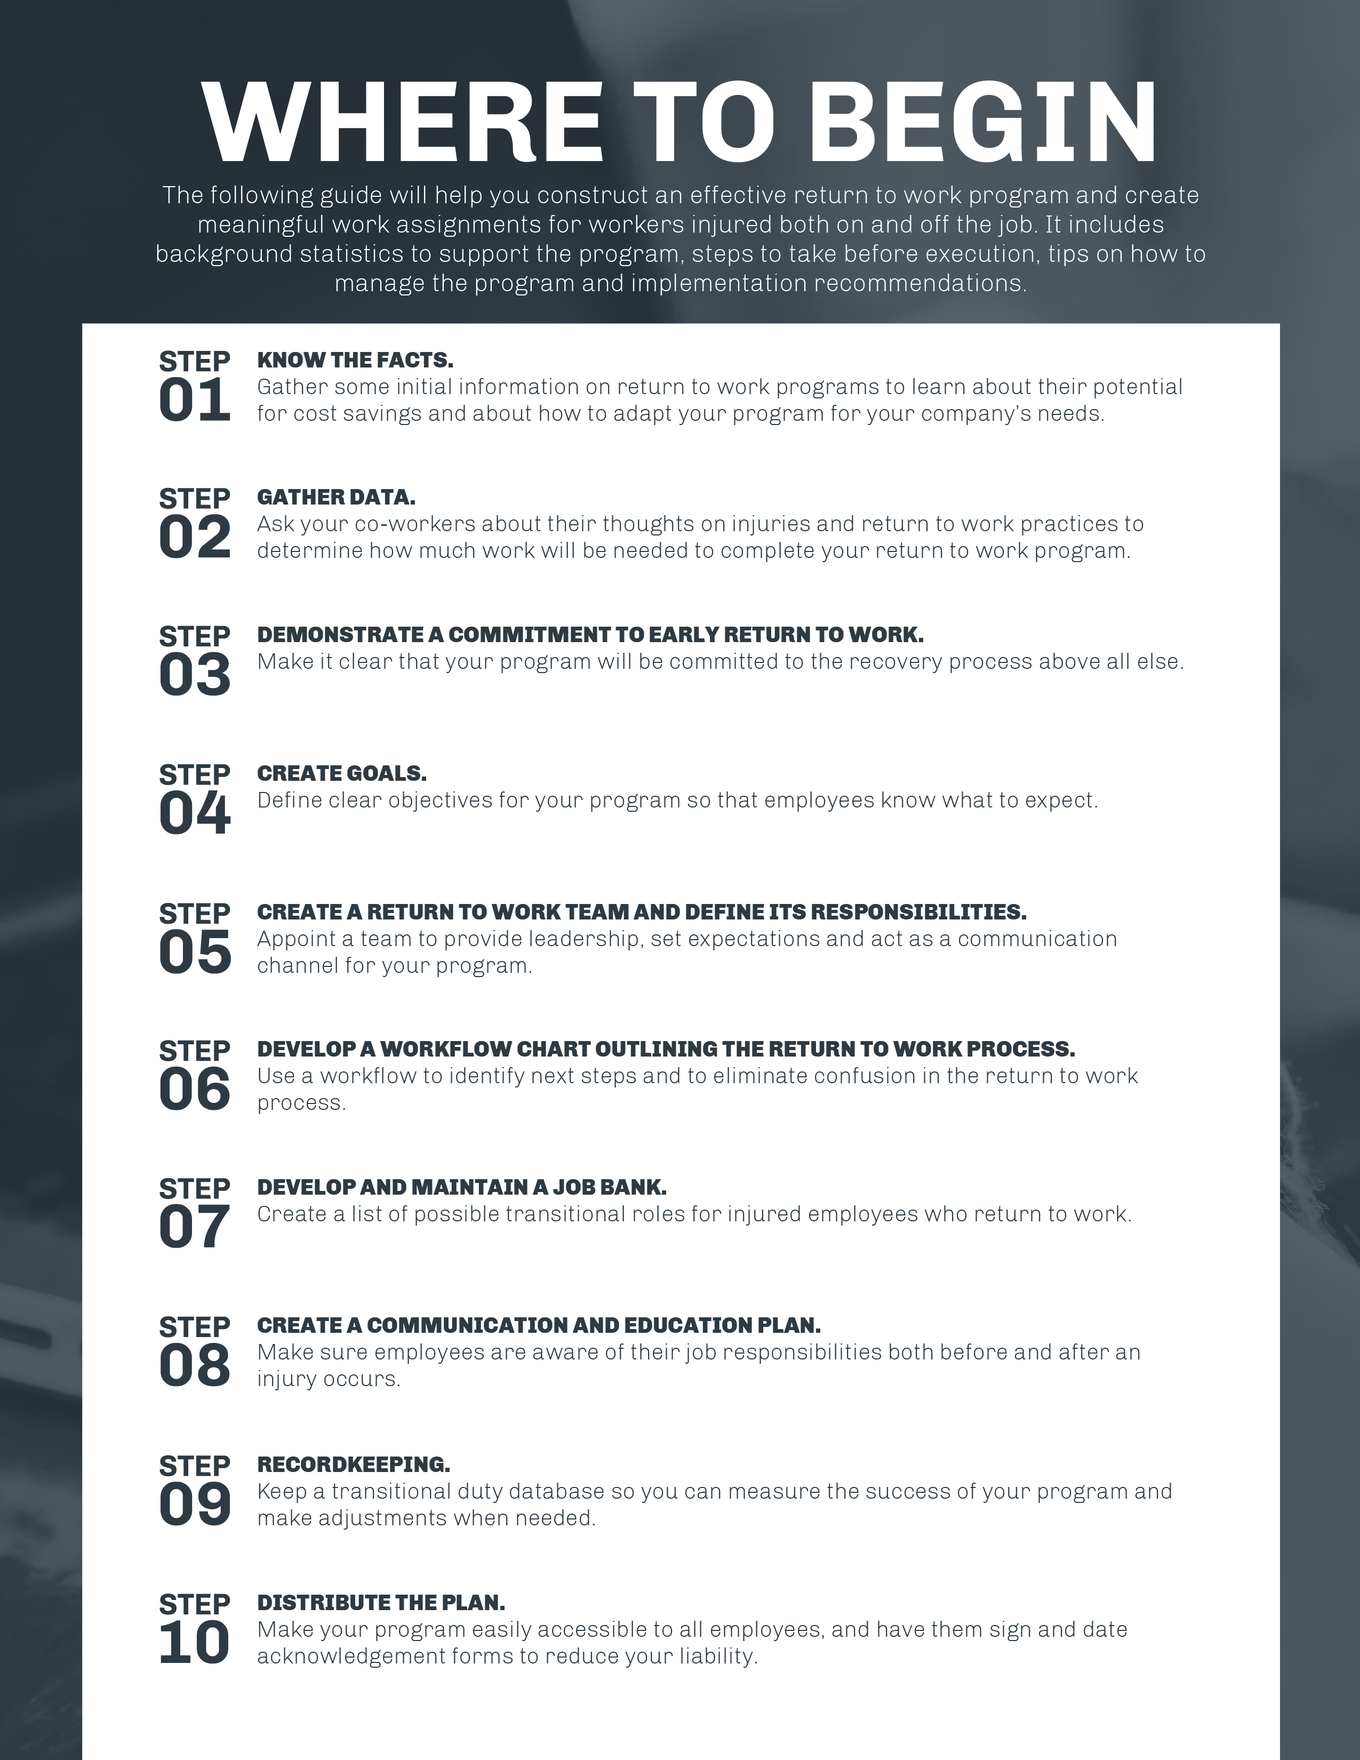

Supporting your return to work program with evidence that it will help save ABC_Client money is the best way to convince upper management to get on board. Obviously, injured employees drive up company costs in the form of lost work days and workers’ compensation costs. Studies clearly demonstrate that employees who are off work because of injury for more than 16 weeks rarely return to the workforce, and companies get stuck paying hundreds of thousands of dollars each year in unnecessary costs.
Before you institute a return to work program, research your company culture to understand what your employees think about injuries and returning to work. That way, after you create an official return to work program, it will be easier to evaluate and determine whether there has been a positive reaction. Get to know your company culture at all levels and from a range of perspectives. Visit worksites and talk to employees to understand how your current return to work program—or lack thereof—functions. Develop a needs assessment to determine how much work you need to do to shift company culture and practice.
Make sure all levels of employees recognize that early return to work after an injury speeds up the recovery process and reduces the likelihood of permanent disability. Everyone from upper management to hourly employees should understand the goals, purpose and background on the program. There is no reason to take time to enact a program if management does not support and recognize the need.
These elements are the foundation and support for your return to work program. Spend plenty of time on these steps before moving on to create your program.

RETURN TO WORK PROGRAM ELEMENTS
Steps 4 through 7 of this guide will go straight into your written return to work program, as they are the elements that will help you take action and establish a plan.
State ABC_Client’s purpose in creating the program and emphasize management’s commitment to making it work. Keep it positive, but be sure employees understand the return to work program is a serious initiative. This statement is also the place in your written program to define what type of duty you offer or require—your program can revolve around transitional duty, alternate duty or both.
Example Goal Statement: ABC_Client’s return to work program is in place to accommodate injured workers by identifying new duties or modifying jobs to meet their physical capacities and respect doctors’ restrictions. The goal is to return our employees to productive work, regular schedule and full wages as soon as possible, as they are the essential livelihood of ABC_Client. Because our employees are so valuable, we have both a transitional duty program, which is designed as a therapeutic tool to accelerate return to work by addressing physical and emotional limitations, and an alternate duty program, which is a placement service for workers deemed unable to perform the functions of their pre-injury job by a medical professional.
A dedicated return to work team is crucial to the program’s success because it provides leadership, sets expectations for injured employees, acts as a communication channel between all involved parties and ensures the return to work program is being administered correctly. This team should consist of a representative from each of the following areas, and you may want to include these role descriptions directly in your written program:
- Senior management—Ensures implementation, and promotes and supports the program
- Vocational rehabilitation specialist—Serves as an expert on physical and psychosocial aspects of disability, can testify in court as a vocational expert, understands job analysis and physical capacities forms, and supervises return to work program administration
- Workers’ compensation professional (either an in-house representative or someone from your insurance company or third-party administrator)—Provides medical information, problem-solving skills and general support
- Supervisor—Directly supports the injured worker’s return to work by giving out the modified assignments, facilitating communication and ensuring the employee does not exceed the assigned physical restrictions
- Labor union—Promotes ABC_Client’s return to work program to union membership, advocates for employees and assists in planning for specific employees when requested
- Panel physician—Prepares a medical treatment plan that is safe, promotes early return to work and keeps ABC_Client’s program in mind
- HR department—Coordinates with the return to work program manager on employee benefits, wages, family medical leave and workers’ compensation issues
The return to work team should also be responsible for creating and maintaining a transitional duty job bank, which is discussed in greater detail in step 6.
A crucial part of the return to work program is the process and steps involved in administration. An effective workflow chart will eliminate confusion about the program, identify proper actions for all levels of employees and serve as your action plan. Contact Horst Insurance today at (800) 533-2011 to request a sample flowchart—“Return to Work Roles and Responsibilities Flowchart”—to use with your return to work program.

The return to work program manager should be the owner of the job bank. This job bank can be as formal or informal as necessary, but it is essentially a laundry list of tasks or assignments across all departments that ideally should get done but often get overlooked because of lack of staff, time or funds. However, the return to work program manager should meet with supervisors and managers to identify adequate transitional tasks. The manager can also encourage all employees to submit ideas for transitional duty tasks. The tasks in the job bank can, and should, vary by the levels of physical strain required to complete them. It might be helpful to organize the job bank both by work location and by physical demand level to find the most appropriate task for an injured employee.
Keep in mind that while the safety of the employee is the most important aspect of a return to work program, it is also essential that the transitional tasks are productive. Make every effort to keep work hours and days off consistent with the injured employee’s work schedule, but also make sure he or she is aware that transitional tasks may require an altered schedule. If the transitional duties in the job bank require considerably less skill than the employee’s pre-injury position, consider paying less than a full-duty rate if your state laws allow. You will pay less in payroll taxes and, at the same time, you will motivate the worker to return to full duty.
To make your return to work program a success, you should have full cooperation with all parties involved. This includes the injured worker, his or her supervisor, union officials, medical providers and workers’ compensation professionals. If any of these parties are not fully committed to the program, your success will be limited.
Here are some important steps to maximize the program’s communication efforts:
- Provide written program descriptions and definitions and make these items readily available, accessible and readable.
- Keep job descriptions and job analyses on file for each employee in case he or she ever becomes injured.
- Review the return to work program with employees during new hire orientation and periodically throughout the year.
- Provide one-on-one sessions with injured employees to reiterate expectations and assign transitional tasks.

FINAL STEPS
The last step in implementing a return to work program is to include a way to measure your progress. Step 9 will offer suggestions on how you can manage your return to work program.
Put simply, the best way to measure the success of your program is to collect return to work data. Financial savings may be difficult to quantify, but one thing you can do is track the money you save on an individual basis for each injured employee who goes on transitional duty. Also, it will be helpful to keep a transitional duty database. This database should be used to monitor the following:
- The number of employees assigned to transitional duty
- The average duration of transitional duty assignments
- The number of employees filing new claims each month who are placed in transitional duty
- All receipts of work release to transitional duty assignments from a medical professional
After you create your written return to work program using these guidelines, distribute it to employees at every level. In addition to all of the steps included in this guide, be sure to include the following in the return to work program that you distribute:
- Your return to work policy, which should have a section to be signed and dated. Once signed, this policy should be returned to HR and filed for each employee.
- The return to work flowchart
- Other relevant material that may be helpful to employees experiencing work-related injuries or illnesses, including workers’ compensation information
You might also consider holding a meeting to build support for the program and allow employees to ask questions. Revisit the return to work program annually to evaluate the written procedures and policies and analyze the program’s success.
If you have further questions about writing or implementing your return to work program, contact the team of experts at Horst Insurance.

This guide is merely a guideline. It is not meant to be exhaustive nor be construed as legal advice. It does not address all potential compliance issues with Federal, State, local OSHA or any other regulatory agency standards. Consult your licensed Commercial Property and Casualty representative at Horst Insurance or legal counsel to address possible compliance requirements.

