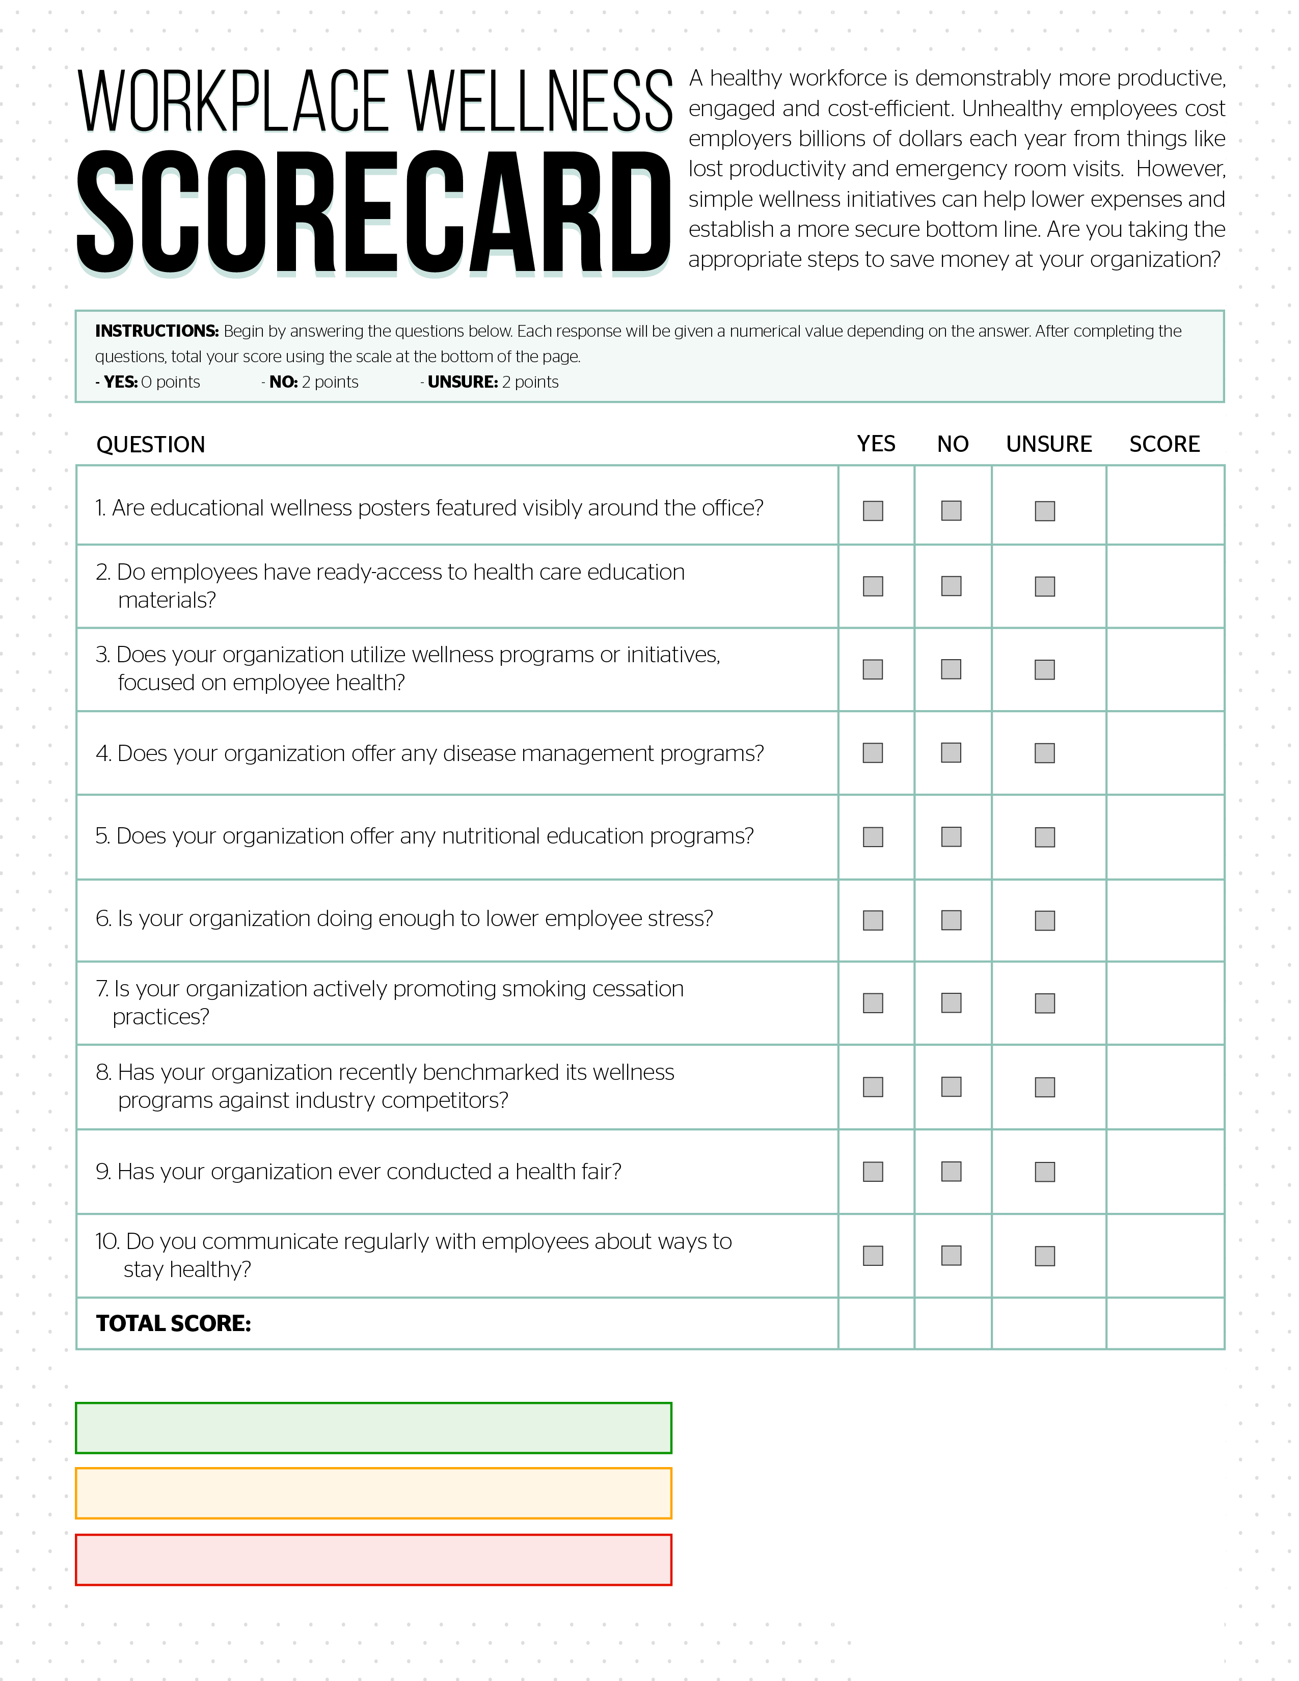
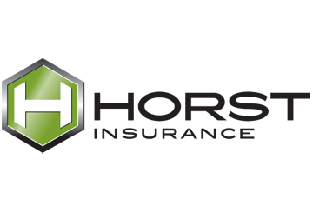
Low risk. Contact Horst Insurance to confirm: 0-6

Moderate risk. Contact Horst Insurance today: 7-13

High risk. Contact Horst Insurance today: 14-20

