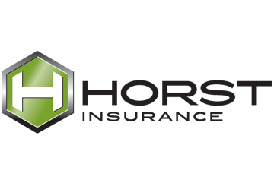
Provided by: Horst Insurance
320 Granite Run Drive, P.O. Box 3320
Lancaster, PA 17604-3320
Tel: (800) 533-2011
Follow these directions to help avoid serious injury:
- Always follow all safety rules and protocols associated with a task.
- Always wear the proper personal protective equipment (PPE).
- Don’t try to lift or lower more than is specified by protocol or procedure.
- If a task calls for two people, don’t try to do it yourself.
- When bending down, bend at the knees, not the waist.
- Always use appropriate lifts, hoists, conveyors, pallets and other equipment to assist in lifting and lowering tasks. If any equipment is broken or malfunctioning, inform your supervisor immediately.
- Avoid bending and twisting at the same time, when possible.
- When lifting, hold the item or load as closely to your body as possible.
- If you have questions about a task, ask your supervisor.
If you do get injured on the job or feel pain associated with a task such as back, joint or wrist pain, inform your supervisor immediately. ABC_Company is committed to a safe and injury-free workplace.
Lifting and lowering tasks can cause
serious injury if not performed properly.

