


Provided by Horst Insurance
Table of Contents
Introduction 3
Types of Insurance Plans 3
In-network vs. Out-of-network Care 5
The Basics 5
Billing and Claim Differences 5
Health Care and Health Insurance Terminology 6
Definitions 6
Acronyms 7
Health Spending Accounts 8
Shopping Tips 8
The Importance of Preventive Care 10
For More Information 10

Introduction
It’s no secret that the price of health care in the United States has increased over the past several decades. While there is no single reason for the explosion in health care prices, there are a few surprising contributing factors—none more so than consumers themselves.
Luckily, a new trend in the industry, called consumer driven or consumer directed health care (CDHC) continues to transform the health care system one step at a time. CDHC is based on the premise that the consumer is gaining information, taking responsibility and becoming more in touch with the true cost of health care. With health care costs continuing to rise, it’s more important than ever to take responsibility for your medical care choices. Asking questions and researching your options are good ways to start taking control of how much you spend on health care.
Becoming more informed on health care-related topics, however, can be a time-consuming, confusing and difficult task. ABC Company is committed to making health care easier to understand. This guide provides information on general health care and health insurance topics and is designed to help you take the guesswork out of health care and health insurance.

This guide is provided by Horst Insurance and is intended for informational purposes only. It is not intended to replace the advice of an insurance or medical professional.
© 2017 Zywave, Inc. All rights reserved.

Types of Insurance Plans
Making careful health care decisions is vital for keeping your health care costs down. You can control your out-of-pocket costs by carefully reviewing your health insurance plan options and choosing the one that best fits your needs. For example, if you have many medical problems or need recurring medication, you might want to pay a higher premium for more coverage and a lower deductible. If you are generally healthy and rarely need to visit the doctor, a high deductible health plan (HDHP) with lower monthly premiums might be the most cost-effective option.
It’s important to understand the key differences between plans in order to choose the one that’s best for you. The three most common types of health insurance plans include the following:
- Preferred provider organizations (PPOs)
- Health maintenance organizations (HMOs)
- High deductible health plans (HDHPs) with a health savings account (HSA)
Side-by-side Comparison
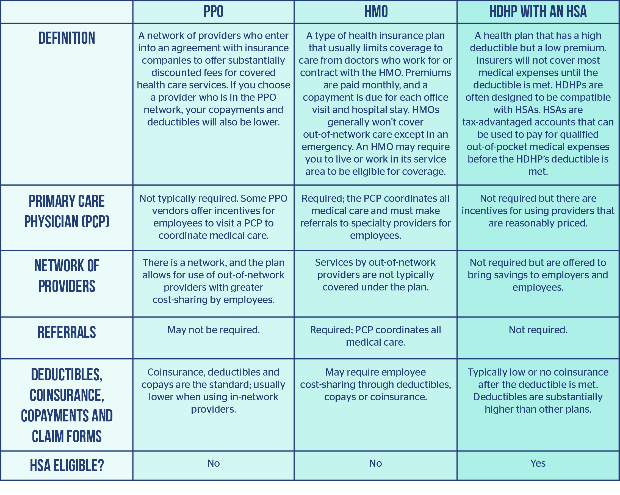
The chart below compares PPOs, HMOs and HDHPs side-by-side.

In-network vs. Out-of-network Care

The Basics
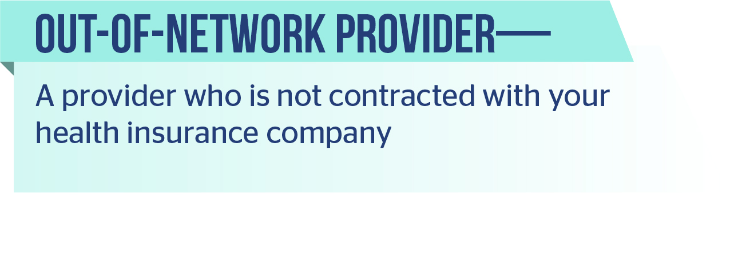
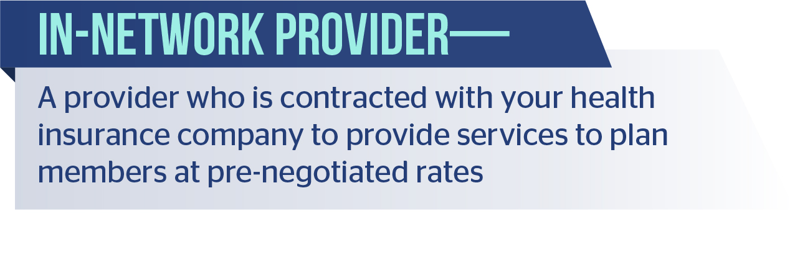
Knowing the difference between an in-network and out-of-network provider can save you a lot of money.

In general, if you visit an in-network provider, you will get your health care at a lower price. If you have a PPO or HDHP, there is likely some coverage for using an out-of-network provider. However, if you have an HMO, this is likely not the case, unless you have an accidental injury or medical emergency, or you obtain preapproval from your provider to use an out-of-network provider.
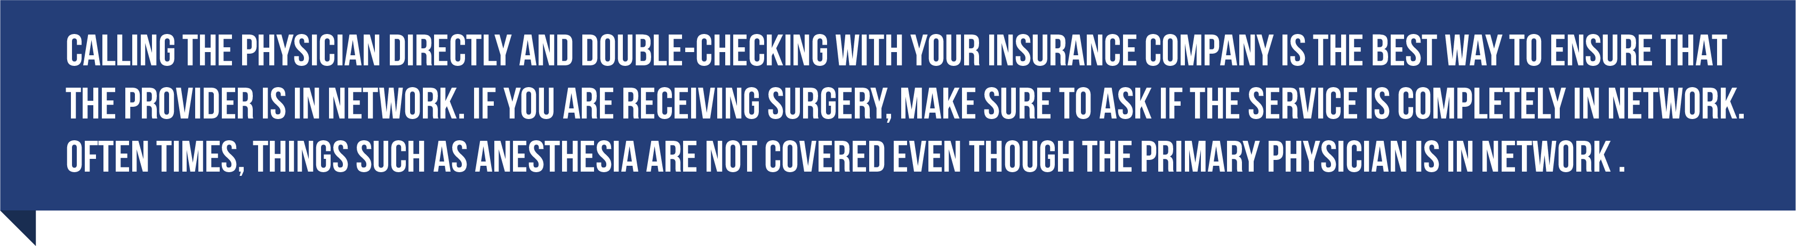
If you decide to go out of network voluntarily, there are several resources that can help you make the best financial decisions, such as www.fairhealthconsumer.org. This nonprofit is dedicated to helping consumers receive and estimate health care cost information.

Billing and Claim Differences
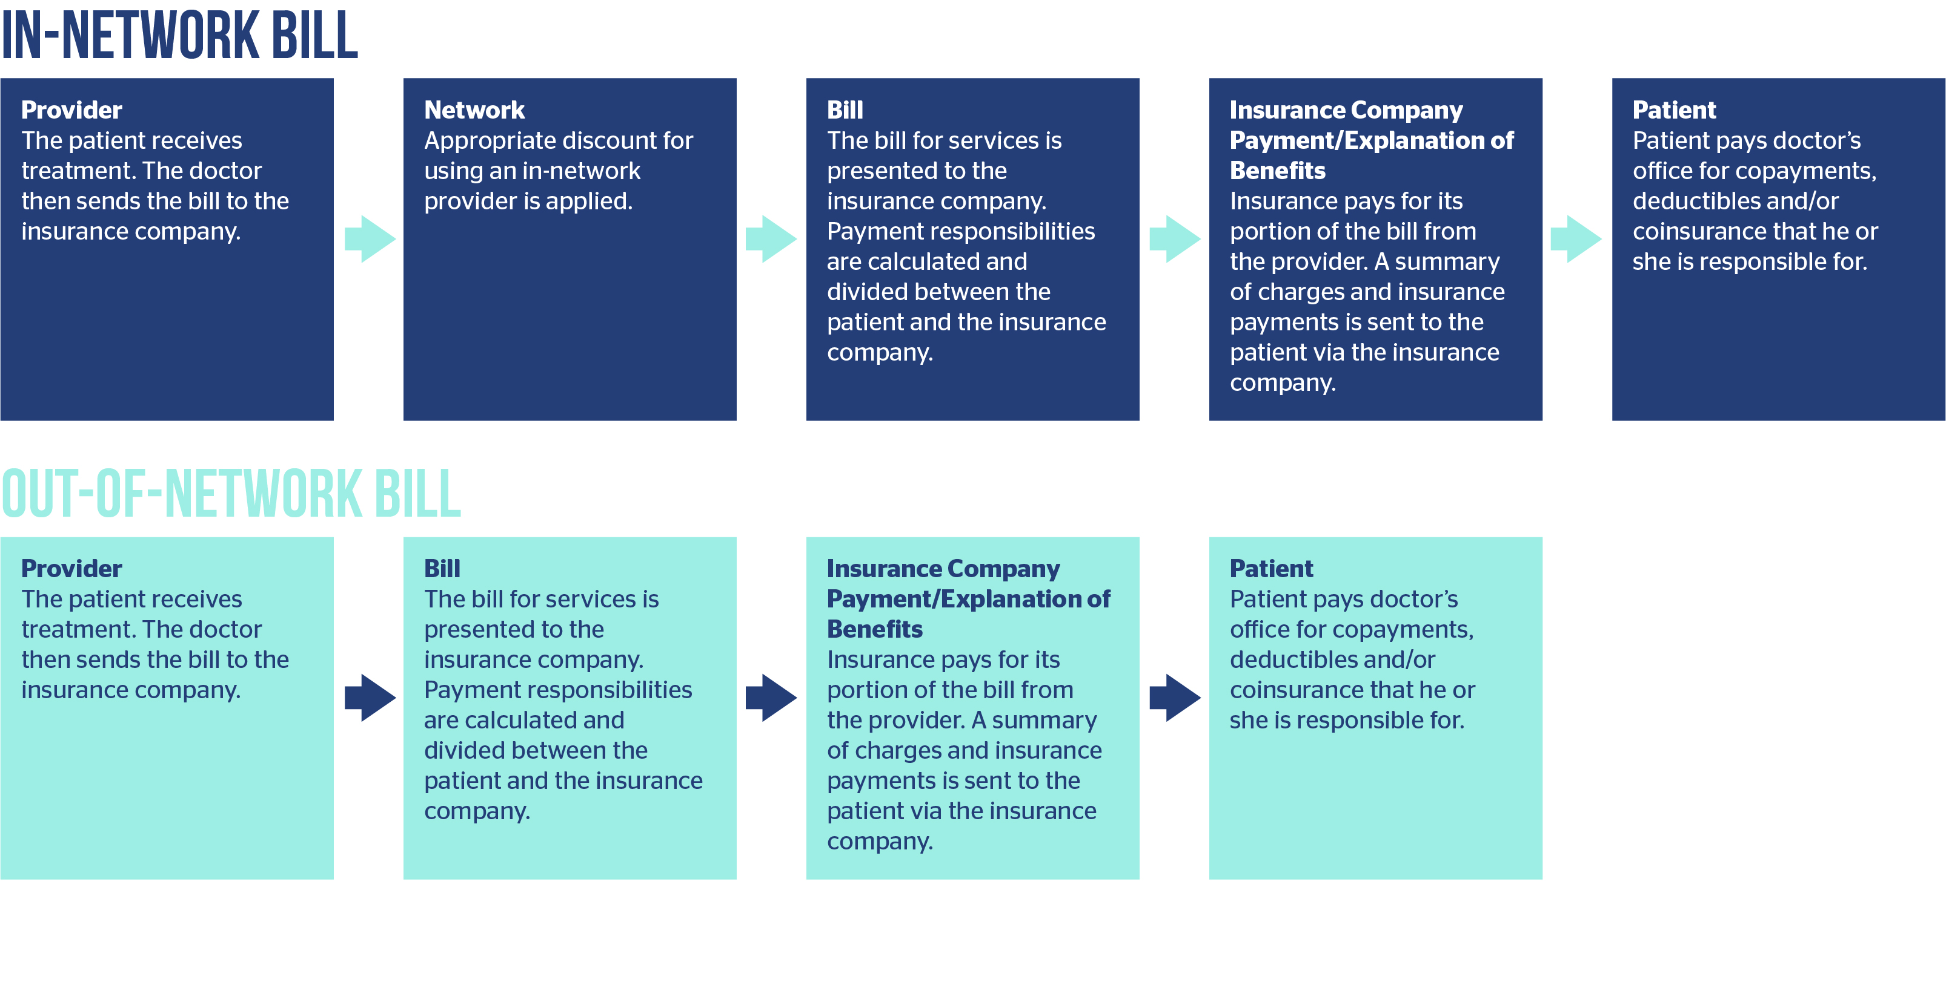
Because in-network and out-of-network providers are treated differently by your health insurance company, you will be billed differently depending on the type of provider you use for your care.

Health Care and Health Insurance Terminology
The world of health insurance has many terms that can be confusing. Understanding your costs and benefits—and estimating the price of a visit to the doctor—becomes much easier once you are able to make sense of the terminology.

Definitions
- Annual limit—Cap on the benefits your insurance company will pay in a given year while you are enrolled in a particular health insurance plan.
- Claim—A bill for medical services rendered.
- Cost-sharing—Health care provider charges for which a patient is responsible under the terms of a health plan. This includes deductibles, coinsurance and copayments.
- Coinsurance—Your share of the costs of a covered health care service calculated as a percentage of the allowed amount for the service.
  - Example: John’s second surgery occurs in the same plan year as his first surgery and costs a total of $3,200. Because he has only paid $800 toward his $1,000 annual deductible, John will be responsible for the first $200 of the second surgery. After that, he has met his deductible and his carrier will cover 80 percent of the remaining cost, for a total of $2,400. John will still be responsible for 20 percent, or $600, of the remaining cost. The total John must pay for his second surgery is $800.
- Copayment (copay)—A fixed amount you pay for a covered health care service, usually when you receive the service.
- Deductible—The amount you owe for health care services each year before the insurance company begins to pay
  - Example: John has a health plan with a $1,000 annual deductible. John falls off his roof and has to have three knee surgeries, the first of which is $800. Because John hasn’t paid anything toward his deductible yet this year, and because the $800 surgery doesn’t meet the deductible, John is responsible for 100 percent of his first surgery.
- Dependent Coverage—Coverage extended to the spouse and children of the primary insured member. Age restrictions on the coverage may apply.
- Explanation of Benefits (EOB)—A statement sent from the health insurance company to a member listing services that were billed by a provider, how those charges were processed and the total amount of patient responsibility for the claim.
- Group Health Plan—A health insurance plan that provides benefits for employees of a business.
- Inpatient Care—Care rendered in a hospital when the duration of the hospital stay is at least 24 hours.
- Insurer (carrier)—The insurance company providing coverage.
- Insured—The person with the health insurance coverage. For group health insurance, your employer will typically be the policyholder and you will be the insured.
- Open Enrollment Period—Time period during which eligible persons may opt to sign up for coverage under a group health plan.
- Out-of-pocket Maximum (OOPM)—The maximum amount you should have to pay for your health care during one year, excluding the monthly premium. After you reach the annual OOPM, your health insurance or plan begins to pay 100 percent of the allowed amount for covered health care services or items for the rest of the year.
- Outpatient Care—Care rendered at a medical facility that does not require overnight hospital admittance or a hospital stay lasting 24 hours or more.
- Policyholder—The individual or entity that has entered into a contractual relationship with the insurance carrier.
- Premium—Amount of money charged by an insurance company for coverage.
- Preventive Care—Medical checkups and tests, immunizations and counseling services used to prevent chronic illnesses from occurring.
- Provider—A clinic, hospital, doctor, laboratory, health care practitioner or pharmacy.
- Qualifying Life Event—A life event designated by the IRS that allows you to amend your current plan or enroll in new health insurance. Common life events include marriage, divorce, and having or adopting a child.
- Qualified Medical Expense—Expenses defined by the IRS as the costs attached to the diagnosis, cure, mitigation, treatment or prevention of disease, or for the purpose of affecting any structure or function of the body.
- Summary of Benefits and Coverage (SBC)—An easy-to-read outline that lets you compare costs and coverage between health plans.

Acronyms

- ACA—Affordable Care Act
- CDHC—Consumer driven or consumer directed health care
- CDHP—Consumer driven health plan
- CHIP—The Children’s Health Insurance Program. A program that provides health insurance to low-income children, and in some states, pregnant women who do not qualify for Medicaid but cannot afford to purchase private health insurance.
- CPT Code—Current procedural terminology code. A medical code set that is used to report medical, surgical, and diagnostic procedures and services to entities, such as physicians, health insurance companies and accreditation organizations.
- FPL—Federal poverty level. A measure of income level issued annually by the Department of Health and Human Services (HHS) and used to determine eligibility for certain programs and benefits.
- FSA—Flexible spending account. An employer-sponsored savings account for health care expenses.
- HDHP—High deductible health plan
- HMO—Health maintenance organization
- HRA—Health reimbursement arrangement. An employer-funded arrangement that reimburses employees for certain medical expenses.
- HSA—Health savings account. A tax-advantaged savings account that accompanies HDHPs.
- OOP—Out-of-pocket limit. The maximum amount you have to pay for covered services in a plan year.

- PCE—Pre-existing condition exclusion. A plan provision imposing an exclusion of benefits due to a pre-existing condition.
- PPO—Preferred provider organization. A type of health plan that contracts with medical providers (doctors and hospitals) to create a network of participating providers. You pay less when using providers in the plan’s network, but can use providers outside the network for an additional cost.
- QHP—Qualified health plan. A certified health plan that provides an essential health benefits package. Offered by a licensed health insurer.

Health Spending Accounts
Health spending accounts are tax-advantaged accounts that allow you to set money aside to pay for qualified medical expenses like deductibles, copays and out-of-network care. There are three main types of health spending accounts.
- HSAs—Health savings accounts
- HRAs—Health reimbursement arrangements
- FSAs—Flexible spending accounts
Each type of health spending account functions differently and provides different benefits to the user. The chart below compares each type of health spending account side-by-side.
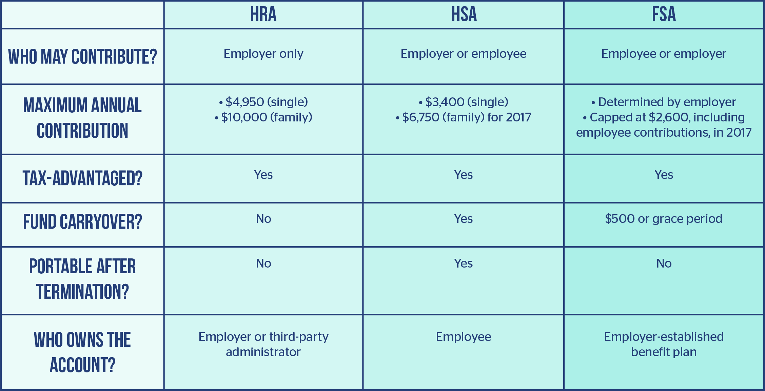

Shopping Tips
Consumer driven health care, or consumerism, revolves around the idea that consumers should be able to make informed choices about their medical care based on price and quality information. The eventual goal is for well-informed health care consumers to compare prices—choosing more wisely and ultimately lowering overall health care costs for everyone. However, the apples-to-apples comparison used for most products or services is mostly useless in the health care marketplace. Learn to shop for value when it comes to health care. With a little effort, you can save thousands of dollars on your medical bills.

Use the following six tips to become a smarter health care shopper.

Patients often accept their doctors’ advice without truly understanding what treatment alternatives are available, and what—if any—differences there are in cost and effectiveness among those alternatives. A few simple questions can help you decide what treatment plan is best for both your health and your wallet. Ask questions such as the following:
- Why is this treatment necessary?
- What is the CPT code of this treatment?
- How much will my treatment cost?
- Can I be treated another way that is equally effective but less costly?



Once you know more about the treatment you will be receiving, you should spend some time “shopping around” for the best quality and best priced treatment options. Most consumers spend time comparison shopping for new electronics or cars, but may find the concept of shopping around for health care strange. This can be accomplished by doing cost comparisons, understanding differences in quality of service and using a personal cost-benefit equation to determine whether the expense is worthwhile. Some ways to find out the prices of certain services include the following strategies:
- Call around. Call local hospitals, doctors and clinics and ask for an estimated quote for the treatment you need. Make sure to check that the providers you are calling are considered in-network providers.
- Use a price comparison tool. Ask your employer if they have any price comparison tools, like Amino. These type of tools allow you to enter information like your treatment’s CPT code or your location and then use that information to find local doctors and estimated procedure prices. Your insurance carrier may provide a price comparison tool as well.
- Look at your insurer’s website. Large insurance companies like UnitedHealthcare, Cigna and Aetna list rates of health care services on their websites.
Remember that these tools and the prices you obtain may only be estimated costs of services. Make sure to confirm pricing of a treatment before you contract a doctor or hospital to perform a service.



You may be able to save some money by paying with cash up front. Doctors lose thousands of dollars every year on credit card processing fees, unpaid bills and collection fees. Ask your doctor or hospital if they offer a discount for self-pay patients. Self-pay patients are patients who don’t have health insurance or are choosing to not use their insurance. Sometimes, using your insurance to help pay for a service may save you more money than paying with cash.
Carefully evaluate if it would be more cost-effective for you to pay with cash and forego any insurance-related discounts, or if it would be better to pay with your insurance.



Finding exact prices beforehand is notoriously difficult in the health care industry; however, a host of resources have become available online in recent years, allowing you to at least obtain a rough estimate for a service, or to compare one facility and region against another.
- Pricing Healthcare—This website lists the “cash” rates for hospitals and surgery centers.
- Healthcare Bluebook—This website lists “fair” prices for services based on ZIP codes.
- New Choice Health—This website offers to match consumers to low-cost providers, based on their location.
- Goodrx.com—This website compares cash prices for prescription drugs at local pharmacies and retailers.



Sometimes, the best advice comes from people you know. Ask friends, family or co-workers for a referral. These people will not only be able to tell you if the doctor, procedure or hospital was expensive, but they will also be able to tell you about the quality of care they received. When it comes to your health care, quality is key.



Staying up to date on health care topics is beneficial for your physical, financial and mental health. You will feel more confident in making major health care decisions if you are well-informed.

The Importance of Preventive Care
Preventive care is a type of health care whose purpose is to shift the focus of health care from treating sickness to maintaining wellness and good health. Preventive care occurs before you feel sick or notice any symptoms and is designed to prevent or delay the onset of illness and disease.
In its broadest definition, prevention includes a healthy lifestyle, exercise, diet and other similar efforts. Preventive care in a medical setting includes a variety of health care services, such as a physical examination, screenings, laboratory tests, counseling and immunizations. Regular health evaluations will help keep you healthy and prevent more serious problems later.
Preventive care can save you money in two ways. First, preventive care helps lower the long-term cost of managing disease because it helps catch problems in the early stages when most diseases are more readily treatable. The cost of early treatment or diet or lifestyle changes is less than the cost of treating and managing a full-blown chronic disease or serious illness.
When preventive care services are combined with a lifestyle that is focused on wellness, significant savings can be realized. The Trust for America’s Health predicts that there is a return of $5.60 for every $1 spent on proven preventive care strategies in America. Ultimately, preventive care provides the benefit of saving lives and improving the quality of your health for years to come.

For More Information
Being a wise health care consumer means taking the time to learn about your insurance and medical care options, choosing the plan and treatments that are best for you, and reviewing medical bills to ensure the charges are correct.
ABC Company is dedicated to providing you with the necessary tools to help you make the most informed health care decisions. If you need additional information on any specific topic, please let us know. We will work to provide you with additional resources as requested.

