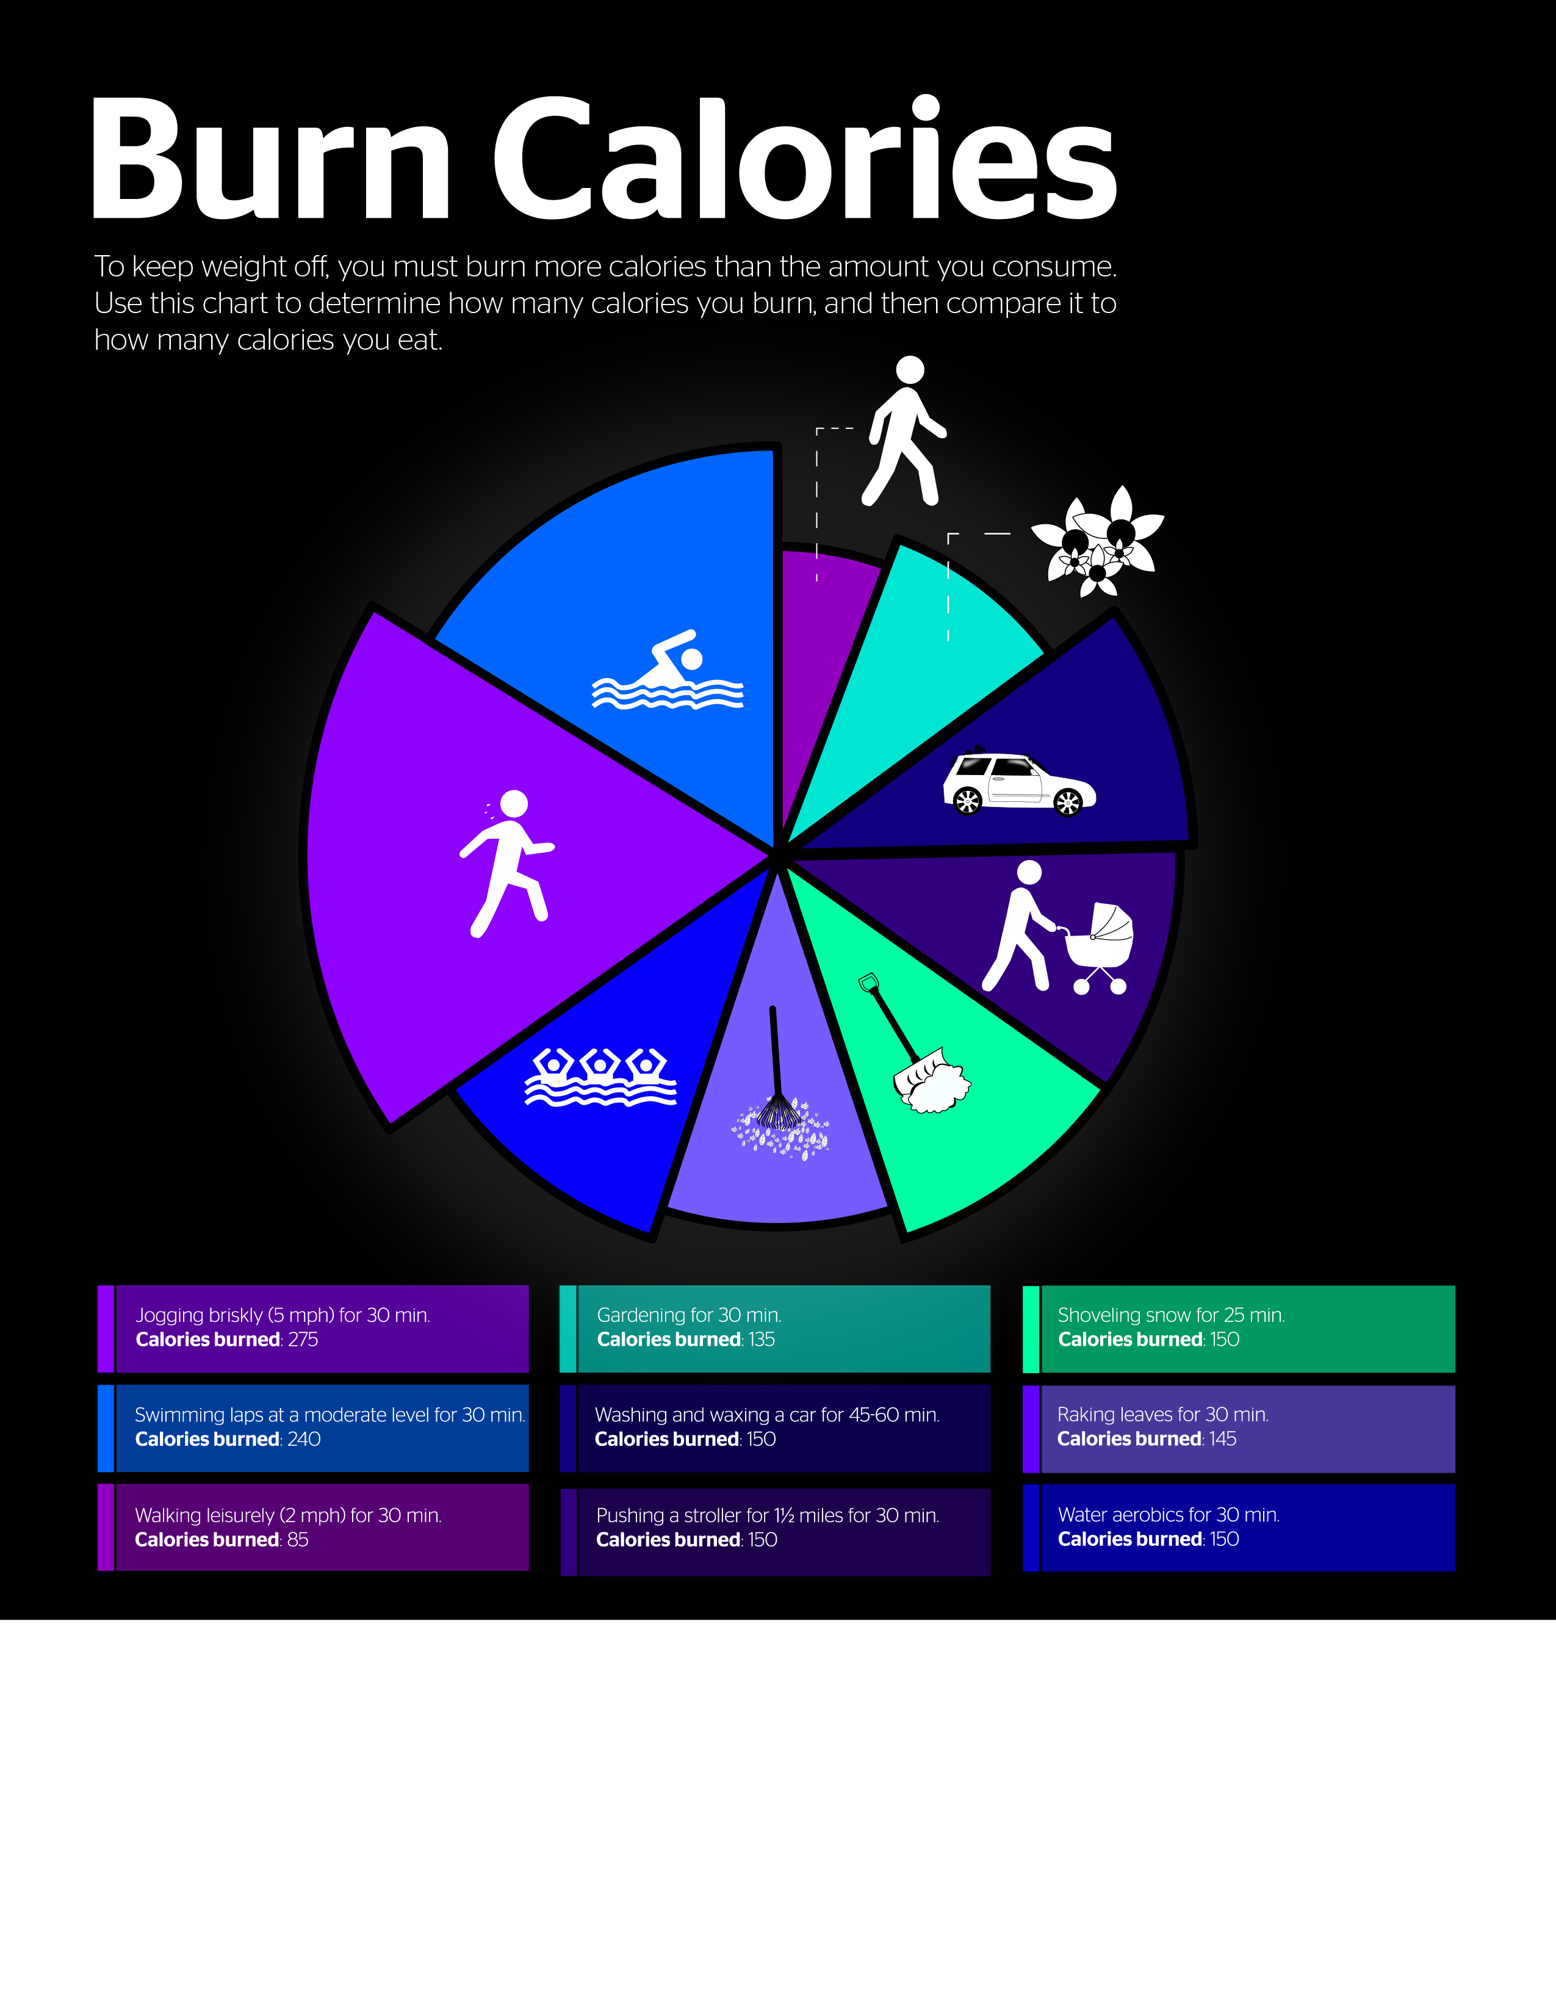
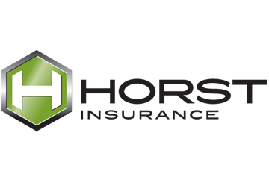
Provided by: Horst Insurance
320 Granite Run Drive, P.O. Box 3320
Lancaster, PA 17604-3320
Tel: (800) 533-2011

© 2007, 2011, 2015 Zywave, Inc. All rights reserved.

