 | CHRISTOPHER J. FANTASKI
 |  | Account Advisor
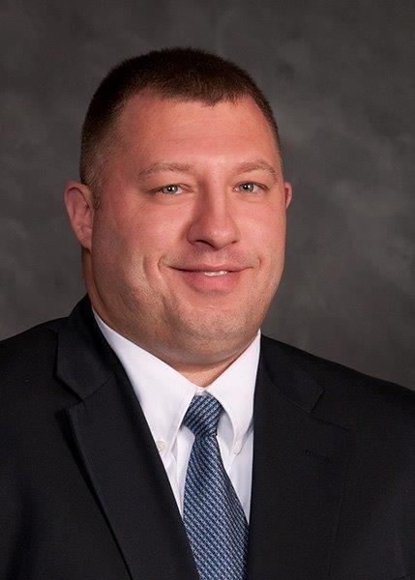 | Professional Profile: |  | Chris Fantaski is a Commercial Lines Account Advisor headquartered in the Lancaster, PA office and works primarily with select commercial accounts. Chris’s ultimate goal is to understand the insurance exposures that face his “main-street” client-base and provide the coverage and services needed to protect their business. Chris serves a wide variety of client’s with commercial property and casualty insurance and specialized risk management programs, including commercial condominium associations and homeowners associations.  Chris enjoys the variety of people and businesses he encounters each day as an Account Advisor and that every day is different from the last.
CONTACT INFORMATION  Office – 717-581-9894  Fax – 717-581-9812  Toll-Free – 800-533-2011  Email – CFantaski@HorstInsurance.com  MAILING ADDRESS  320 Granite Run Drive  PO Box 3320  Lancaster, PA 17604-3320  - COMMERCIAL INSURANCE  - EMPLOYEE GROUP BENEFITS  - PERSONAL / FAMILY INSURANCE  - RISK MANAGEMENT  - FINANCIAL SERVICES | Work Experience: |  | Chris’s insurance career began in 2001 as a policy screener for Nationwide Insurance Company. After joining Horst in 2008, Chris advanced from Account Administrator to Account Manager in 2010. He now serves as Account Advisor to his clients.
 | Education: |  | - Harrisburg Area Community College  - Hartford School of Insurance – Commercial Lines Coverage Specialist (CLCS) designation  - The National Alliance for Insurance Education and Research – Certified Insurance Service Representative (CISR) designation  - The American Insurance Marketing and Sales Society – Certified Professional Insurance Agent (CPIA) designation
 | Professional Associations: |  | - Insurance Agents & Brokers Future’s Program  - Lancaster Chamber Young Professionals Network
 | Hobbies / Interests: |  | - Golfing  - Member of Area Softball Teams  - Sports Memorabilia Collector

