
Are you aware of the changes to FLSA overtime wage payment rule? On May 18, 2016, the Department of Labor (DOL) released a new rule overhauling overtime wage payment in the United States. Our resources will ensure that you’re doing everything you can to promote compliance with this new rule.
Have you examined your company’s overtime pay policies? We have the information you need to determine whether you are in compliance with the new rule and how to make any necessary fixes, so that you can avoid costly penalties and lawsuits.
Do you have unanswered questions about the overtime rule?
Gain access to the client portal where you will find answers to frequently asked questions about overtime pay. You will also find the employee communications tools you need to inform your employees about changes in their employee status, pay and benefits.

717-560-1919
http://www.HorstInsurance.com

Sample Documents
Table of Contents
Employer Resources

Overtime Rule Change: Cost Calculator 4
HR Toolkit – Overtime Rule 5
Overview of Overtime Rule Changes 6
Overtime Rule: Communication Strategies 7

Employee Communication Resources

Changes Regarding the New Overtime Rule 8
Employee Letter About Changes to the Overtime Rule 9

DOL Resources

Overtime Rule Change: Guidance for Private Employers 10
Overtime Rule Change: Guidance for Nonprofit Organizations 11

Overtime Rule Change: Guidance for Higher Education Institutions 12

Additional Resources
DOL Issues New Overtime Payment Rules 13
Overtime Concerns for Employers with Mobile Devices 14
Fair Labor Standards Act: Administrative Exemption 15
Fair Labor Standards Act: Computer Professional Exemption 16
Fair Labor Standards Act: Outside Sales Exemption 17
Fair Labor Standards Act Reference Guide 18
Overtime Approval Form 19
Fair Labor Standards Act: The White Collar Exemption Rules 20

Additional Resources (continued)

DOL Wage and Hour Audits 21
The Importance of Accurate Job Descriptions 22
Fair Labor Standards Act Reference Guide 23
Overtime Wage Payment Compliance: Avoiding Lawsuits and Liability 24

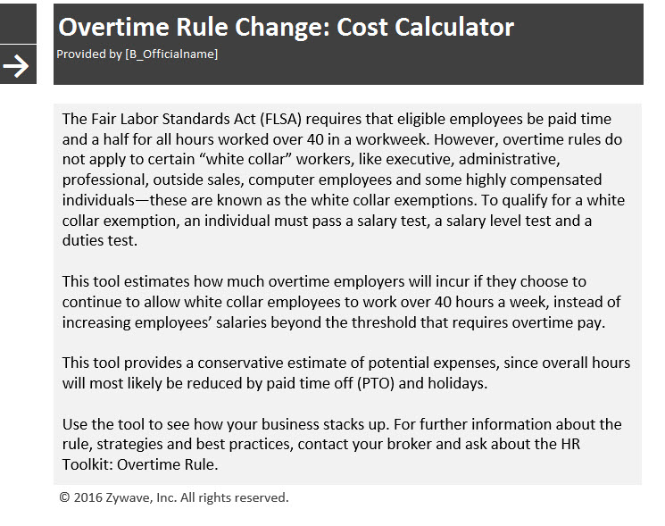

This is a sample document provided by Horst Insurance
4



Brought to you by the insurance professionals at

Overview of Overtime Rule Changes
The DOL issued changes to overtime regulations due to concerns that they were outdated, since the salary thresholds have only changed twice in the past 40 years. For instance, in 1975, more than 60 percent of salaried workers were eligible for overtime pay. Now, only 8 percent of full-time, salaried workers are eligible.
On May 18, 2016, the U.S. Department of Labor (DOL) released a new rule that will overhaul overtime wage payment in the United States. The new rule will more than double the salary threshold that employees must meet to qualify for overtime wage payment exemption—a change that could affect more than 4 million workers across the United States.

What is changing?
The Fair Labor Standards Act (FLSA) requires that eligible employees be paid time and a half for all hours worked over 40 hours in a workweek. However, overtime rules do not apply to certain “white collar” workers, like executive, administrative, professional, outside sales, computer employees and some highly compensated individuals—these are known as the white collar exemptions.
Currently, the salary threshold (salary level test) for overtime pay eligibility under the white collar exemptions is $23,660 a year or $455 per week. The new rule more than doubles the salary threshold to $47,476 per year or $913 a week. It also increases the $100,000 salary level for highly compensated individuals to $134,004 per year—the 90th percentile of full-time salaried workers nationally.

How will this affect employers?
The new rule is controversial since it will require employers to review employees’ exempt status, update overtime policies, notify employees of changes and adjust payroll systems. According to estimates from the DOL, employers will spend more than $592 million to comply with the new rule—representing a significant cost for employers.

Preparation Strategies
Employers must comply with the new rule by Dec. 1, 2016. Given the magnitude of this new rule, it is important to start preparing now for changes to overtime regulations. The following are some strategies employers can adopt:
This is a sample document provided by Horst Insurance
6

Brought to you by the insurance professionals at
Horst Insurance

Overtime Rule: Communication Strategies
On May 18, 2016, the Department of Labor (DOL) released a new rule regarding overtime pay requirements. Currently, employees who meet certain criteria are eligible for overtime pay if they make less than $23,660 per year—under the new rule, this amount would increase to $47,476 per year.
Employees may have already heard news about the overtime changes, so it is important to get ahead of any rumors and reduce employee anxiety and stress by presenting the facts and informing them about upcoming changes.

Given the significant impact the new rule could have on employee satisfaction, developing an effective communication plan is key. The earlier you start, the better. Employees may have already heard news about the overtime changes, so it is important to get ahead of any rumors and reduce employee anxiety and stress by presenting the facts and informing them about upcoming changes.

What You Can Do
Determine who will be in charge of communication efforts. Depending on the size of your company and the scale of the changes, you may want to form a small group dedicated to managing communications. The group may include individuals from the marketing, public relations, human resources, accounting and legal departments as well as the executive team. Identify a point person for questions (often a human resources professional), and make sure this person’s name and contact information is available on all communications.
Educate department heads and front-line managers on changes. Employees may ask initial questions to their direct supervisors, so make sure these individuals are prepared and know how they can escalate questions if necessary.
To ensure that your message is reaching your employees, use a wide variety of communication platforms—including email, intranet postings, group or individual meetings, PowerPoint presentations and social media. When crafting your message, consider the following strategies:
This is a sample document provided by Horst Insurance
7

F
From [C_Officialname
Changes Regarding the New Overtime Rule

Dear employee:
On May 18, 2016, the Department of Labor (DOL) announced a new rule overhauling overtime pay requirements in the United States. This new rule will more than double the salary threshold that employees must meet in order to qualify for overtime pay.
strives to provide you with a benefits package that is all-encompassing and competitive. As a result of this new rule, though, we have had to make some changes to our overtime policies and employees’ exempt status. Effective Dec. 1, 2016, we will begin tracking your hours in order to ensure that you are not working more than 40 hours per week.
We’ve made this change, because under the new overtime rule, you will now be considered a “non-exempt employee”—meaning you are eligible for overtime pay. While we appreciate your dedication to the job, under the new system, overtime work is not permitted unless you have manager approval. [Insert any other condition regarding overtime pay and approval here].
We understand that this reclassification may be a change for you. The goal of this change is not to micromanage you, but to ensure that we are adhering to the new federal guidelines regarding overtime pay, so that we can avoid paying unnecessary penalties—allowing us to instead focus our resources on our employees and growing the company.
Please note that if you do receive approval for overtime work, you will be paid time and a half for all hours worked over 40 in a workweek. [Insert any other conditions regarding overtime pay and approval here.] We do not anticipate overtime work being the norm, as we hope this new time tracking system will encourage a healthier work-life balance and allow you spend more time with your family and friends.
Please know that this change is not a demotion and is in no way an indication of the value of your work. We appreciate the hard work you do each and every day and our success would not be possible without you. This change was only made so we can comply with the new federal overtime rule.
This is a sample document provided by Horst Insurance
8

Dear employee:
On May 18, 2016, the Department of Labor (DOL) released a new rule regarding overtime pay requirements. This new rule will more than double the salary threshold that employees must meet in order to qualify for overtime wage payment exemption. The following is a list of frequently asked questions about new changes to overtime pay.
How will this new rule affect me?
The new overtime regulations may impact whether you are eligible for overtime pay. This determination will be based on a variety of factors, including your annual salary and the type of work you perform. Overtime regulations are complex, so they are many caveats to whether you are considered eligible. For more information on your specific status, contact [insert contact name].
I work over 40 hours a week now; why don’t I get overtime pay?
Under federal law, not all employees are eligible for overtime pay if they work more than 40 hours in a workweek. For instance, certain jobs like executive, administrative, professional, outside sales, computer employees and some highly compensated individuals are not eligible for overtime pay. In addition, if you currently make more than $23,660 per year (will change to $47,476 per year under the new rule), you are likely not eligible for overtime pay.
When does the new rule go into effect?
Employers must comply with the new rule by Dec. 1, 2016. is doing everything we can now to prepare for this change and ensure a smooth transition.
Why are my benefits and/or salary being cut?
strives to provide employees with benefits packages that are all-encompassing and competitive. However, as a result of the federal government’s new overtime rules, we have come to a difficult decision. Effective [insert date], [describe benefit or salary changes].
We understand the impact this change will have on you and your family. We reviewed several options, though, and we believe these changes will best support ’s long-term growth and will have the least amount of impact on our employees overall.
We value you and appreciate all the hard work you do. Our success would not be possible without you, and we look forward to continuing to have you on our team.
If you have any questions, please feel free to reach out to [insert contact name].
Why are my hours now being tracked? My time was never tracked before.
Due to the federal government’s new overtime rule, we have enacted a new time tracking system. We understand that this may be a change for many of you.
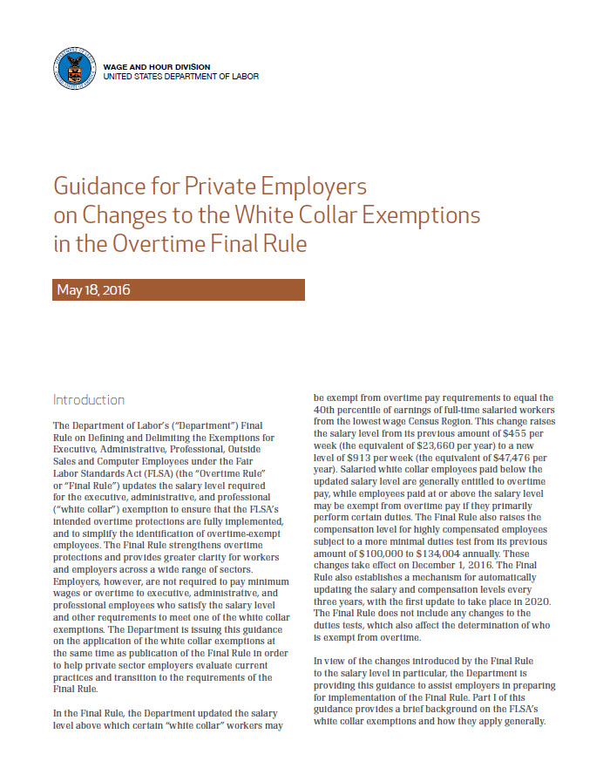
This is a sample document provided by Horst Insurance
10
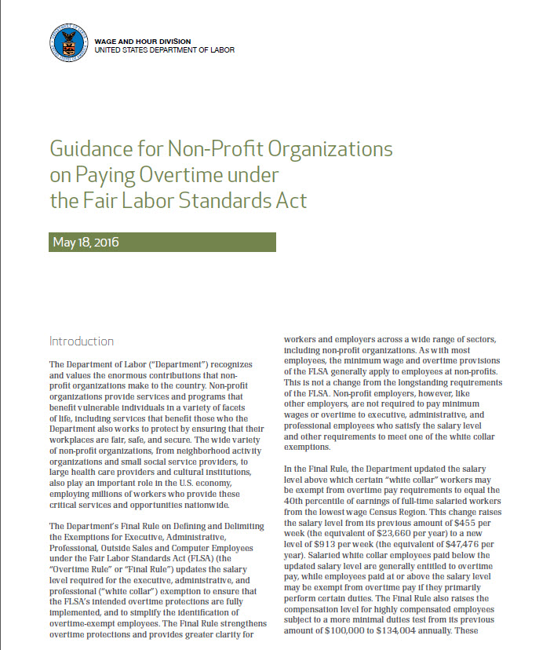
This is a sample document provided by Horst Insurance
11
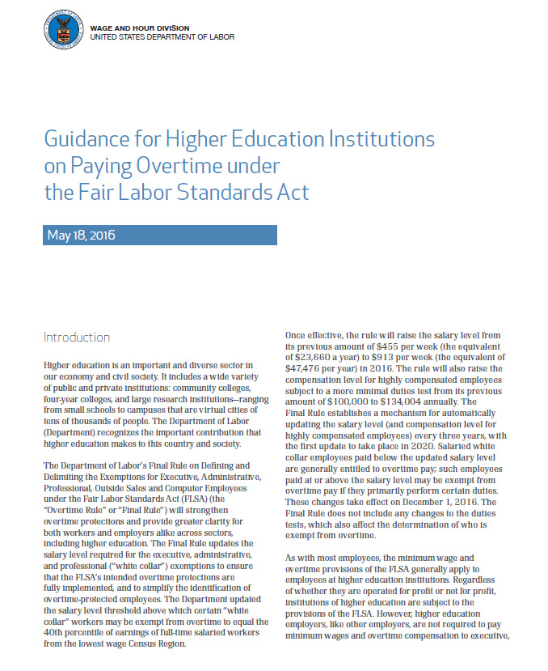
This is a sample document provided by Horst Insurance
12

HIGHLIGHTS
The salary level for administrative, executive and professional employee exemptions will increase to $47,476.
The salary level for the highly compensated employee exemption will increase to $134,004.
The final rule does not change the duties test for white collar exemptions.

IMPORTANT DATES
May 18, 2016
The DOL announced a final rule updating white collar exemption qualification requirements.
December 1, 2016
The final rule becomes effective. Employers are required to comply with the final rule by this date.
Provided By:
Horst Insurance
DOL Issues New Overtime Payment Rules

OVERVIEW
On May 18, 2016, the U.S. Department of Labor (DOL) announced a final rule regarding overtime wage payment qualifications for the “white collar exemptions” under the Fair Labor Standards Act (FLSA).
The final rule increases the salary an employee must be paid in order to qualify for a white collar exemption. The required salary level is increased to $47,476 per year and will be automatically updated every three years. The final rule does not modify the duties test employees must meet to qualify for a white collar exemption.
Employers will need to comply with this rule by Dec. 1, 2016.

ACTION STEPS
Employers must become familiar with the new rule and identify which employees will be affected. Employers should reclassify employees as exempt or non-exempt, as necessary, by Dec. 1, 2016.
Employers should also consider communicating any work schedule changes to affected employees before the date mentioned above.
Finally, employers should evaluate whether implementing new timekeeping practices and training for managers and supervisors on the new requirements is necessary.
This is a sample document provided by Horst Insurance
13
Overtime Concerns for Employees with Mobile Devices
Increasing use of employer-provided mobile devices is reshaping working practices worldwide. By staying connected to their offices, employees have been able to become more productive and more valuable to their employers. Indeed, it’s not unusual these days to find individuals checking their email during their morning commute, preparing a report from the local coffee shop or participating in a video conference from home, hours after the office has closed.

However, this connectivity revolution is also a source of concern for employers and employees alike. Employees worry about the amount of time they spend working outside the office. They feel increasing pressure, particularly during difficult economic times, to take their work with them wherever they go. Employers worry about overtime liabilities that may arise when employees work remotely during unconventional hours.

Ironically, this changing dynamic is still regulated by legislation that has not changed much in the last 50 years. Still, a careful consideration of overtime provisions and exceptions under applicable law can help employers avoid the liability that may arise when employees work beyond the traditional nine-to-five schedule.
FLSA OVERTIME REGULATIONS AND PENALTIES
Most employers in the United States are subject to the Fair Labor Standards Act (FLSA). Under the FLSA, there is no limit on the number of hours employees may work in any workweek, but employees must receive one and one-half times their regular wage rate for all hours worked over 40 hours in a workweek. Sanctions for violating FLSA overtime regulations can be severe, and may include fines of up to $10,000, imprisonment for up to six months, civil liability and any other penalty a federal or state court considers appropriate.
The main difficulties employers face when determining whether an employee working remotely is entitled to overtime compensation are:
- Whether the employee is exempt from overtime regulations; and
- Whether the employee’s remote work is compensable time.
FLSA EXEMPTIONS
If an employee falls within an FLSA overtime exemption, then the employer does not need to worry about how many hours the employee spends working remotely. The FLSA provides a number of exemptions to overtime compensation, such as exemptions for outside sales employees, computer and information technology personnel and certain commissioned workers of retail or service establishments.
However, the most common exemptions for employees using employer-provided mobile devices are known as the white collar exemptions. Contact Horst Insurance for more information on FLSA regulations and exemptions.
This is a sample document provided by Horst Insurance
14

Brought to you by the insurance professionals at
Horst Insurance

Fair Labor Standards Act: Administrative Exemption
Certain job positions qualify for an exemption from FLSA minimum wage and overtime laws, including certain administrative employees. Learn the rules regarding this exemption to ensure your business is in compliance with federal law.

The Fair Labor Standards Act (FLSA) requires that most employees in the United States be paid at least the federal minimum wage for all hours worked and overtime pay at time and one-half the regular rate of pay for all hours worked over 40 hours in a workweek.

However, Section 13(a)(1) of the FLSA provides an exemption from both minimum wage and overtime pay for administrative employees. To qualify for exemption, employees generally must meet certain tests regarding their job duties and be paid on a salary basis at not less than $455 per week. Job titles do not determine exempt status. In order for an exemption to apply, an employee’s specific job duties and salary must meet all the requirements of Department of Labor regulations.

On June 30, 2015, the U.S. Department of Labor (DOL) issued proposed changes to this exemption, seeking to increase the minimum weekly wage requirement to qualify for the administrative exemption to $921 per week. Because this increase was based on the 40th percentile of worker wages for 2013, the DOL may adjust the salary level requirement for the administrative exemption to its projected 2016 equivalent of $970. Furthermore, the proposed changes would also implement automatic annual updates of this number.

Administrative Exemption
To qualify for the administrative employee exemption, all of the following tests must be met:
- The employee must be compensated on a salary or fee basis (as defined in the regulations) at a rate not less than $455 per week (the DOL has proposed increasing this rate to $921 per week, subject to annual updates);
- The employee’s primary duty must be the performance of office or non-manual work directly related to the management or general business operations of the employer or the employer’s customers; and
This is a sample document provided by Horst Insurance
15

Brought to you by the insurance professionals at
Horst Insurance

Fair Labor Standards Act: Computer
Professional Exemption
The Fair Labor Standards Act provides an exemption from both minimum wage and overtime pay for skilled workers in the computer field who meet certain requirements regarding compensation and primary job duties.

The Fair Labor Standards Act (FLSA) requires that most employees in the United States be paid at least the federal minimum wage for all hours worked, and overtime pay at one and one-half the regular rate of pay for all hours worked over 40 hours in a work week.
However, section 13(a)(1) and section 13(a)(17) of the FLSA provide an exemption from both minimum wage and overtime pay for computer employees, such as computer systems analysts, computer programmers, software engineers and other similarly skilled workers in the computer field.
Because job titles vary widely and change quickly in the computer industry, an employee’s job title alone is insufficient to determine whether the exemption applies. To qualify for the computer employee exemption, employees must satisfy the following compensation and primary duties requirements.

Compensation Requirements
Salaried and hourly computer employees must receive at least $455 per week or $27.63 per hour to qualify for a minimum wage and overtime exemption. However, on June 30, 2015, the U.S. Department of Labor (DOL) proposed increasing the weekly salary requirement to $921 per week. Because this number is based on 2013 data, the DOL may adjust this number to its 2016 equivalent of $970. In addition, the DOL is proposing to automatically update this minimum salary requirement on annual basis.

Primary Duties Requirement
To qualify for an exemption from the federal minimum wage and overtime requirements, computer employees must also be primarily employed in:
- The application of systems analysis techniques and procedures, including consulting with users to determine hardware, software or system functional specifications;
This is a sample document provided by Horst Insurance
16

Fair Labor Standards Act: Outside Sales Exemption
The FLSA provides an exemption from both minimum wage and overtime pay for certain employees, including those who work in outside sales. To qualify for the exemption, employees must generally meet certain tests regarding their job duties. This article discusses the outside sales exemption.

Brought to you by the insurance professionals at
Horst Insurance
As technology has developed, so has people’s ability to overcome the traditional communication barriers of time and distance. The practice of telemedicine is a step forward in the health care industry to use telecommunications to bridge the gap of time, distance and affordability to reach patients in need of medical attention.
The Fair Labor Standards Act (FLSA) requires that most employees in the United States be paid at least the federal minimum wage for all hours worked and overtime pay at time and one-half the regular rate of pay for all hours worked over 40 hours in a workweek.

However, Section 13(a)(1) of the FLSA provides an exemption from both minimum wage and overtime pay for certain employees, including those who work in outside sales. To qualify for exemption, employees must generally meet certain tests regarding their job duties and be paid on a salary basis at not less than $455 per week. Job titles do not determine exempt status. In order for an exemption to apply, an employee’s specific job duties and salary must meet all the requirements of the Department’s regulations.

Outside Sales Exemption
To qualify for the outside sales employee exemption, the following tests must be met:
- The employee’s primary duty must be making sales (as defined in the FLSA) or obtaining orders or contracts for services or for the use of facilities for which a consideration will be paid by the client or customer; and
- The employee must be customarily and regularly engaged away from the employer’s place or places of business.

Salary requirements do not apply to the outside sales exemption. An employee may qualify as an exempt employee under one of the other exemptions allowed by Section 13(a)(1) of the FLSA and the Part 541 regulations if all the criteria for the exemption is met.
This is a sample document provided by Horst Insurance
17

Fair Labor Standards Act Reference Guide
The Fair Labor Standards Act (FLSA) establishes minimum wage, overtime pay, recordkeeping and child labor standards affecting full-time and part-time workers in the private sector and in federal, state and local governments.
The Fair Labor Standards Act (FLSA) establishes minimum wage, overtime pay, recordkeeping and child labor standards affecting full-time and part-time workers. This article discusses the provisions of the FLSA, including requirements, exemptions and enforcement.

The Wage and Hour Division (WHD) of the U.S. Department of Labor (DOL) administers and enforces FLSA with respect to private employment, state and local government employment and federal employees of the Library of Congress, U.S. Postal Service, Postal Rate Commission, and the Tennessee Valley Authority. The FLSA is enforced by the U.S. Office of Personnel Management for the employees of other executive branch agencies, and by the U.S. Congress for covered employees of the legislative branch.
Special rules apply to state and local government employment involving fire protection and law enforcement activities, volunteer services and compensatory time off instead of cash overtime pay.

Basic Wage Standards
Covered, nonexempt workers are entitled to a minimum wage of $7.25 per hour. Special provisions apply to workers in American Samoa and the Commonwealth of the Northern Mariana Islands. Nonexempt workers must be paid overtime pay at a rate of not less than one and one-half times their regular rates after 40 hours of work in a workweek.
Wages required by FLSA are due on the regular payday for the pay period covered. Deductions made from wages for items such as cash or merchandise shortages, employer-required uniforms and tools of the trade are not legal to the extent that they reduce the wages of employees below the minimum rate required by FLSA or reduce the amount of overtime pay due under FLSA.
The FLSA contains some exemptions from these basic standards. Some apply to specific types of businesses; others apply to specific kinds of work.
While FLSA does set basic minimum wage and overtime pay standards and regulates the employment of minors, there are a number of employment practices which FLSA does not regulate.
This is a sample document provided by Horst Insurance
18
Overtime Approval Form
NOTE: Overtime must be approved before it is worked.
Employee Name Social Security Number
- -
Department Phone Number

The above employee is approved to work hour(s) of overtime on [insert date].
Reason for Overtime:

My signature certifies that I approve this overtime.
Supervisor Signature Date
Overtime pay will be one-and-a-half times the employee’s regular rate of pay for each hour worked over forty in one workweek.
FOR COMPLETION AFTER HOURS ARE WORKED
Total Hours Worked:
Overtime Pay Earned:
Date:
Supervisor Signature
Please return this form to Human Resources upon completion.
This is a sample document provided by Horst Insurance
19
Fair Labor Standards Act: The White Collar Exemption Rules
The “white collar” exemption was strengthened in August 2004 with the adoption of final regulations under the Fair Labor Standards Act (FLSA). These regulations updated and implemented the exemption from federal minimum wage and overtime pay for executive, administrative, professional, outside sales and computer employees.
The FLSA was first enacted in 1938. It requires that most employees in the U.S. be paid at least the federal minimum wage for all hours worked, and overtime pay at one and one-half times the regular rate of pay for all hours worked over 40 hours in a workweek.
To be considered exempt, employees must meet certain minimum tests related to their primary job duties and, in most cases, must be paid on a salary basis at not less than the minimum amounts specified in the regulations. The minimum salary level was last updated in 1975, over 30 years ago, while the job duty requirements in the regulations had not been changed since 1949, almost 60 years ago. Revisions to both the salary tests and the duties tests were intended to strengthen the FLSA overtime protections and to reflect federal case law developments prior the revision.
Most notably, the final regulations:
- Explicitly spell out that “blue collar” workers are not subject to the overtime exemption;
- Clarify that “first responders” are entitled to overtime;
- Create a standard duties test for determining whether an employee meets a white-collar exemption;
- Raise the minimum salary requirement for exempt employees;
- Guarantee overtime for employees who earn less than $455 per week ($23,660 annually) without any consideration of their job duties. However, on June 30, 2015, the U.S. Department of Labor (DOL) proposed a revision to the minimum salary requirements. The proposal would raise the minimum salary requirement to $921 per week ($47,862 annually). These figures were based on the 40th percentile of wages earned by employees in 2013. The DOL may adjust the proposed numbers to their projected 2016 equivalents once the rule is implemented—$970 per week and $50,440 annually. The minimum wage level rate would also be subject to annual updates;
- Allow employers to deny overtime to “highly-compensated” employees who make over $100,000 a year and perform at least one exempt job function. However on June 30, 2015, the DOL proposed revisions to this exemption that would set the minimum salary requirement to $122,148, an amount that represents the 90th percentile of wages earned by workers in 2013;
- Allow limited deductions from pay, such as allowing employers to suspend employees for misconduct in one or more full-day increments;
- Permit employers to more easily fix improper deductions from an exempt employee’s pay; and
- Explain the educational requirements for certain employees to be classified as exempt.
This is a sample document provided by Horst Insurance
20

Brought to you by the insurance professionals at
Horst Insurance

DOL Wage and Hour Audits
It is estimated that more than one-half of all employer groups have misclassified their employees under FLSA, though many do not realize it.

An auditor may come knocking at your door if you have errors in your payroll that result in a violation of the Fair Labor Standards Act (FLSA). It is estimated that more than one-half of all employer groups have misclassified their employees under FLSA, though many do not realize it.
Generally, the Department of Labor (DOL) will initiate an audit after a current or former employee files a complaint or during a routine investigation. Much like an audit for a potential ERISA violation, the DOL will visit your organization to conduct interviews, examine time clocks and ensure that all employment notifications are available to your employees. The auditor will also review up to three years of wage and hour records to determine if there are any violations in your payroll practices.
To avoid an overtime DOL audit, consider these recommendations:
- Understand the language and content of FLSA to ensure that you will be in compliance with its regulations.
- Conduct an internal audit to reveal any misclassifications before the DOL has an opportunity to do so. Do this annually, or at the very least, when a red flag occurs. Red flags may include a reorganization that affects job classifications, changes in the federal or state law, or an increase in hours worked by employees who are not clearly exempt or non-exempt.
- Review your employees’ job descriptions to make sure they are accurate and reflect the jobs that the individuals are actually doing.
- Review your employees’ job duties to make sure they fall within the correct exemptions: administrative, executive, professional, computer or outside sales.
- Determine if you have properly calculated overtime for non-exempt employees. State laws differ, so make sure you understand your state’s overtime laws.
- Make sure that all required employment postings are hung up and are visible to your employees.
This is a sample document provided by Horst Insurance
21

The Importance of Accurate Job Descriptions
Job descriptions are an essential component of any organization. Not only is it important that they are thorough and accurate when first crafted, it is also vital that they are kept up-to-date, as employees’ job functions may evolve. Inaccurate or outdated job descriptions can also negatively affect recruiting and productivity, are a detriment to the employer-employee relationship and pose serious legal risks for the company.
Impact on Recruiting
When a recruiter is told to hire a new employee, he or she should have a clear idea of the type of person to hire—specifically which qualities, skills and experience to look for to yield a solid group of candidates. This can be gleaned from a detailed job description. Without one, the recruiter cannot hope to find a candidate that will match the manager’s expectations for the position.
Inaccurate or outdated job descriptions can negatively affect recruiting and productivity, are a detriment to the employer-employee relationship and pose serious legal risks for the company.
Brought to you by the insurance professionals at
Horst Insurance
On the applicant side, prospective employees need specific job descriptions to decide if the position is a good fit for their qualifications and their desired career. Well-written, accurate job descriptions will ensure that the most relevant, qualified candidates apply for the job.

Employer Expectations

Having a comprehensive job description creates a concrete set of expectations for the employer to communicate to the employee. The employee is aware of his or her responsibilities as outlined in the job description, so there is less confusion about job expectations. It can also serve as an evaluation tool for employers to measure job performance based on pre-defined job duties.

Legal Implications
Perhaps most importantly, accurate and up-to-date job descriptions will limit company liability. Job descriptions have been successfully used by employees against former employers in recent litigation.
- Fair Labor and Standards Act (FLSA): The FLSA defines exempt and non-exempt status—exempt employees are not subject to minimum wage and overtime pay
This is a sample document provided by Horst Insurance
22

Fair Labor Standards Act Reference Guide
The Fair Labor Standards Act (FLSA) establishes minimum wage, overtime pay, recordkeeping and child labor standards affecting full-time and part-time workers in the private sector and in federal, state and local governments.
The Fair Labor Standards Act (FLSA) establishes minimum wage, overtime pay, recordkeeping and child labor standards affecting full-time and part-time workers. This article discusses the provisions of the FLSA, including requirements, exemptions and enforcement.

Brought to you by the insurance professionals at
Horst Insurance
The Wage and Hour Division (WHD) of the U.S. Department of Labor (DOL) administers and enforces FLSA with respect to private employment, state and local government employment and federal employees of the Library of Congress, U.S. Postal Service, Postal Rate Commission, and the Tennessee Valley Authority. The FLSA is enforced by the U.S. Office of Personnel Management for the employees of other executive branch agencies, and by the U.S. Congress for covered employees of the legislative branch.
Special rules apply to state and local government employment involving fire protection and law enforcement activities, volunteer services and compensatory time off instead of cash overtime pay.

Basic Wage Standards
Covered, nonexempt workers are entitled to a minimum wage of $7.25 per hour. Special provisions apply to workers in American Samoa and the Commonwealth of the Northern Mariana Islands. Nonexempt workers must be paid overtime pay at a rate of not less than one and one-half times their regular rates after 40 hours of work in a workweek.
Wages required by FLSA are due on the regular payday for the pay period covered. Deductions made from wages for items such as cash or merchandise shortages, employer-required uniforms and tools of the trade are not legal to the extent that they reduce the wages of employees below the minimum rate required by FLSA or reduce the amount of overtime pay due under FLSA.
The FLSA contains some exemptions from these basic standards. Some apply to specific types of businesses; others apply to specific kinds of
This is a sample document provided by Horst Insurance
23
Overtime Wage Payment Compliance: Avoiding Lawsuits and Liability
The Fair Labor Standards Act (FLSA) prescribes the minimum wage and overtime pay standards affecting most private and public employers. The FLSA requires employers to pay certain employees at least the federal minimum wage rate and an overtime wage rate for working more than 40 hours per week. Employers should be aware of state laws affecting overtime payment issues, which may impose more stringent requirements than federal law.
This Legislative Brief provides a summary of the FLSA’s overtime requirements and highlights common overtime compensation errors made by employers. The FLSA is administered by the Wage and Hour Division of the U.S. Department of Labor. For more information go to: www.dol.gov/whd/overtime_pay.htm.
Overtime Pay Requirements of the FLSA
Unless specifically exempted, employees covered by the FLSA must be paid overtime pay for any hours they work in excess of 40 hours during a single workweek. The overtime rate must be at least one and one-half times the employee’s regular rate of pay. The FLSA does not impose a limit on how many hours employees aged 16 and older may work in any workweek. The FLSA does not require overtime pay just for working on Saturdays, Sundays, holidays or regular days of rest.
The FLSA defines a workweek as a fixed and regularly recurring period of 168 hours - seven consecutive 24-hour periods. It may begin on any day and at any hour of the day. Different workweeks may be established for different employees or groups of employees.
An employee’s regular rate of pay is the total amount of compensation he or she receives on average, for every hour he or she worked during a workweek. An employee’s total compensation may be determined on a piece-rate, salary, commission or some other basis. Because overtime pay is based on an hourly rate, his or her regular wage rate is calculated by the employee’s the total compensation (except for the statutory exclusions) in any workweek by the total number of hours actually worked during that workweek. The FLSA prohibits employers from averaging the hours an employee works during one workweek with the hours the employee works during other weeks.
Exempt Employees
The FLSA exempts all workers that act in a bona fide professional, executive or administrative capacity from overtime protections. However, job titles alone are not sufficient to avoid the overtime requirements. To qualify as exempt, the employee must meet both parts of the following two-part test:
The salary basis test: In order to meet this requirement, employees must be paid a salary that amounts to at least $455 per week (about $23,600 annually). Some types of employees, such as teachers, lawyers and doctors may be classified as exempt without meeting this income requirement. On June 30, 2015, the U.S. Department of Labor (DOL) issued a proposed rule seeking to increase the salary level required for this exemption to $921 per week ($47,892 per year).
This is a sample document provided by Horst Insurance
24

